2017 Performance Improvement Report
STRATEGIC PRIORITY
1. Develop world-leading healthcare and research

Project Name
Activation of the LinkOut Feature between the Annals of Saudi Medicine, PubMed, and Google Analytics
Site |  | Department
Riyadh |  | Academic and Training Affairs (ATA), Scientific Publications Office
Project Status | Project Start Date |  | Project End Date
Completed | 01-01-2016 |  | 12-31-2016

Problem:  Why the project was needed?  The Annals of Saudi Medicine (ASM) aims to increase the number of visitors, sessions, and hits via the ASM website by activating the LinkOut feature between PubMed and the journal website.  This feature helps in recording the number of hits (number of times users clicked the ASM website); in addition, it measures the online traffic of the website and helps in making further improvements to our advertising campaigns.  The ASM is also heading towards its goal to be an international journal where Saudi Arabia and the United States go on top of the ASM audience list. | Aims: What will the project achieve?  To increase the number of visitors, sessions and hits via the ASM website by around 45% from the baseline before the end of 2016.
Benefits/Impact: What is the improvement outcome?  (check all that apply)  ☐ Contained or reduced costs  ☐ Improved productivity  ☒ Improved work process  ☐ Improved cycle time  ☒ Increased customer satisfaction  ☐ Other (please explain)  Click or tap here to enter text. | Quality Domain: Which of the domains of healthcare quality does this project support?  (Select only one)  Efficient

Measures: Performance metrics to be evaluated | Targets: Expected outcomes
- Number of times users clicked each of the ASM articles via PubMed  - Number of downloads and views via the ASM website  - Number of visitors via the ASM website | - > 45% from baseline  - > 60% from baseline  - > 50% new visitors

Interventions: Overview of key steps/work completed
- Editorial Staff analyzed the problem of too few sessions and visitors via the journal website.
- Technical team has been hired to activate the Google Analytics feature and PubMed LinkOut feature.
- Activation request for the LinkOut feature has been accepted by PubMed.
Results: Insert relevant graphs and charts to illustrate improvement pre and post project
(insert relevant graphs, data, charts, etc.)
Number of downloads and views via the Annals of Saudi Medicine website in 2016
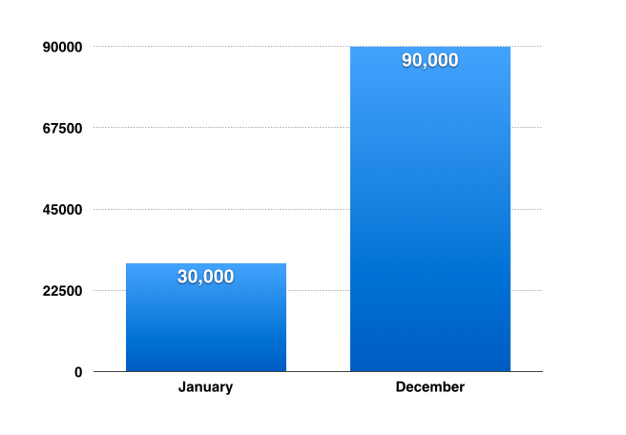
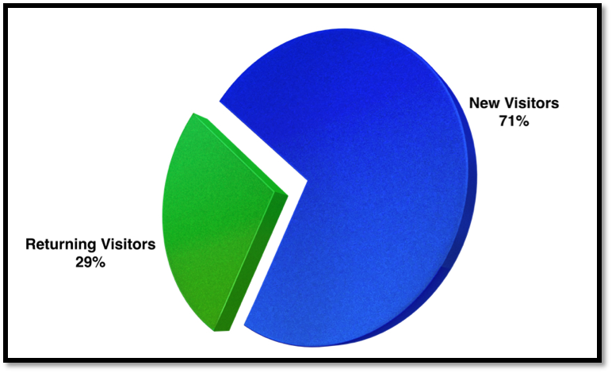
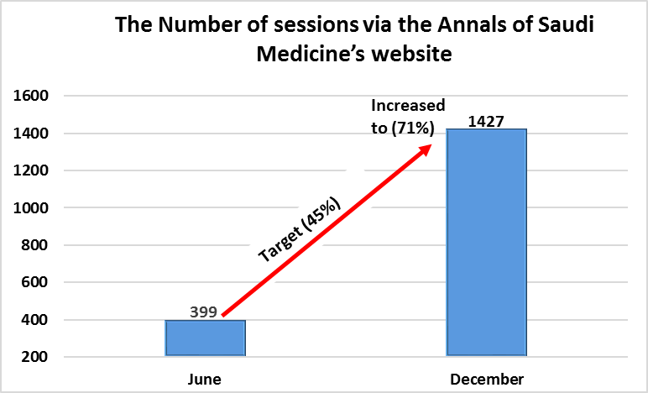
Number of visitors via the Annals of Saudi Medicine website
Number of times users clicked each of the Annals of Saudi Medicine articles via PubMed

Project Lead | Team Members
Name  (person accountable for project) | Names  (persons involved in project)
Prof. Nasser Al-Sanea, Editor-in-Chief of ASM | Dr. Yaser Adi, Scientist  Amal Al-Ghammas, Editorial Supervisor and Senior Editorial Assistant  Reina Tejano-Berina, Desktop Publisher  Raquel Glorioso-Rivera, Editorial Assistant  Kimberly Cristobal, Editorial Assistant  Janelle Vales-Yasay, Editorial Assistant

