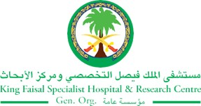
2017 Performance Improvement Report
STRATEGIC PRIORITY
2. Increase capacity and patient access

Project Name
Promote utilization of Pre implantation Genetic Diagnosis (PGD) treatment cycle to the maximum current unit capacity.
Site |  | Department
Riyadh |  | Obstetric & Gynecology Department
Project Status | Project Start Date |  | Project End Date
Completed | 02-05-2017 |  | 09-30-2017

Problem:  Why the project was needed?  The average number of patients Cycle Day 1 (CD1) to start PGD treatment cycle per month is 353, which is huge and far away from unit capacity that is 20 to 22 per month. The process of IVF/PGD treatment Cycle was mapped and it reflected the need of improving communication and coordination between the IVF clinic and the PGD laboratory team to minimize waste of PGD/IVF treatment cycle. | Aims: What will the project achieve?  Increase PGD slot utilization to be greater than 20 per month by the end of September 2017
Benefits/Impact: What is the improvement outcome?  (check all that apply)  ☐ Contained or reduced costs  ☒ Improved productivity  ☒ Improved work process  ☐ Improved cycle time  ☒ Increased customer satisfaction  ☐ Other (please explain)  Click or tap here to enter text. | Quality Domain: Which of the domains of healthcare quality does this project support?  (Select only one)  Patient Centred

Measures: Performance metrics to be evaluated | Targets: Expected outcomes
PGD Slot number | Above 20 slots per month

Interventions: Overview of key steps/work completed

- Patients from the waiting list / patient calling list were called ahead of time to compensate the cancelled / missing cycle.
- New staff was recruited in the PGD team to increase the slot capacity.
- PGD scientist and laboratory team will be involved in the plan to schedule the due patients for Ovum Pick Up (OPU) procedure.

Results: Insert relevant graphs and charts to illustrate improvement pre and post project
(insert relevant graphs, data, charts, etc.)

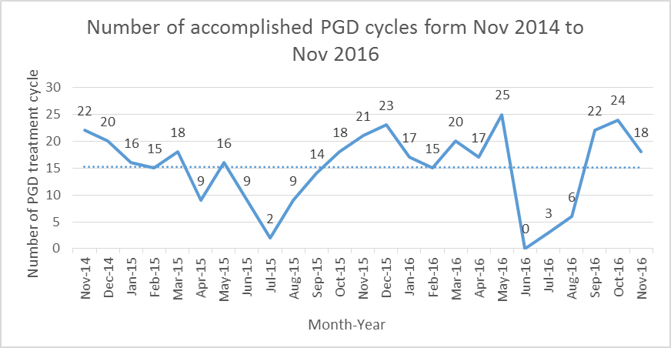

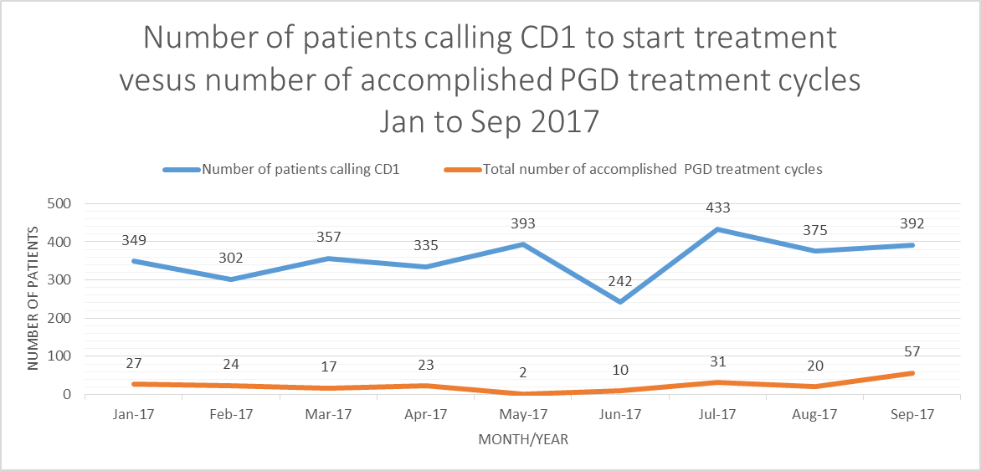

Note: Manual coordination to replace each cancelled cycle, was limited due to human factor; so some treatment cycles were lost in the months of January and February; on the other side, some cycles, in March, were cancelled by patients themselves or due to clinical reasons in late stage of treatment protocol, this is why, they were not replaced. Also, patient interest was limited around Ramadan, so we could not recruit patients to replace the cancellations as seen in May June and July

Project Lead | Team Members
Name  (person accountable for project) | Names  (persons involved in project)
Dr. Saad Al- Hassan. | Dr Serdar Coskun.  Izdehar Zain Alabdean.  Salam Alotaibi.  Pradiksha Sigh.

