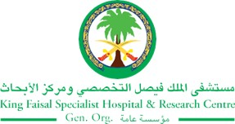
2017 Performance Improvement Report
STRATEGIC PRIORITY
3. Improve efficiency and decision-making

Project Name
Enhancement of Hospital Wide Hand Over Communication Project
(Hand Over is similar to Hand off or Transition of care)
Site |  | Department
Riyadh |  | Medical and Clinical Affairs, Nursing Affairs, and Quality Management Division – Riyadh and Jeddah
Project Status | Project Start Date |  | Project End Date
Completed | 04-01-2015 |  | 12-31-2017

Problem:  Why the project was needed?  An estimated 80 percent of serious medical errors involve miscommunication between caregivers when patients are transferred or handed-over. (http://www.jointcommission.org/sentinel_event.aspx)  Every transition of care can be risky for patients because important information needs to be communicated from one caregiver to another (between healthcare providers, between different levels of care, between departments and services) to keep patients safe. Also International Patient Safety Goal 2.2 requirements - JCI 5th Edition Required to “Introduces a new requirement for effective handovers of patient care within the hospital”. In addition, KFSH&RC-Riyadh Patient Safety Culture Survey-AHRQ in 2012 showed that we score 37% positive response in the composite for handover and transition while AHRQ USA 25th percentile was 38% | Aims: What will the project achieve?  Optimize patient care and safety by enhancing hand over communications by establishing a standardized physician and nursing tools by end of 2017.
Benefits/Impact: What is the improvement outcome?  (check all that apply)  ☐ Contained or reduced costs  ☐ Improved productivity  ☒ Improved work process  ☐ Improved cycle time  ☐ Increased customer satisfaction  ☐ Other (please explain)  Click or tap here to enter text. | Quality Domain: Which of the domains of healthcare quality does this project support?  (Select only one)  Safe
Measures: Performance metrics to be evaluated | Targets: Expected outcomes
- Percentage of documented/acknowledged physician hand over communication in a set period of time  - Percentage of documented/acknowledged nursing hand over communication in a set period of time | - > 60%  - > 80%

Interventions: Overview of key steps/work completed
- Standardize the process by developing hand over communication tool, and to increase the nursing compliance with an existing tool by doing standardization and enhancement to the content, layout, accessibility -----etc.,
- Simulation testing before go live
- Develop a mechanism to monitor the compliance with tool utilization
- Update / develop a policy with clear roles and responsibilities
- Educational campaign
- Success story board
Results: Insert relevant graphs and charts to illustrate improvement pre and post project
(insert relevant graphs, data, charts, etc.)
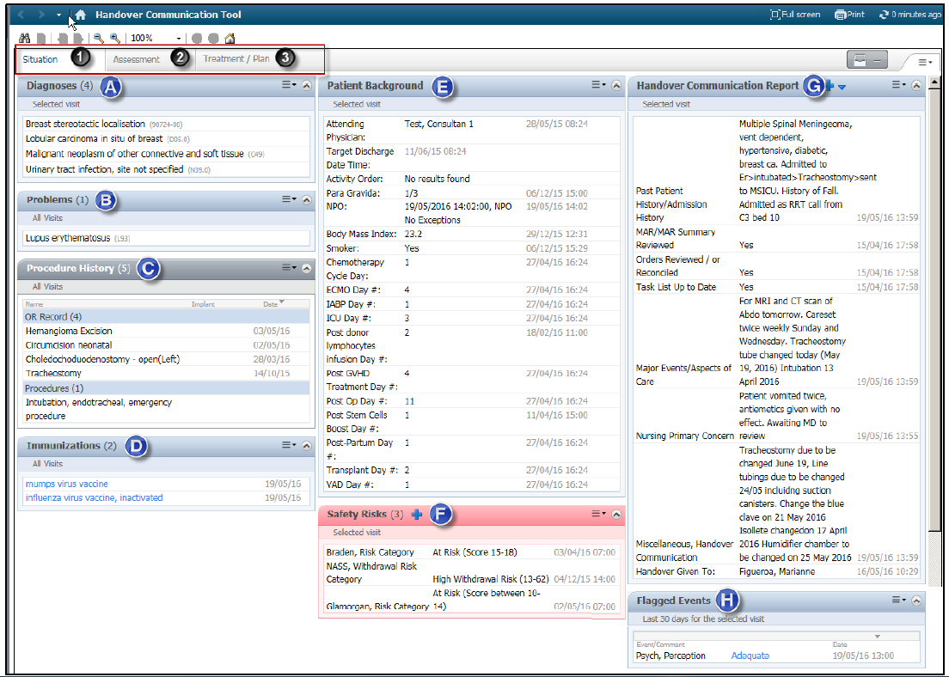
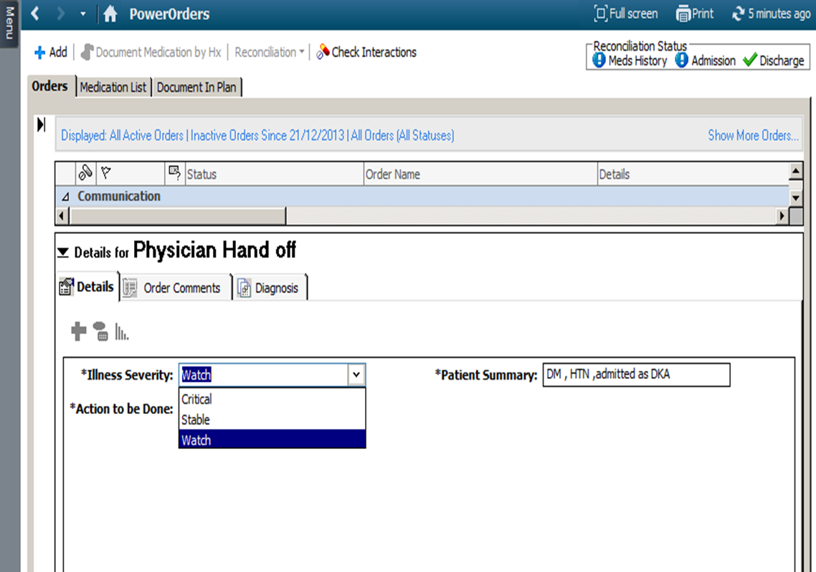

Project Lead | Team Members
Name  (person accountable for project) | Names  (persons involved in project)
Rania Alobari, Project Team leader  Ehab Abu Farhanah, MD Team leader  Amin Abu Shaer, Nursing Team leader | Eyad AlMidani, MD; Mohammed AlQahtani;  Emad Khadawardi, MD; Sharon Berge;  Maisson AlMugbel, MD; Marwan Shaheen; MD;  Rafat Malkawi; Muhannad Hawari, MD  Verdaguer Mary Anchilla; Sasikalan Subaryan;  Marriane Figueroa; Enas Ibrahim;  Mostafa Bleik  Shrouq Zakariya -Jeddah Team Leader: Yousef Alsaid,MD; Lina Bissar, MD; Muntazer Bashir,MD; Ammar Chaudary, MD;

