2017 Performance Improvement Report
STRATEGIC PRIORITY
3. Improve efficiency and decision-making

Project Name
Improve Administrative Staff Performance in Handling New/Revised Submissions
Site |  | Department
Riyadh |  | Academic and Training Affairs (ATA), Scientific Publications Office
Project Status | Project Start Date |  | Project End Date
Completed | 01-01-2016 |  | 12-31-2016

Problem:  Why the project was needed?  The Scientific Publications Office of the Annals of Saudi Medicine (ASM) has administrative staff members responsible for:  • Checking new submissions  • Inputting files for new/revised manuscripts  • Inputting selections/reviews of reviewing editors  • Handling administrative duties  • Preparing/attending biweekly Editorial Board meetings  • Performing other related duties, as assigned.  The ASM has implemented an improved and expedited process in handling new/revised submissions by the administrative staff; this will improve process productivity and efficiency. | Aims: What will the project achieve?  To standardize the average turnaround time of new/revised submissions per administrative staff to be within 7 days before the end of 2016
Benefits/Impact: What is the improvement outcome?  (check all that apply)  ☐ Contained or reduced costs  ☒ Improved productivity  ☒ Improved work process  ☐ Improved cycle time  ☐ Increased customer satisfaction  ☐ Other (please explain)  Click or tap here to enter text. | Quality Domain: Which of the domains of healthcare quality does this project support?  (Select only one)  Efficient

Measures: Performance metrics to be evaluated | Targets: Expected outcomes
New/revised submission turnaround time | Within 7 days

Interventions: Overview of key steps/work completed
- Revise and minimize the technical checklist by means of brainstorming sessions by the administrative staff.
- Create a new guideline for revised submissions.
- Create KPIs for the administrative staff in handling new/revised submissions.

Results: Insert relevant graphs and charts to illustrate improvement pre and post project
(insert relevant graphs, data, charts, etc.)

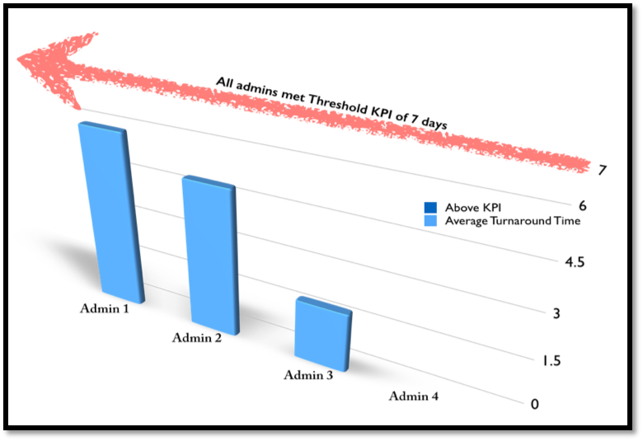
Standard average turnaround time by administrators

Project Lead | Team Members
Name  (person accountable for project) | Names  (persons involved in project)
Prof. Nasser Al-Sanea, Editor-in-Chief of ASM | Dr. Yaser Adi, Scientist  Amal Al-Ghammas, Editorial Supervisor and Senior Editorial Assistant  Reina Tejano-Berina, Desktop Publisher  Raquel Glorioso-Rivera, Editorial Assistant  Kimberly Cristobal, Editorial Assistant  Janelle Vales-Yasay, Editorial Assistant

