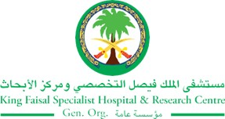
2017 Performance Improvement Report
STRATEGIC PRIORITY
3. Improve efficiency and decision-making

Project Name
Improving the Blood Specimen Transfer Program (BSTP)
Site |  | Department
Riyadh |  | Health Outreach Services Department
Project Status | Project Start Date |  | Project End Date
Completed | 02-01-2017 |  | 10-07-2017

Problem:  Why the project was needed?  Blood Specimen Transfer Program (BSTP) is one of the existing services of Health Outreach Services Department (HOSD). This has been established to help patients of KFSHRC–Riyadh by collecting their samples for laboratory investigations in HOS-regional hospitals before their clinic appointments without the need to travel all the way to Riyadh. The Specimens (Blood / Urine etc...) will properly get packed and put in an ice-box cooler, in order to maintain specimen stability and transportation etiquette. Courier will transport and ship the specimens to KFSHRC–Riyadh main Laboratory Processing Department within 24 hours or less.  Due to many Incidents of discarded or rejected specimens, laboratory results were delayed and patients were called for a second or sometimes third blood collection; This project was initiated to enhance blood specimen transfer program and to enhance its efficiency. | Aims: What will the project achieve?  Increase the efficiency of the Blood Specimen Transfer Program (BSTP) by decreasing the number of specimen related problems at least 50% and enhancing the utilization of this program by September 2017.
Benefits/Impact: What is the improvement outcome?  (check all that apply)  ☒ Contained or reduced costs  ☐ Improved productivity  ☒ Improved work process  ☒ Improved cycle time  ☒ Increased customer satisfaction  ☐ Other (please explain)  Click or tap here to enter text. | Quality Domain: Which of the domains of healthcare quality does this project support?  (Select only one)  Timely

Measures: Performance metrics to be evaluated | Targets: Expected outcomes
Number of specimens related issues from HOS-regional hospitals processing laboratories. | 50%.decrease

Interventions: Overview of key steps/work completed
- Distribution of Specimen Tube Chart / Guidelines to all HOS – Regional Hospital.
- Monitor BSTP by tracking.
- Collaboration, good teamwork and proper coordination were ensured between lab technicians at HOS regional and BSTP coordinator.
- Education was conducted: A videoconference meeting and teachings were given to HOS–regional hospitals’ coordinators and lab technicians to eliminate errors.
- Automation of the outreach care set (CS) in ICIS to avoid requesting a test not included on approved lab list for BSTP
Results: Insert relevant graphs and charts to illustrate improvement pre and post project
(insert relevant graphs, data, charts, etc.)

Fig1: Continuous Increase of Number of Specimens Transferred through BSTP As of April 2017
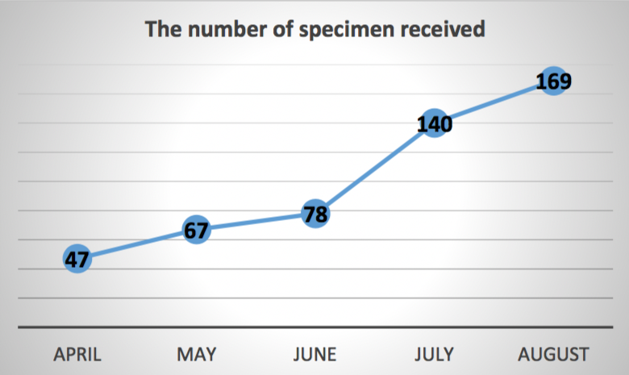

Project Lead | Team Members
Name  (person accountable for project) | Names  (persons involved in project)
Jovie Taer (Staff Nurse I) | Meshal Al Johani. Lead Technical Assistant, DPLM  Nada AlHarbi, Patient Safety Specialist, QMD  Saleh Al Shehri Administrative Coordinator I, HOS

