2017 Performance Improvement Report
STRATEGIC PRIORITY
3. Improve efficiency and decision-making

Project Name |  | Department
Managing Look-alike Drugs of the Carousels and Shelves |  | Pharmaceutical Care Division, North Tower Pharmacy
Project Status | Project Start Date |  | Project End Date
Completed | 01-03-2016 |  | 01-28-2016

Problem:  Why the project was needed?  Managing Look-alike Sound Alike (LASA) Medications is one of the major challenges in the era of medication safety. Improper display of these drugs would result in serious incidents affecting patient safety by giving the wrong medication or the wrong strength.  The project aimed for complete separation of look-alike medications to prevent any further potential errors using colorful labels to attain attraction. | Aims: What will the project achieve?  - To enhance accessibility and proper identification of LASA Medications (total of 16 drugs) by the end of January 2016.  - To decrease the number of mixed LASA medications incidents caught by pharmacists at least 90% from baseline by the end of January 2016.  - To reach zero SRS of patients receiving wrong look alike medication by the end of January 2016.
Benefits/Impact: What is the improvement outcome?  (check all that apply)  ☐ Contained or reduced costs  ☐ Improved productivity  ☒ Improved work process  ☐ Improved cycle time  ☐ Increased customer satisfaction  ☐ Other (please explain)  Click or tap here to enter text. | Quality Domain: Which of the domains of healthcare quality does this project support?  (Select only one)  Safe

Measures: Performance metrics to be evaluated | Targets: Expected outcomes
- LASA medication identification  - Incidents of mixed LASA medications caught by pharmacists (%)  - Number of SRS’s of patients receiving wrong look alike medication (%) | - All 16 drugs  - At least 90% from baseline  - Zero

Interventions: Overview of key steps/work completed
- The project included 16 Drugs rearranged where look-alike packages and names were completely separated.
- Slow moving drugs were removed from carousels and fast moving ones were added in a way to ease their accessibility and to separate them from their look-alikes.
- Colorful labels were used for drugs that resemble in packaging and name but differ in strengths in order to attract attention (red labels for high-strengths and blue labels for lower-strengths).
- Larger fonts were used for medications strength on the labels.
- The changes were informed to all pharmacists.
Results: Insert relevant graphs and charts to illustrate improvement pre and post project
(insert relevant graphs, data, charts, etc.)
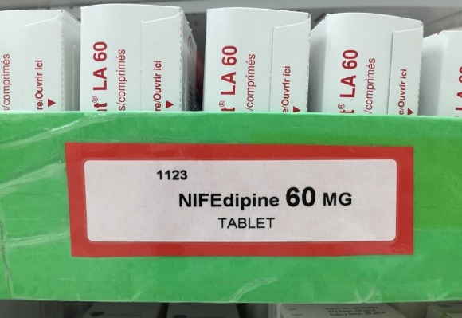
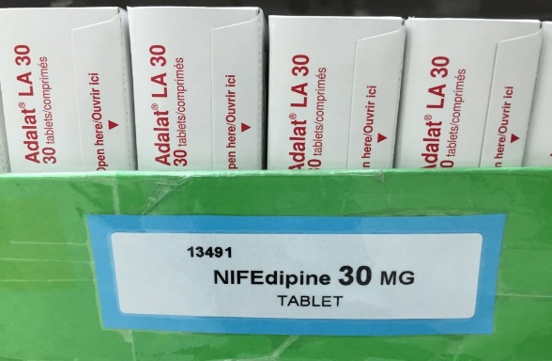
Using colorful labels for medications with different strengths (Red for high-strengths and blue for lower-strengths) for 16 drugs

Project Lead | Team Members
Name  (person accountable for project) | Name  (person accountable for project)
Heba Awwad | Rolla Gharib

