2017 Performance Improvement Report
STRATEGIC PRIORITY
3. Improve efficiency and decision-making

Project Name
Nursing Affairs Dashboard
Site |  | Department
Riyadh |  | Nursing Quality and Magnet
Project Status | Project Start Date |  | Project End Date
Completed | 02-26-2017 |  | 09-30-2017

Problem:  Why the project was needed?  Nursing Quality Section did a survey in February 2017 to evaluate the perception of nurses for the Nursing Affairs dashboards (i.e. sample size 57); only 78% agreed that the current process is efficient in terms of use and display of nursing quality indicators. | Aims: What will the project achieve?  To improve perceived effectiveness of nursing affairs dashboard by 15% from the baseline (78%) by the 3Q 2017; this improvement will be reflected on the below domain:  - Standardized display  - Staff involvement  - Data driven decision making  - Efficiency
Benefits/Impact: What is the improvement outcome?  (check all that apply)  ☐ Contained or reduced costs  ☐ Improved productivity  ☐ Improved work process  ☐ Improved cycle time  ☒ Increased customer satisfaction  ☐ Other (please explain)  Click or tap here to enter text. | Quality Domain: Which of the domains of healthcare quality does this project support?  (Select only one)  Efficient

Measures: Performance metrics to be evaluated | Targets: Expected outcomes
Nursing Perception / Satisfaction (%) | 18 % improvement from baseline

Interventions: Overview of key steps/work completed

- Draft of Nursing Affairs Dashboards was prepared for all nursing units. Then, reviewed and finalized by a group of front-line Nurses and unit Managers from various nursing units, and data experts (i.e. Nursing Quality Improvement Coordinators and Analysts).
- Approved dashboards were disseminated to all concerned units.

Results: Insert relevant graphs and charts to illustrate improvement pre and post project
(insert relevant graphs, data, charts, etc.)
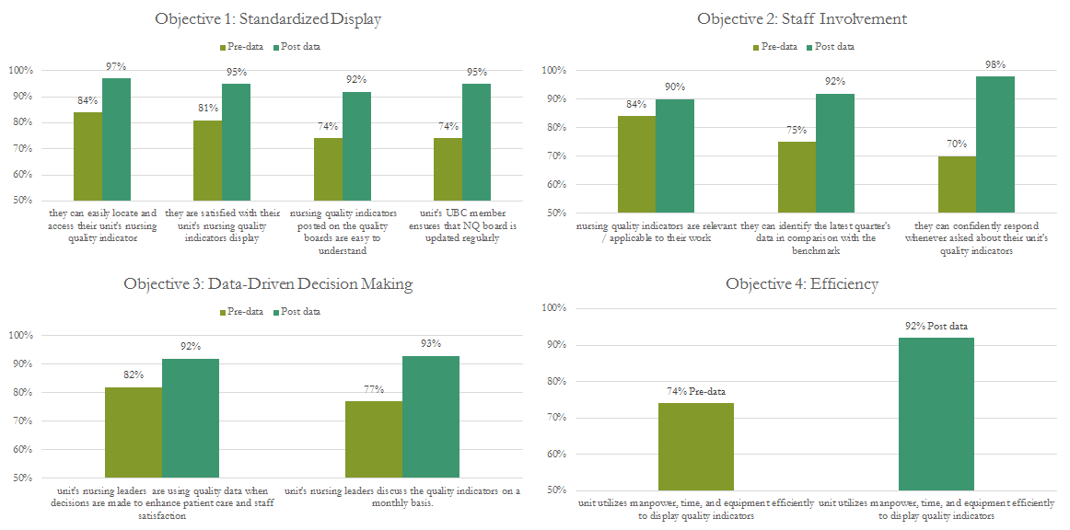

Project Lead | Team Members
Name  (person accountable for project | Names  (persons involved in project)
Yves Laurent Lumaque, Nursing Quality Analyst | • Naser Hussein Shwaihet, Program Director, Nursing Quality Section  • Sasikalan Subrayan, Nursing Quality Manager, Nursing Quality Section  • Eyad Jabr Saleh Bashtawi, Nursing Quality Improvement Coordinator, Nursing Quality Section  • Faten Shahab Eddeen, Nursing Quality Improvement Coordinator, Nursing Quality Section  • Mary Anchilla Cana Verdaguer, Nursing Quality Improvement Coordinator, Nursing Quality Section  • Shazia Arif, Nursing Quality Improvement Coordinator, Nursing Quality Section  • Youssef Daibes, Nursing Quality Improvement Coordinator, Nursing Quality Section  • Nouf Hajji Alharbi, Nursing Quality Analyst, Nursing Quality Section  • Aljohara Abdulrahm Almujahid, Nursing Quality Analyst, Nursing Quality Section

