2017 Performance Improvement Report
STRATEGIC PRIORITY
3. Improve efficiency and decision-making

Project Name
Quality Management Administrative Tasks Automation
Site |  | Department
Riyadh |  | Quality Management Division – Riyadh
Project Status | Project Start Date |  | Project End Date
Completed | 01-01-2017 |  | 09-30-2017

Problem:  Why the project was needed?  The rational behind this project is to use QMD resources wisely and efficiently in the administrative tasks | Aims: What will the project achieve?  To Achieve 100% Paper- less (i.e. Automation) in the following QMD administrative processes by the end of 3Q 2017:  - Overtime/ Time-back  - Staff Leaves Requests  - Attendance Justifications  - Meetings Minutes (PI Council, Accreditation and Managerial Committees, Hospital Safety Committee, Emergency Preparedness Committee & QMD-R Staff Meetings)  - Who Cares Workshop
Benefits/Impact: What is the improvement outcome?  (check all that apply)  ☒ Contained or reduced costs  ☐ Improved productivity  ☐ Improved work process  ☒ Improved cycle time  ☐ Increased customer satisfaction  ☐ Other (please explain)  Click or tap here to enter text. | Quality Domain: Which of the domains of healthcare quality does this project support?  (Select only one)  Efficient

Measures: Performance metrics to be evaluated | Targets: Expected outcomes
- Paper consumption reduction (%)  - Cycle time reduction per task (%) | - 100%  - Not Applicable

Interventions: Overview of key steps/work completed
- Utilize the meeting application
- Use soft copies of administrative QMD requests
- Staff training on the on line applications
Results: Insert relevant graphs and charts to illustrate improvement pre and post project
(insert relevant graphs, data, charts, etc.)
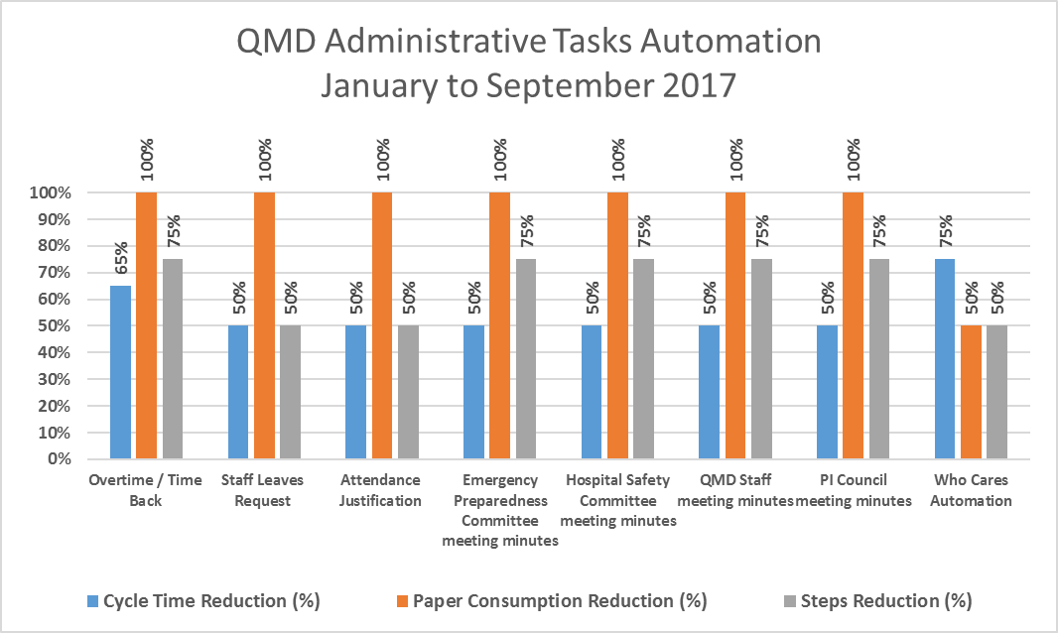

Project Lead | Team Members
Name  (person accountable for project) | Names  (persons involved in project)
Fadwa Abu Mustafa | Rania Al-Obari,  Akram Bashairah,  Joumana Al Messharawi  Hanan Al- Ghammas  Ghiwa Najjar

