2017 Performance Improvement Report
STRATEGIC PRIORITY
3. Improve efficiency and decision-making

Project Name
Reduce Overtime Budget Hours for Endoscopy Clinic
Site |  | Department
Riyadh |  | Endoscopy, Ambulatory Care Nursing
Project Status | Project Start Date |  | Project End Date
Completed | 01-01-2017 |  | 09-30-2017

Problem:  Why the project was needed?  This project was selected to improve efficiency and productivity of endoscopy staff through appropriate management of staff working hours. | Aims: What will the project achieve?  To decrease 2016 overtime budget hours by 50% before the end of 2017.
Benefits/Impact: What is the improvement outcome?  (check all that apply)  ☒ Contained or reduced costs  ☒ Improved productivity  ☐ Improved work process  ☐ Improved cycle time  ☐ Increased customer satisfaction  ☐ Other (please explain)  Click or tap here to enter text. | Quality Domain: Which of the domains of healthcare quality does this project support?  (Select only one)  Efficient

Measures: Performance metrics to be evaluated | Targets: Expected outcomes
Budget overtime hours for Endoscopy Clinic | At least 50% reduction from 2016

Interventions: Overview of key steps/work completed
- Reduction of endoscopy’s overtime budget.
- Providing 100 overtime hours to another area suffering from shortage of hours.
- Introducing a new shift (weekend shift) towards reducing overtime usage.

Results: Insert relevant graphs and charts to illustrate improvement pre and post project
(insert relevant graphs, data, charts, etc.)

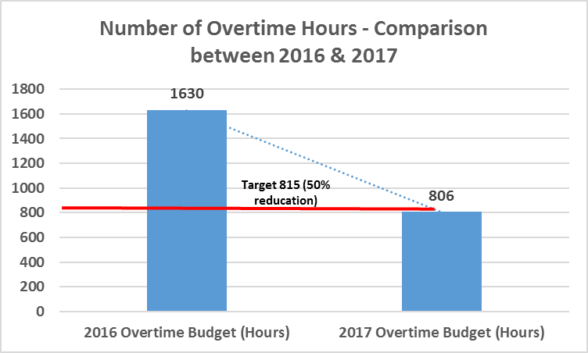

Project Lead | Team Members
Name  (person accountable for project) | Names  (persons involved in project)
Vanessa Lewis | Laurie Watts

