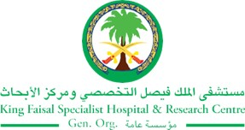
2017 Performance Improvement Report
STRATEGIC PRIORITY
4. Enhance staff recruitment and retention

Project Name
Hemodialysis: Intra & Inter Staff Cross Training
Site |  | Department
Riyadh |  | Hemodialysis Unit, Ambulatory Care Nursing
Project Status | Project Start Date |  | Project End Date
Completed | 01-01-2017 |  | 09-30-2017

Problem:  Why the project was needed?  This project was selected to build up capacity; this will help to enhance staff retention and efficiency by promoting staff training to expand their competencies. | Aims: What will the project achieve?  - To train 25% of hemodialysis nurses (11 out of 42 staff nurses) on handling suspected peritonitis cases and sample collection for body fluid post working hours for all peritoneal patients.  - To check off 100% vascular access nurses (3 out of 3 staff nurses) for hemodialysis competencies  This process will be completed by the end of 3Q 2017.
Benefits/Impact: What is the improvement outcome?  (check all that apply)  ☐ Contained or reduced costs  ☒ Improved productivity  ☒ Improved work process  ☐ Improved cycle time  ☒ Increased customer satisfaction  ☐ Other (please explain)  Click or tap here to enter text. | Quality Domain: Which of the domains of healthcare quality does this project support?  (Select only one)  Efficient

Measures: Performance metrics to be evaluated | Targets: Expected outcomes
- Hemodialysis Cross-Trained Staff in Peritoneal dialysis (%)  - Vascular Access Staff Cross-Trained in Hemodialysis (%) | - 25%  - 100%

Interventions: Overview of key steps/work completed
- Training provided for 2 days outside KFSH&RC for the 11 nurses in Hemodialysis.
- In-services provided to those 11 nurses, in addition to the check-off competencies.
- Continuous training provided to the 3 Vascular Access Nurses, in addition to the check-off competencies
Results: Insert relevant graphs and charts to illustrate improvement pre and post project

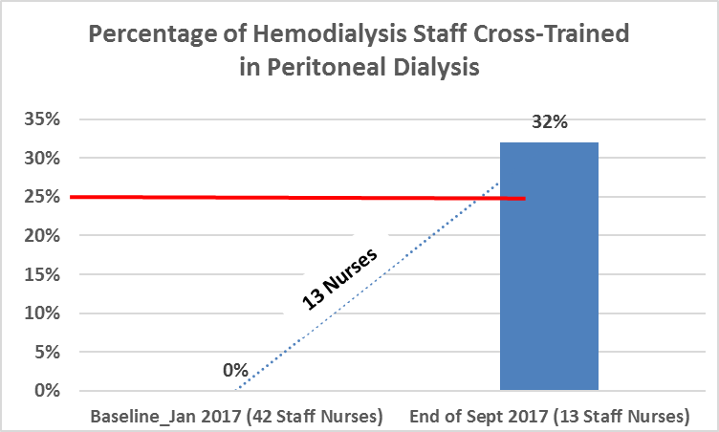
Target: 11 Nurses (25%)

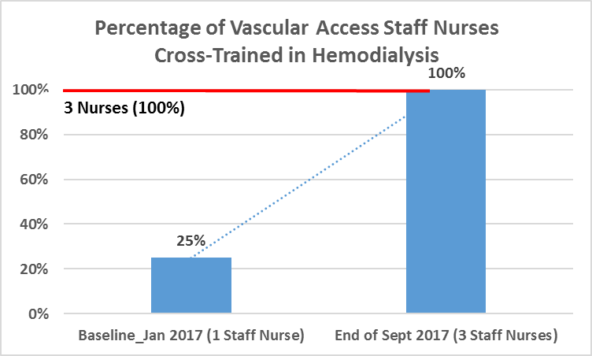

Project Lead | Team Members
Name  (person accountable for project) | Names  (persons involved in project)
Maha Al-Wahsh | Wesam Abedrabo  Nisreen Hannoun

