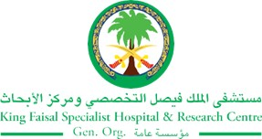
2017 Performance Improvement Report
STRATEGIC PRIORITY
1. Develop world-leading healthcare and research

Project Name
Reduce Fall Incident in Pediatrics Oncology
Site |  | Department
Jeddah |  | Pediatric Oncology
Project Status | Project Start Date |  | Project End Date
Completed | 03-23-2016 |  | 12-31-2016

Problem:  Why the project was needed?  Poor staff compliance to falls assessment/reassessment. | Aims: What will the project achieve?  reduce the incidence by 10% per each quarter
Benefits/Impact: What is the improvement outcome?  (check all that apply)  ☐ Contained or reduced costs  ☐ Improved productivity  ☐ Improved work process  ☐ Improved cycle time  ☐ Increased customer satisfaction  ☒ Other (please explain)  Improve patient safety | Quality Domain: Which of the domains of healthcare quality does this project support?  (Select only one)  Safe

Measures: Performance metrics to be evaluated | Targets: Expected outcomes
Fall Risk Assessment | Reduce the incidence by 10% per each quarter

Interventions: Overview of key steps/work completed
- A questionnaire has been developed utilizing evidence-based practice of pediatric nurses partnering with parents to reduce falls incident in inpatient pediatric oncology unit.
- Three articles has been reviewed from ProQuest Nursing & Allied Health Database, and another article reviewed from The Joanna Briggs Institute to identify the best evidence for fall risk prevention.
- Multi-language fall prevention poster placed in all patient room.
- Partnership safety agreement with patient parents/sitter of fall prevention to be sign by parents/caregiver and primary nurse upon admission.
- To provide a copy of fall prevention education tool in Arabic version to parents/caregiver.
Results: Insert relevant graphs and charts to illustrate improvement pre and post project
(insert relevant graphs, data, charts, etc.)

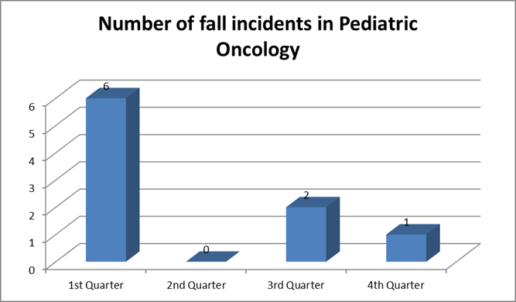

PONC (Pediatric Oncology)
Monthly Nursing Performance Measures
Measures | Internal Trigger | Jan-16 | Feb-16 | Mar-16 | Apr-16 | May-16 | Jun-16 | Jul-16 | Aug-16 | Sep-16 | Oct-16 | Nov-16 | Dec-16
Total FALLS | 1.1/1000 patient days | 3.5 | 1.8 | 3.4 | 0.0 | 0.0 | 0.0 | 1.7 | 1.9 | 0.0 | 1.7 | 0.0 | 0.0
Falls with injury | 1.1/1000 patient days | 3.5 | 1.8 | 0.0 | 0.0 | 0.0 | 0.0 | 1.7 | 0.0 | 0.0 | 0.0 | 0.0 | 0.0

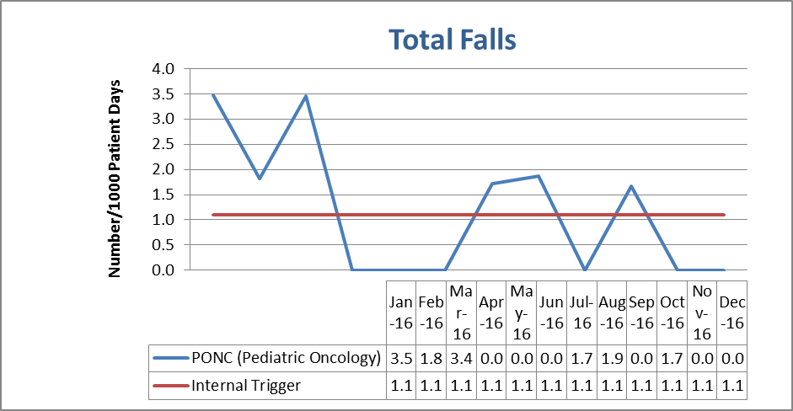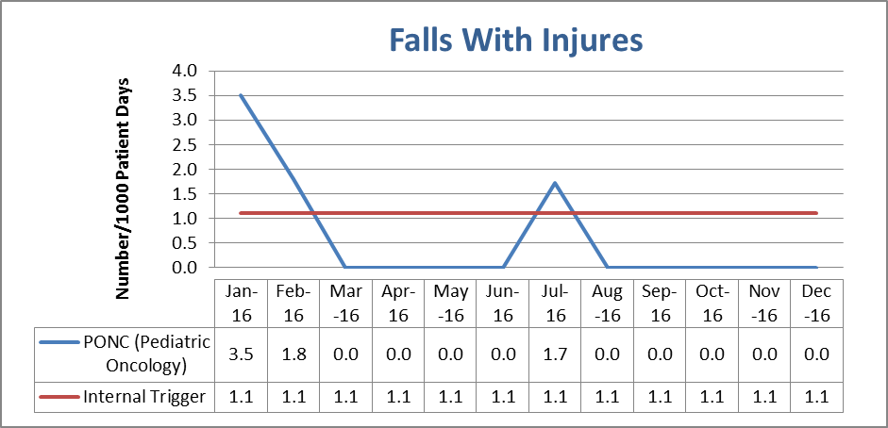

Project Lead | Team Members
Name  (person accountable for project) | Names  (persons involved in project)
Shara ALHarbi | Bigy Raphael  Linda Othamn  Kristy Nedira  Emma Araya  Shoinse Young  Abeer Aljoudy  Gillian Sedgewick,  Amal Al-Othmani  Ohood Al-Haddad

