2017 Performance Improvement Report
STRATEGIC PRIORITY
1. Develop world-leading healthcare and research

Project Name
Reduction of Hospital Acquired Pressure Injury ( HAPI) rate in adult oncology
Site |  | Department
Jeddah |  | Adult Oncology
Project Status | Project Start Date |  | Project End Date
Completed | 02-01-2016 |  | 07-31-2016

Problem:  Why the project was needed?  Hospital Acquired Pressure Injury Rate, in particular about our stage 2 and above.  During the Jan/2016 we were above the trigger 3.5, which is the trigger 0.75/1000 patient days | Aims: What will the project achieve?  Decrease unit acquired HAPI Stage 2& above from 3.5 to less than internal trigger of 0.75/1000 patient days by end of Jul /2017.
Benefits/Impact: What is the improvement outcome?  (check all that apply)  ☒ Contained or reduced costs  ☐ Improved productivity  ☒ Improved work process  ☐ Improved cycle time  ☒ Increased customer satisfaction  ☐ Other (please explain)  Click or tap here to enter text. | Quality Domain: Which of the domains of healthcare quality does this project support?  (Select only one)  Safe

Measures: Performance metrics to be evaluated | Targets: Expected outcomes
Hospital Acquired Pressure Injury Rate | Decrease unit acquired HAPI Stage 2& above from 3.5 to less than internal trigger of 0.75/1000 patient days by end of Jul /2017.

Interventions: Overview of key steps/work completed
- The group identified the high risk patients for HAPI and patients with Pressure Injury (PI)
- Audit tool has been created, auditing started with a focus on documentation
- Strict compliance with changing of position Q 2 Hours for high risk patient and for patient with pressure injury
- Education to the Staff about pressure injury was given on quarterly basis
- Created educational material for the patient and relative to increase awareness and help prevent PI, the educational material was also translated in Arabic
- Admission checklist for skin integrity was created and approved by the group and Implemented for every patient admission or transfer from home, other facility or other unit.
Results: Insert relevant graphs and charts to illustrate improvement pre and post project
(insert relevant graphs, data, charts, etc.)

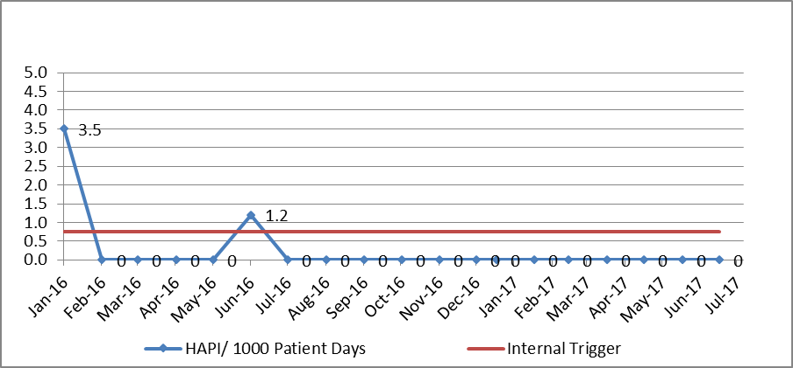

Project Lead | Team Members
Name  (person accountable for project) | Names  (persons involved in project)
Ahmad Maghari | Enciso, Judy Fe Aragon  Salas, Maiden Marinas  Tan, Kemban  Claudette Gay Aguilar  Renze, Angela  Joseph, Sherin  Pabico,Katherine Joy  Sarbonza Meera

