2017 Performance Improvement Report
STRATEGIC PRIORITY
3. Improve efficiency and decision-making

Project Name
Enhance the Accounts Payable Suppliers Communication Process
Site |  | Department
Jeddah |  | Financial Service
Project Status | Project Start Date |  | Project End Date
Completed | 04-01-2017 |  | 05-31-2017

Problem:  Why the project was needed?  Data shows an average of 80 complaints per month were received from suppliers related to phone communication with finance department. Suppliers used to call finance department to ask about different things related to accounts payable transactions, however they used to face challenges such as staff they are unable to answer their inquiry, need to reach accounts payable head, different language and more. | Aims: What will the project achieve?  To reduce the number of suppliers complaint (average 80 complaint per month to 30 complaint per month or less) by the end of May 2017.
Benefits/Impact: What is the improvement outcome?  (check all that apply)  ☐ Contained or reduced costs  ☒ Improved productivity  ☒ Improved work process  ☐ Improved cycle time  ☐ Increased customer satisfaction  ☐ Other (please explain)  Click or tap here to enter text. | Quality Domain: Which of the domains of healthcare quality does this project support?  (Select only one)  Efficient

Measures: Performance metrics to be evaluated | Targets: Expected outcomes
Number reported complaint by suppliers | To reduce the number of suppliers complaint (average 80 complaint per month to 30 complaint per month or less) by the end of May 2017.

Interventions: Overview of key steps/work completed
- An e-mail address was created to improve the communication with the Suppliers, where suppliers can direct their quires to this e-mail. (DisbursementsJeddah@kfshrc.edu.sa)
- The new communication process were introduced and shared with all suppliers.
- Staff from finance department was assigned to answer the suppliers quires in timely manner.

Results: Insert relevant graphs and charts to illustrate improvement pre and post project
(insert relevant graphs, data, charts, etc.)

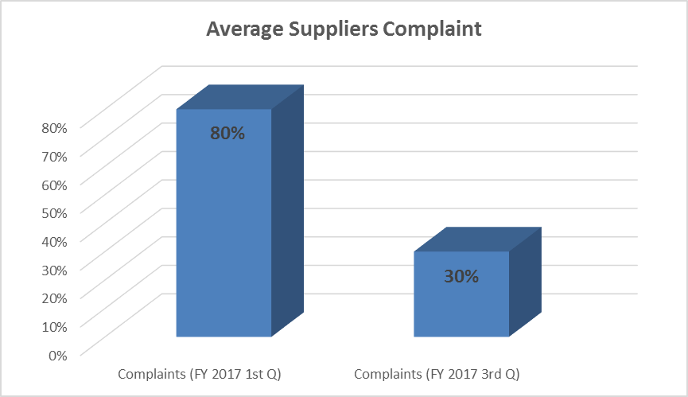

Project Lead | Team Members
Name  (person accountable for project) | Names  (persons involved in project)
Ghada Abdulmajeed | Finance team from, Accounts payable  Abdrhman Mohammed Abdrhman  Fatin Alsaid As Consultant  Samer Dards

