2017 Performance Improvement Report
STRATEGIC PRIORITY
3. Improve efficiency and decision-making

Project Name
Improve compliance with the process of documenting of POCT Glucose Critical Result Notification.
Site |  | Department
Jeddah |  | Department of Pathology and Laboratory Medicine / Point of Care Testing Section
Project Status | Project Start Date |  | Project End Date
Completed | 01-02-2017 |  | 12-31-2017

Problem:  Why the project was needed?  - In 2016 there was only 60 % compliance to critical result documentation of point of care (POCT) glucose.  - Standards for Joint Commission International Accreditation (JCIA) and CAP that all critical results must be communicated to the caregiver and this communication must be documented. | Aims: What will the project achieve?  To increase percentage of documentation compliance of critical result notification to be 100%.
Benefits/Impact: What is the improvement outcome?  (check all that apply)  ☐ Contained or reduced costs  ☐ Improved productivity  ☒ Improved work process  ☐ Improved cycle time  ☒ Increased customer satisfaction  ☐ Other (please explain)  Click or tap here to enter text. | Quality Domain: Which of the domains of healthcare quality does this project support?  (Select only one)  Safe

Measures: Performance metrics to be evaluated | Targets: Expected outcomes
Percentage of documentation compliance of POCT Glucose Critical Result Notification | Increase documentation compliance of critical result notification to be 100%.

Interventions: Overview of key steps/work completed
- Increase the machine lockout time (shutdown time) from 5 to 30 minutes to allow time for nurse to call physician, manage the patient care, and document in the Glucometer (AccuCheckII)
- Send monthly report of non-compliance rate to the head nurses for their information and corrective action.
- Staff education communicated through POC site managers about the importance of documentation of the critical notification as one of patient safety measure. That also includes the procedure on how to comply with documentation process.
- POCT Coordinator initiating safety reports (SRS) on hospital Quality Information System (QIS) for occurrences of not documented POC critical result notifications.
Results: Insert relevant graphs and charts to illustrate improvement pre and post project
(insert relevant graphs, data, charts, etc.)
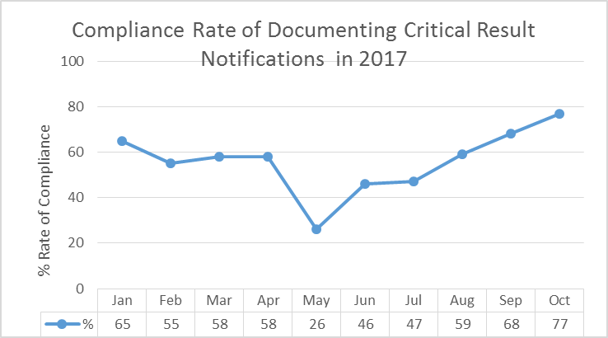

Project Lead | Team Members
Name  (person accountable for project) | Names  (persons involved in project)
Ahmad Shanaa | Dr. Nabeela Al Baz  Dr. Sandra Lovering  Gillian Sedgewick  Sarfinaz Hanbazaza  Samer Dardas

