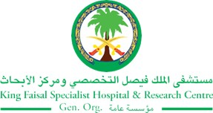
2017 Performance Improvement Report
STRATEGIC PRIORITY
3. Improve efficiency and decision-making

Project Name
Improve Percentage of Radiation End of Treatment (EOT) Reports Submitted to Medical Records Within Two Weeks After Completion of Radiation.
Site |  | Department
Jeddah |  | Section of Radiation, Oncology Department
Project Status | Project Start Date |  | Project End Date
Completed | 01-01-2017 |  | 03-31-2017

Problem:  Why the project was needed?  Radiation treatment is given in an institute outside KFSH and requires the EOT reports to be sent across from KAUH to KFSH to be filed. This is manually sent across within a month of patient’s end of radiation treatment, without a record. Following this, there is risk of mishandling. Not all the EOT reports are filed in medical records. This has been seen in the radiation oncology clinic when the patient comes for follow-up. There is no record regarding the details of radiation treatment which poses a huge problem for the continuity of care. Documentation of treatment is imperative.  Our previous percentage of EOT report submission varied from 0-47% within 1 month of patient’s end of radiation treatment. | Aims: What will the project achieve?  To improve percentage of Radiation End of Treatment (EOT) reports submitted to Medical Records from 47% within 1 month to be within two weeks after completion of radiation to 90% or more.
Benefits/Impact: What is the improvement outcome?  (check all that apply)  ☐ Contained or reduced costs  ☒ Improved productivity  ☒ Improved work process  ☒ Improved cycle time  ☐ Increased customer satisfaction  ☐ Other (please explain)  Click or tap here to enter text. | Quality Domain: Which of the domains of healthcare quality does this project support?  (Select only one)  Efficient
Measures: Performance metrics to be evaluated | Targets: Expected outcomes
Percentage of Radiation End of Treatment (EOT) Reports Submitted to Medical Records Within Two Weeks After Completion of Radiation. | To improve percentage of Radiation End of Treatment (EOT) reports submitted to Medical Records from 0-47% within 1 month to be within two weeks after completion of radiation to 90% or more

Interventions: Overview of key steps/work completed
- In collaboration with Cerner steering committee, the team explore the possibility of scan and upload the EOT report into ICIS.
- To scan the EOT Reports into ICIS process was approved.
- December 2016, the new process tested and the feedback was collected from the end users.
- The EOT reports are sent electronically from KAUH to Medical Records and (ODU) Oncology Data Unit at KFSH by email, so there is a record of the data being sent.
- Specific staff were assigned to generate the EOT report from MOSAIQ (electronic medical record system at KAUH), to send the report via email and to scan the report into the Power Chart.
- Process measure was selected to measure the compliance with the new process.
Results: Insert relevant graphs and charts to illustrate improvement pre and post project
(insert relevant graphs, data, charts, etc.)
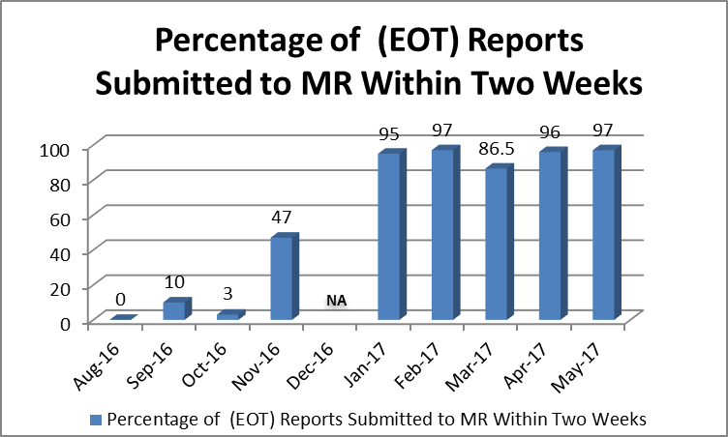

Project Lead | Team Members
Name  (person accountable for project) | Names  (persons involved in project)
Zaheeda Mulla | Amina Weber  Jocelyn Caber  Abdullah Amohammed  Tarik Boubakra  Jocelyn Caber  Dr Osama Soliman  Dr Iqbal Hafez  Ghassan Abdulmoula  Lookman Abdullah  Peter Rufon  Johnson Curtis  Sarbonza Meera

