2017 Performance Improvement Report
STRATEGIC PRIORITY
3. Improve efficiency and decision-making

Project Name
Reduce turnaround time for the diagnostic procedures of Multiple Sclerosis patients form 20 weeks to two week by August 2017.
Site |  | Department
Jeddah |  | Neurophysiology - Neurosciences
Project Status | Project Start Date |  | Project End Date
Completed | 04-01-2017 |  | 09-30-2017

Problem:  Why the project was needed?  Multiple visits (four visits) of the patients for completion of mandatory tests for diagnosis of Multiple Sclerosis (MS) patients causing discomfort, dis-satisfaction and a very high cost of supplies and consumables and delay in initiation of treatment. In addition, no-show rates of these procedures were also around 40%. | Aims: What will the project achieve?  - Reduce turnaround time for the diagnostic procedures of Multiple Sclerosis patients form 20 weeks to two week.  - To avoid the multiple visit of the patients for three different test by accommodating them in single visit through better scheduling and time management
Benefits/Impact: What is the improvement outcome?  (check all that apply)  ☒ Contained or reduced costs  ☒ Improved productivity  ☒ Improved work process  ☒ Improved cycle time  ☒ Increased customer satisfaction  ☐ Other (please explain)  Click or tap here to enter text. | Quality Domain: Which of the domains of healthcare quality does this project support?  (Select only one)  Timely

Measures: Performance metrics to be evaluated | Targets: Expected outcomes
Turnaround time for the diagnostic procedures of Multiple Sclerosis patients | Reduce turnaround time for the diagnostic procedures of Multiple Sclerosis patients form 20 weeks to two week

Interventions: Overview of key steps/work completed
- Data was collected and analyzed for the factors contributing in long waiting period for MS Diagnostic tests appointments and cost of supplies and consumables due to multiple visits
- Define and Implement Strategies for Remedies:
- After data analysis Jan – March 2017, Pareto Analysis (80/20) rule was used to target the core issues and following strategies were adopted to embark on vital few for remedies and implemented them from in 2017 and data was collected again to analyze the outcome.
- Major Strategies were:
- The mandatory test for Diagnosis of MS that is SEP (Somatosensory Evoked Potential), MEP (Motor Evoked Potential) and VEP Visual Evoked Potential) was clubbed in one group.
- Patients were given one appointments for the group rather individual test to avoid multiple visits.
- Three group appointments were schedule on assigned days, twice a week to accommodate three patients per day.
- Staff duty roster reviewed and test schedule changed to accommodate these patients.
- Patient and family education broacher was revised for the details of the patient preparations for these tests.
- Liaison with referring physician was further strengthening for better management of appointment.
- Lab logistic arrangement re-designed to minimize the loss of time between the tests.
- All three required tests done as a one-window operation under one roof.

- Develop and implement Performance Measure (Indicator):
- The performance indicator for measuring outcome after implementing strategies developed
- and data was collected simultaneously for review and analysis. Indicator measured was:
- Turnaround time of completion of mandatory tests of Multiple Sclerosis patients.

Results: Insert relevant graphs and charts to illustrate improvement pre and post project
(insert relevant graphs, data, charts, etc.)
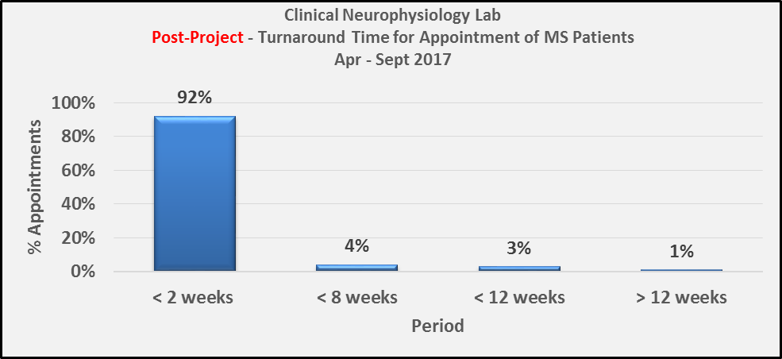

Project Lead | Team Members
Name  (person accountable for project) | Names  (persons involved in project)
Mustafa Khan | Ghada Kadi  Gulzar Karim  Haji Khan  Daifallah Al Huthali  Samer Dardas

