2017 Performance Improvement Report
STRATEGIC PRIORITY
3. Improve efficiency and decision-making

Project Name
Reduction Of Overtime Hours
Site |  | Department
Jeddah |  | Anesthesia Auxiliary
Project Status | Project Start Date |  | Project End Date
Completed | 01-01-2017 |  | 09-30-2017

Problem:  Why the project was needed?  During year 2016 the overtime utilization reached more than 800 hours in Anesthesia Auxiliary Department, we have been requested by higher management to identify areas where we can cut the cost without compromising patient’s safety and then we start working on the overtime utilization plan | Aims: What will the project achieve?  To reduce overtime hours utilization in Anesthesia Auxiliary Department from more than 800 hours to 400 hours or less while in 2017.
Benefits/Impact: What is the improvement outcome?  (check all that apply)  ☒ Contained or reduced costs  ☐ Improved productivity  ☐ Improved work process  ☐ Improved cycle time  ☐ Increased customer satisfaction  ☐ Other (please explain)  Click or tap here to enter text. | Quality Domain: Which of the domains of healthcare quality does this project support?  (Select only one)  Efficient

Measures: Performance metrics to be evaluated | Targets: Expected outcomes
Overtime Utilization in Anesthesia Auxiliary Department per Hours | Reduce overtime hours utilization in Anesthesia Auxiliary Department from more than 800 hours to 400 hours or less while in 2017

Interventions: Overview of key steps/work completed
- Time back process for the staff has been initiated
- Re-scheduling of the duty Rota during and after the working hours
- New process started which is overtime approval
- Improve the workflow of the Anesthesia Technologist assigned on the area
- Contained or reduced the cost of the overtime hour’s budget of the department

Results: Insert relevant graphs and charts to illustrate improvement pre and post project
(insert relevant graphs, data, charts, etc.)
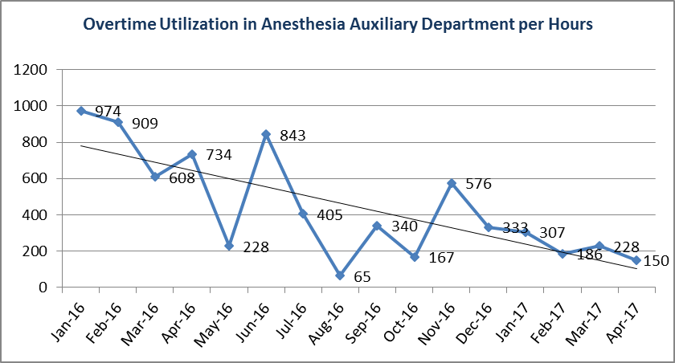
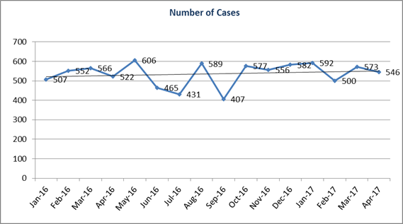

Project Lead | Team Members
Name  (person accountable for project) | Names  (persons involved in project)
Zahid Aziz | Jafar Badandi  Amal Nassar  Samer Dardas

