2017 Performance Improvement Report
STRATEGIC PRIORITY
3. Improve efficiency and decision-making

Project Name
Improving the Quality and Effectiveness of Initial Inpatient Consultation Note
Site |  | Department
Jeddah |  | Medicine Dept.
Project Status | Project Start Date |  | Project End Date
Completed | 01-01-2017 |  | 05-31-2017

Problem:  Why the project was needed?  KFSH & RC (Gen. Org.) Jeddah ensures compliance with quality requirements for documentation.  JCI requires peer-review process. Good written and verbal communication is essential for high-quality, safe consultation. The Department of Medicine provides consultation services hospital-wide.  By setting standards for the Quality of Initial Consultation Notes in the Department of Medicine and engaging members of the Department in peer review audits and providing feedback, practice-based learning improvement and high-quality consultative skills will be promoted.  Baseline audit revealed significant room for improvement in all the elements of the tool, with 37% overall compliance | Aims: What will the project achieve?  Improve the compliance with “elements of high quality and effective initial electronic consultation note” from 37% to at least 85% by end of May 31st 2017
Benefits/Impact: What is the improvement outcome?  (check all that apply)  ☐ Contained or reduced costs  ☐ Improved productivity  ☒ Improved work process  ☐ Improved cycle time  ☐ Increased customer satisfaction  ☐ Other (please explain)  Click or tap here to enter text. | Quality Domain: Which of the domains of healthcare quality does this project support?  (Select only one)  Effective
Measures: Performance metrics to be evaluated | Targets: Expected outcomes
Compliance with “elements of high quality and effective initial electronic consultation note” | Improve the compliance with “elements of high quality and effective initial electronic consultation note” from 37% to at least 85% by end of May 31st 2017

Interventions: Overview of key steps/work completed
- Standards of the elements of the Initial Consultation Note were developed. Education was provided to the members of the Department, verbally during Department Meetings and in writing.
- A pocket tool was developed (adapted from the University of California San Francisco EBM tool) to provide structure for feedback and evaluation of trainees, and promote practice-based learning improvement and high quality consultative skills.
- Members of the Department were engaged in the peer review assessment and received regular feedback by supervising consultants during the rotations
- Monthly audit was done to monitor the compliance with the elements of essential consultation notes for all sections. Results were discussed monthly in the department of Medicine meeting
Results: Insert relevant graphs and charts to illustrate improvement pre and post project
(insert relevant graphs, data, charts, etc.)
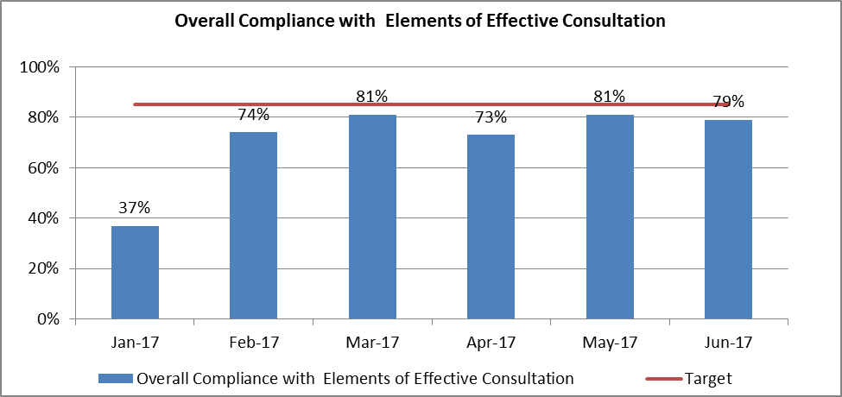
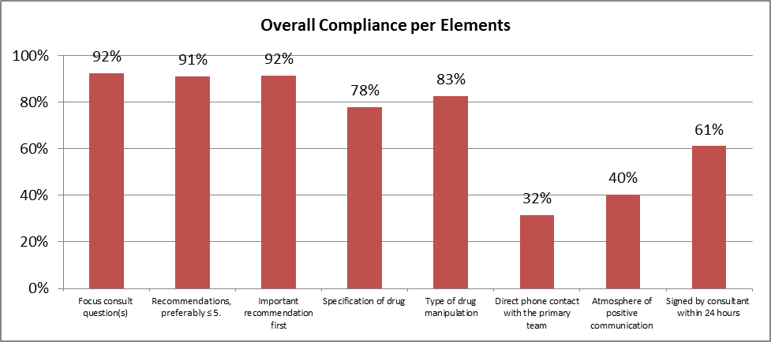

Project Lead | Team Members
Name  (person accountable for project) | Names  (persons involved in project)
Lina Bissar | Ismail Qushmaq  Zulfiqar Farooqui  Romina Sohail  Basem Alraddadi  Ahmed Alharbi  Sarmad Chaudhry  Naqi Idress  Salim Abdo  Mohammed Hamzi  Shahd Algorashi  Alanood Abdulfattah

