2017 Performance Improvement Report
STRATEGIC PRIORITY
5. Promote external relations and funding

Project Name
Cost reduction of Epilepsy Monitoring Unit (EMU) Spare parts in 2017
Site |  | Department
Jeddah |  | Neurophysiology Laboratory / Neurosciences
Project Status | Project Start Date |  | Project End Date
Completed | 01-01-2017 |  | 08-01-2017

Problem:  Why the project was needed?  Due to the frequent incidents of breakdowns of these expensive parts of Epilepsy monitoring unit (EMU), the services to the patients is facing frequent interruption causing delays in diagnosis (42% down time) and significantly increase in the cost (SR:250 thousand / annum) of the equipment repair. Success of this project with in-house repair of these parts was expected to improve the uptime of service, accommodate more patients with reducing cost and increase the efficiency of the staff. | Aims: What will the project achieve?  To reduce the cost of Epilepsy Monitoring Unit spare parts replacement due to frequent damage from 250 thousand SAR in 2016 to 50 thousand SAR in 2017.
Benefits/Impact: What is the improvement outcome?  (check all that apply)  ☒ Contained or reduced costs  ☒ Improved productivity  ☒ Improved work process  ☒ Improved cycle time  ☒ Increased customer satisfaction  ☐ Other (please explain)  Click or tap here to enter text. | Quality Domain: Which of the domains of healthcare quality does this project support?  (Select only one)  Efficient

Measures: Performance metrics to be evaluated | Targets: Expected outcomes
- Cost of Epilepsy Monitoring Unit spare parts replacement due to frequent damage | From 250 thousand SAR in 2016 to 50 thousand SAR or less.

Interventions: Overview of key steps/work completed
Define and Implement Strategies for Remedies:
After data analysis of 2016, Pareto Analysis (80/20) rule was used to target the core issues and following strategies were adopted to embark on vital few for remedies and implemented them in 2017. Data was collected again to analyze the outcome.
- Major Strategies were:
  - Patient and family education for handling the gadgets was reviewed and a more detailed module was developed to educate the patient and family.
  - The gadgets were secured in a relatively safer pouch to avoid any damage during the involuntary movements (Convulsions) by the patient.
  - Staff was instructed to monitor the patients more vigilantly so the patient should not play with the gadgets and whenever necessary, staff should deal with it to help the patient.
  - In addition to all these strategies, Clinical engineering (Biomedical) department was engaged in this project to find an in-house component repair solution.
  - After a thorough technical review of the components of these gadgets and with clinical assistance from the Neurophysiology department, Biomedical engineers were agreed and decided that these gadgets can be repaired in-house with cannibalizing / salvaging (use of component for repair of these gadgets from the old write off equipment) technique.
  - The major cause of Isolator – connector pins damage was due to disconnecting and re-connecting the cable with Isolator by the patient or attendant. So that connection was secured by fixing it permanently.
  - The damaged connector were taken to the Biomedical engineering department and were repaired with salvaging technique.
  - In addition, alternate solution were explored by using new technology of wireless data collection processer through trade - in methodology with the vendor for a permanent solution.

Develop and implement Performance Measure (Indicator):
The performance indicator for measuring outcome after implementing strategies was developed and
data was collected simultaneously for review and analysis

Results: Insert relevant graphs and charts to illustrate improvement pre and post project
(insert relevant graphs, data, charts, etc.)
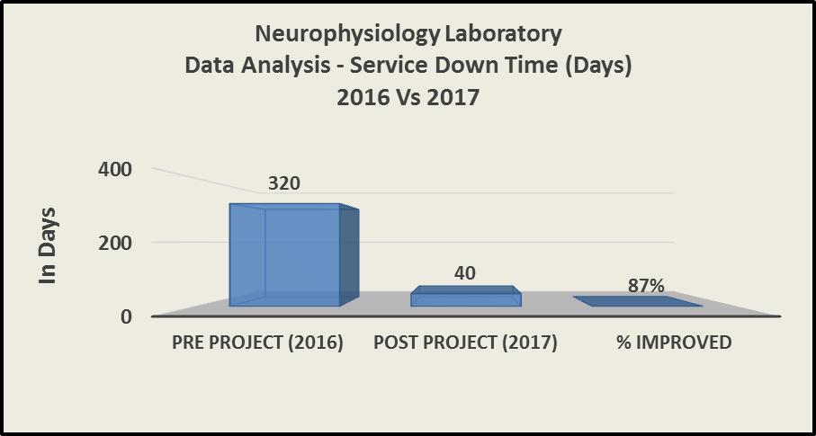
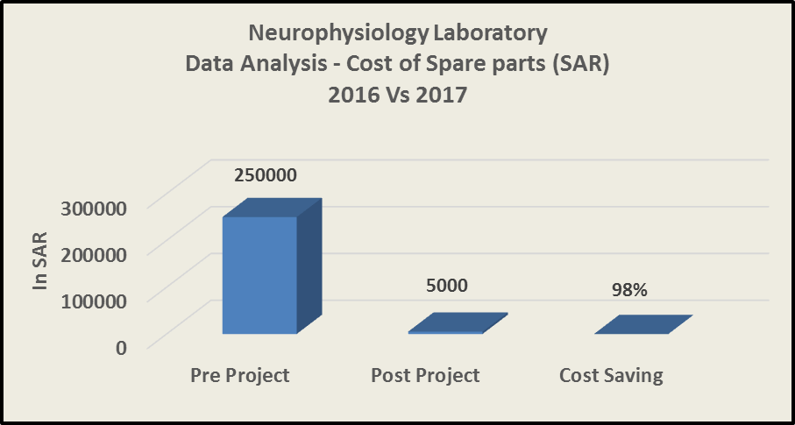

Project Lead | Team Members
Name  (person accountable for project) | Names  (persons involved in project)
Mustafa Khan | Ghada Kadi
 | Abdullah Al Osaimi
 | Alaa Subhi
 | Jawad Ahmed Sarkar
 | Bignotia, Reynaldo
 | Samer Dardas

