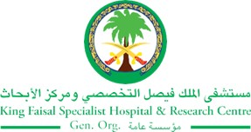
2017 Performance Improvement Report
STRATEGIC PRIORITY
5. Promote external relations and funding

Project Name
Reduce Patient’s Meal Wastage at Outpatient Treatment Units.
Site |  | Department
Jeddah |  | Food Services
Project Status | Project Start Date |  | Project End Date
Completed | 08-20-2017 |  | 09-15-2017

Problem:  Why the project was needed?  On daily basis, we are serving meals to the Outpatients Treatment Wards (Renal Dialysis Unit, Endoscopy and Daily Producer Unit and chemo therapy units for adult & pediatric around (5000) meals per month. We are facing approximately (500-700) meals wastage per month which cost around (11,745 – 16,500) SAR monthly, (140,940 – 387,585) SAR yearly. | Aims: What will the project achieve?  1- Reduce the Number of food trays wastage from approximately (500-700) meals per month to (200-300) meals or less per month.  2- Reduce the food cost for out-patients Treatment units
Benefits/Impact: What is the improvement outcome?  (check all that apply)  ☒ Contained or reduced costs  ☒ Improved productivity  ☐ Improved work process  ☐ Improved cycle time  ☒ Increased customer satisfaction  ☐ Other (please explain)  Click or tap here to enter text. | Quality Domain: Which of the domains of healthcare quality does this project support?  (Select only one)  Efficient

Measures: Performance metrics to be evaluated | Targets: Expected outcomes
- Number of food trays wastage | - From approximately (500-700) meals per month to (200-300) meals or less per month.

Interventions: Overview of key steps/work completed
- A team from Food Service visited the outpatients area’s and monitored the meals from ordering until receiving we found out that wastage of food come from DPU & Endoscopy Unit due to :
- Patients refused food.
- Procedure of the patients cancelled.
- Patient still NPO during the meal time.
- Patients bring his food from home.

- New food Technologies is dedicated to offer our patients the best products and service by providing :
- Outpatients food trolley was established and offered by food server to patients who can chose from a variety of available food choices.
- Improved work processes by systemized the outpatient’s diet order entry in ICIS, for all outpatients’ and viewed thru Food Services Software (FSS).
- Special Hotel menu (breakfast – lunch) with verity of food items were developed.
- Food Trolley round six times daily.
Results: Insert relevant graphs and charts to illustrate improvement pre and post project
(insert relevant graphs, data, charts, etc.)
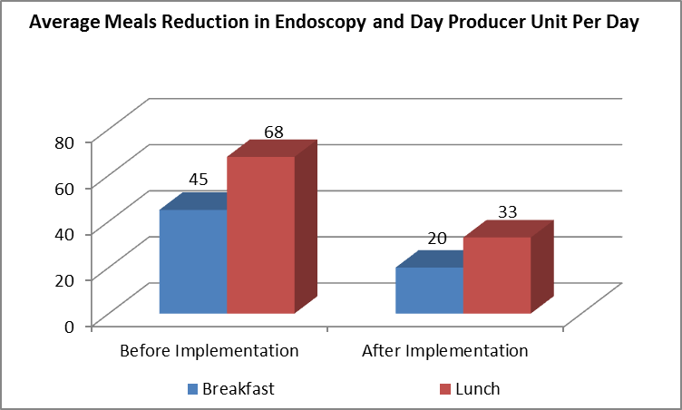
Endoscopy And Day Producer Unit:
- Before we served breakfast around 40-45 “average 45” meals daily after the implementation we served around 15-25 “average 20” meals per day.
- Before we served Lunch around 65 -70 “average 68” meals per day after the implementation we served around 30-35 “average 33” meals
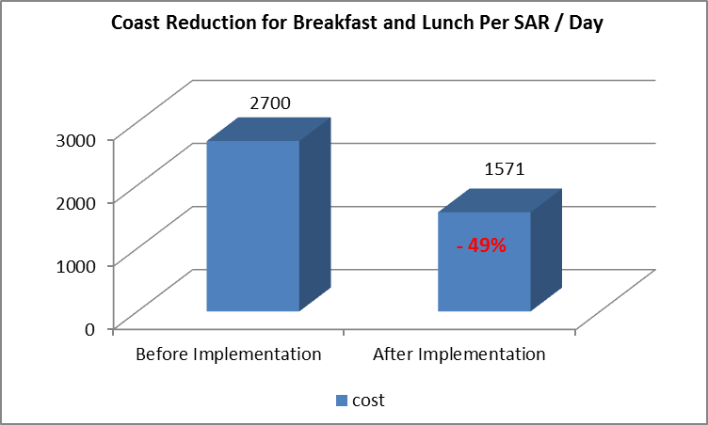
Cost reduction:
- Before the project Breakfast cost was around SAR. 1057 after the implementation reduced to SAR. 652 per day
- Lunch 1643 SAR to 919 SAR per day
- Saved around 30,000 SAR monthly /360,000 yearly.

Project Lead | Team Members
Name  (person accountable for project) | Names  (persons involved in project)
Ahmed Alhasanat | Huda Muhy El din
 | Wejdan Al-Ahmadi
 | Neda Abu- Ahmed
 | Ahmed Gharib
 | Manuel Sia II
 | Gregoria Piezas
 | Chandranas Talekar
 | Reahbeln G. Alzate
 | Lujain Alenaizan
 | Suja Annie John
 | Vimela Moodley
 | Samer Dardas

