2017 Performance Improvement Report
STRATEGIC PRIORITY
5. Promote external relations and funding

Project Name
Reduction of Energy Usage in Corridors and Public Lobbies
Site |  | Department
Jeddah |  | Engineering Utility &Maintenance
Project Status | Project Start Date |  | Project End Date
Completed | 02-15-2017 |  | 07-01-2017

Problem:  Why the project was needed?  In 2016 Electricity Consumption density of KFSH&RC was 468 kWh/m2, which is ~ 84% higher than international benchmarks; e.g. 254 kWh/m2 for IFMA - Healthcare Facility Management Report 2013.  Current annual electrical usage for targeted normal power lighting circuits in hallways and corridors is 725,590 kWh (kilo-Watt-hour), amounting to 232,189 SAR. Giving an annual saving of ~46,000 SAR. | Aims: What will the project achieve?  - The target is to reduce energy usage from lighting in Hospital corridors and hallways by 20%, by reducing normal lighting circuits operation from 24 hrs. to 16 hrs. per day by the end of June 30, 2017.
Benefits/Impact: What is the improvement outcome?  (check all that apply)  ☒ Contained or reduced costs  ☐ Improved productivity  ☐ Improved work process  ☐ Improved cycle time  ☐ Increased customer satisfaction  ☐ Other (please explain)  Click or tap here to enter text. | Quality Domain: Which of the domains of healthcare quality does this project support?  (Select only one)  Efficient

Measures: Performance metrics to be evaluated | Targets: Expected outcomes
- Annual energy use for Corridors & Hallways lighting in kWhr | - 20% reduction comparing with 2016.

Interventions: Overview of key steps/work completed
Lighting in public corridors and hallways are kept On 24/7, a study was done to identify the possibility of reducing the lighting levels from 10:00 pm to 6:00 am. By switching off normal lighting circuits in corridors, hallways & offices of the Hospital after hours; gave a measured and calculated reduction of >20% in electricity usage for those areas.

This task was performed manually at no cost by the Maintenance Service provider staff or the hospital.

Results: Insert relevant graphs and charts to illustrate improvement pre and post project
(insert relevant graphs, data, charts, etc.)
- 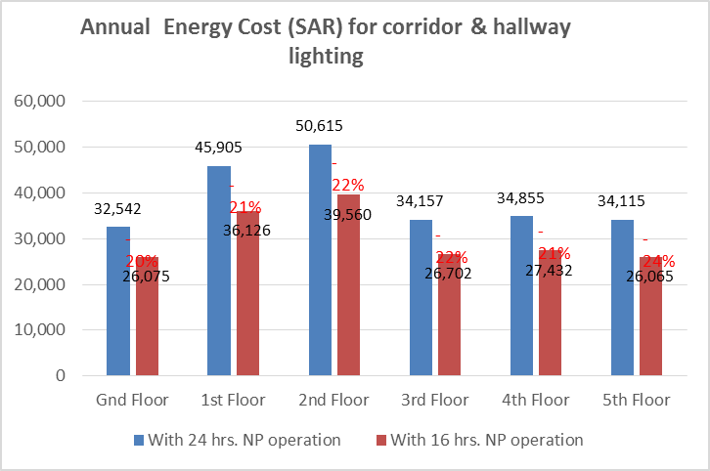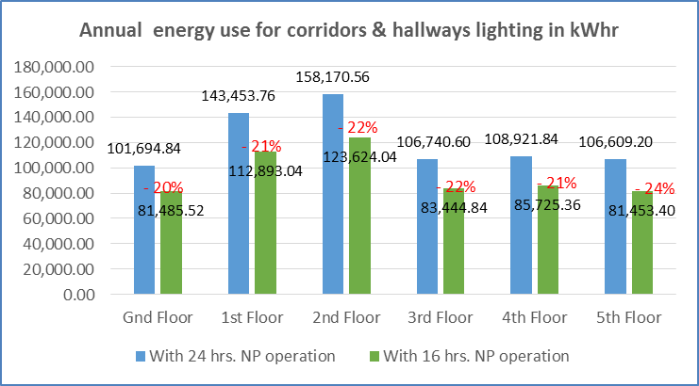
kWh: Kilo Watt Hour - unit for measuring the amount of electrical energy

Project Lead | Team Members
Name  (person accountable for project) | Names  (persons involved in project)
Hani Elkhatib | Abdulrahman Al Ghatani
 | Amer Kassar
 | Saeed Alzahrani
 | Alanood Abdulfattah

