2017 Performance Improvement Report
STRATEGIC PRIORITY
3. Improve efficiency and decision-making

Project Name
Improvement of work flow by decreasing the incorrect/ incomplete information of patients/ plan of care transferred to Home Health Care (HHC) from outpatient clinic
Site |  | Department
Jeddah |  | Family Medicine/ Home Health Care
Project Status | Project Start Date |  | Project End Date
Completed | 01-01-2017 |  | 06-30-2017

Problem:  Why the project was needed?  HHC was receiving a referrals without clear plan of care / incomplete information for patients seen and discharge from the outpatient clinic before the HHC acceptance or even evaluation, as consequences, extra work will be done to clarify /complete the plan of care and this cause delay/rejection of the referral, and in other occasions it require to call patient to come back to hospital for proper evaluation | Aims: What will the project achieve?  Decrease the percentage of patients with incorrect/ Incomplete information of patients transferred to (HHC) from outpatient clinic by 25 percent by the end of second quarter (Q2) of 2017
Benefits/Impact: What is the improvement outcome?  (check all that apply)  ☐ Contained or reduced costs  ☒ Improved productivity  ☒ Improved work process  ☐ Improved cycle time  ☒ Increased customer satisfaction  ☐ Other (please explain)  Click or tap here to enter text. | Quality Domain: Which of the domains of healthcare quality does this project support?  (Select only one)  Efficient

Measures: Performance metrics to be evaluated | Targets: Expected outcomes
percentage of patients with incorrect/ Incomplete information of patients transferred to (HHC) from outpatient clinic | 25 % Reduction comparing with year 2016

Interventions: Overview of key steps/work completed

- HHC E-Referral was updated in ICIS with new features and requirements (by collaboration of a team from HHC Jeddah & Riyadh, HITA Jeddah & Riyadh, out-patient members) (7th May 2017New referral gone on live)

- The Completion of all the required data become mandatory in the referral before the submission

- Making a special reoccurring encounter for HHC (help to enter the medication and order for the whole HHC admission duration without redoing a new encounter for each entry)

- Making a Direct connection between the E-referral and ICIS for medication order and blood works

- Grand round presentation for education has been done by HHC (in collaboration with HITA & ATA training Dep.) done on 20 April 2017

- General distribution and newsletter were sent to Chairmen clarifying the new requirements and new features in the updated referral (Sent on April 2017)

- Special communication with the high demand referring physicians to update them about the new and complete requirements (different meetings and communications with palliative, surgery and internal medicine physicians done)

- List of all required referral’s data is created and become available for the referring physicians

- Involving the related specialty (referral and plan of care should be submitted only after being reviewed and supported by the related specialty and this happen after a proper evaluation and acceptance of this related specialty)

Results: Insert relevant graphs and charts to illustrate improvement pre and post project
(insert relevant graphs, data, charts, etc.)
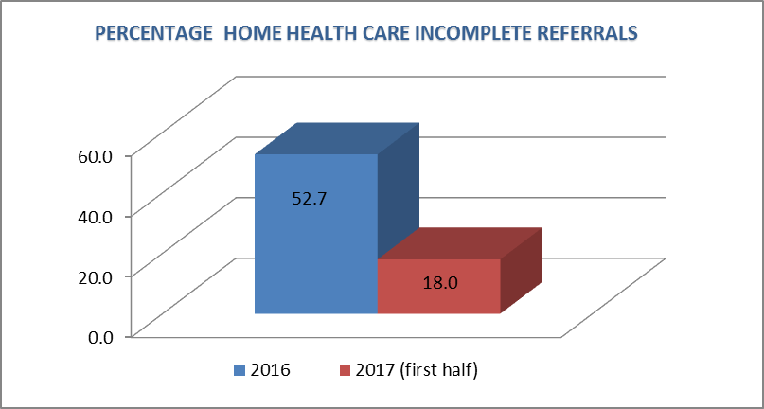

Project Lead | Team Members
Name  (person accountable for project) | Names  (persons involved in project)
Aref Abdallah, MD | Seyd Nehal Neamatullah, MD
 | Aletta Barnard
 | Al Qahtani Mohammad
 | Erie Analee
 | Bagayo Jenlyn
 | Jamal ilyas
 | Samer Dardas

