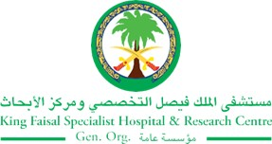
2017 Performance Improvement Report
STRATEGIC PRIORITY
4. Enhance staff recruitment and retention

Project Name
Improving Standardized Documentation Of N95 Mask Fit Testing For Relevant Employees, To Streamline Re-Contracting Process
Site |  | Department
Jeddah |  | FAMILY MEDICINE- Nursing
Project Status | Project Start Date |  | Project End Date
Completed | 03-30-2017 |  | 06-27-2017

Problem:  Why the project was needed?  With new requirements for health screening during re-contracting we notice that although employees did the mask fit test it was never been entered in ICIS by the respective people who did the test.  This increase the multiple appointments in family medicine and increase delay in re-contracting.  If any re-contract requirements like fit testing not done the employee had to go back to the unit to enter their mask fit testing by their nurse clinician, then they will get another appointment with family medicine clinic to do the health screening. This use to delay the re-contract process an average of three to five days. | Aims: What will the project achieve?  To improve compliance of N95 mask fit testing documentation entry in ICIS from 4% to 100% by June 2017.
Benefits/Impact: What is the improvement outcome?  (check all that apply)  ☐ Contained or reduced costs  ☒ Improved productivity  ☐ Improved work process  ☐ Improved cycle time  ☒ Increased customer satisfaction  ☐ Other (please explain)  Click or tap here to enter text. | Quality Domain: Which of the domains of healthcare quality does this project support?  (Select only one)  Safe

Measures: Performance metrics to be evaluated | Targets: Expected outcomes
Documentation compliance of N95 mask fit testing in ICIS | 100% N95 mask fit testing documentation compliance.

Interventions: Overview of key steps/work completed

Instead of getting the mask fit testing results from relevant departments, new process were introduced where family medicine department got the results of all mask fit testing were done directly from infection control.
Family Medicine arranged for staffs to enter all those employees in ICIS so that by June 2017 100% all results were entered and completed in ICIS.
In collaborations with all areas, the results of the mask fit testing must be sent to family medicine daily to check if the test is entered in ICIS and this will be a continuous process.

Results: Insert relevant graphs and charts to illustrate improvement pre and post project
(insert relevant graphs, data, charts, etc.)

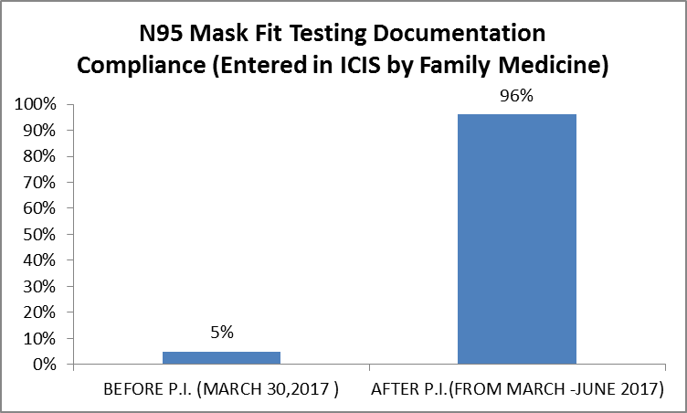

Project Lead | Team Members
Name  (person accountable for project) | Names  (persons involved in project)
ALETTA BARNARD | MARY FLORENCE RESCATE
 | RENAMOL LALAPPAN
 | ANESAH DEL RAYS
 | MA.VANESSA CRUZ
 | GEMMA DE LEON
 | LORETA CORTERO
 | MENAR DOGAN
 | AFNAN HAMED
 | AFRAH ABDULMOHSIN
 | DONNA SACULSAN
HATOON SAIEDI
SAMER DARDAS

