Pre-qualification Questionnaire

Project Management Organization Services and Construction Management for King Faisal Specialist Hospital & Research Centre (KFSHRC)

Contents
Instructions Pertaining to Pre-qualification 3
Section 1: General Information 11
Section 2: Financial Information 12
Section 3: Organization Charts and Key Personnel 13
Section 4: Certifications & Licenses 14
Section 5: Health & Safety Questionnaire 15
Section 6: Quality 18
Section 7: Resources (World-wide) 19
Section 8: Experience Statement 21
Section 9: Subconsultants 23
Section 10: National Programs and Strategic Infrastructure Planning Experience 24
Section 11: Automation and Data Management Capability and Experience 25
Section 12: Enterprise Content Management System (ECMS) 28

Instructions Pertaining to Pre-qualification

- Overview of Package

King Faisal Specialized Hospital & Research Center (KFSH&RC) has advertised for expressions of interest from Companies for the future Tender of a Contract for Project Management Organization (PMO) Services with a planned Award Date of 30th August 2019 and Duration of 60 months from Award.

KFSH&RC requests proposals from experienced International consulting firms that will provide Project Management Organization (PMO) Services for the management of the planning, design, construction, and handover of Hospital projects within the region of the Kingdom of Saudi Arabia.

The Company as part of its expression of interest has confirmed by its actions it maintains a valid Classification in the minimum categories required to receive this Prequalification Questionnaire.

- Scope

The PMO services envisaged include the following broad scope:

- Set-up, staff and operate the PMO, as per Mashroat designated functional organization.
- Provide Project Management Services for the delivery of KFSH&RC’s Infrastructure Projects, existing and future.
- Implement Mashroat processes and procedures in the running of the newly established PMO.
- Fully integrate the existing KFSH&RC resources in the day-to-day operation of the PMO and establish long term sustainable individual career paths for those resources.
- Undertake extensive training of the existing KFSH&RC Saudi National resources on Mashroat deliverables.
- Undertake additional tasks related to the management of KFSH&RC’s portfolio of Infrastructure Projects.

Figure 2.1 is a map depicting the location of the current and currently planned projects around the Kingdom. As at January 2019, there are 28 KFSH&RC individual projects or project packages comprising:

- 9 Ongoing or to commence in 2019 Projects, with Government funding that will be core scope for the end-end Project Management Organization Services - 7 Projects are in Riyadh, and 2 Projects in Jeddah.

- 19 Future Projects / Project Packages in both Riyadh (18 no.) and Jeddah (1 no.) that are anticipated to either require Government funding or become privatization opportunities and that will require a minimum of Strategic Planning, Concept Design and Project Development Planning, and Design and Procurement activity.

2 Ongoing
1 Future
7 Ongoing
18 Future
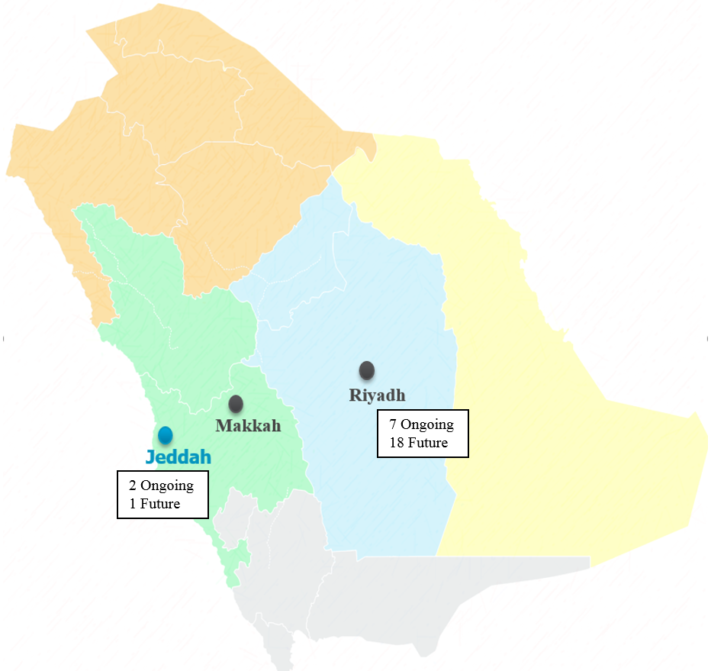

Figure 2.1: Number and location of Projects

The PMO will be required to manage the remaining work of ongoing projects. This may include overseeing and supporting an existing PMO / PMC Contractor in the management and close out of their projects.

The provision of Project Management Services by the Company will include the deployment of two hundred and thirty-five (235) program management and project delivery professionals at peak, plus a further, minimum of, twenty-five (25) Saudi Engineer Work Program recent university graduates. Staff will be split between KFSH&RC’s offices in Riyadh and at project locations as demanded by the needs of the projects. The majority of the two hundred and thirty-five (235) are expected to be company internally developed employees with a minimum of three (3) to five (5) years of experience with the company (years of experience required with the company and in total are based on the level within the project).

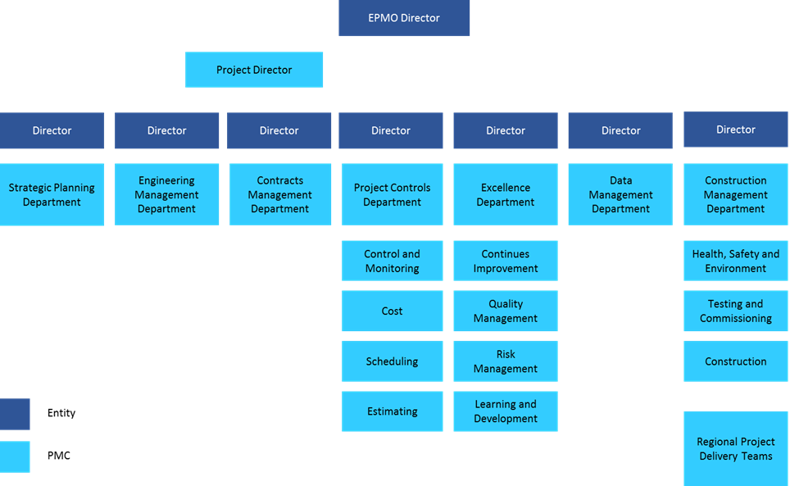

Figure 2.2: Typical EPMO Organizational Model

The Company as part of its response has confirmed by its actions it maintains a valid Classification in the minimum categories required to receive this Pre-qualification Questionnaire.

KFSH&RC may elect to execute the second round of prequalification prior to the issuance of the full RFP.

Company shall note that all responses given in prequalification may be used as part of subsequent RFP evaluations.

- Definitions

The following definitions are used and have the meanings defined herein:

Company | Means entity that will prepare and submit its Submission in relation to this Prequalification Questionnaire following its expression of interest to KFSH&RC in response to the Advertisement
Authority/Government Entity | Means KFSH&RC, its entities or other official office that has issued this Prequalification Questionnaire to a Company
Tenderer | Means a Company that has been selected following the evaluation of the Submission to participate in the future Tender
Tender | Means the future Invitation to Tender that will be issued to the Tenderers under a separate selected tender process
Submission | Means the Company response to this Prequalification Questionnaire

- Preparation of Responses

Responses to this Prequalification Questionnaire (“Submission”) shall be submitted in hard copy and electronic using the forms included herein. Electronic copies shall be text searchable. Failure to comply with these requirements may be cause for rejection of the Submission.

Partial or incomplete Submissions will not be considered and Submissions shall be in strict conformity with the Prequalification Questionnaire and any addenda.

Any Submission received after the due date and time stated in the Submission Invitation Letter may be rejected at the sole discretion of the Authority.

- Language of Submissions

All prequalification submissions shall be submitted in English and Arabic languages and all communications between the Authority and the Company shall utilize the same language.

- Company Entities

Each Submission shall show the full legal name and business address of the Company, including its street address if it differs from its mailing address, and shall be signed with the usual signature of the person or persons authorized by the Company, and shall be dated.

The name of the signatory shall be typed or otherwise clearly imprinted below each signature and corporate Company’s shall state their place of incorporation. When requested, satisfactory evidence of the authority of any signature on behalf of the Company shall be furnished.

Submissions by joint ventures, consortia, associations or partnerships shall designate one single participant to represent all those forming the entity. Submissions shall be signed by a duly authorized representative of the entity and evidence of the signatory's authority signed by and listing the full names and addresses of all participants in the entity shall be attached to the Company's Submission Letter.

- Examination of Prequalification Questionnaire

The Company planning to submit a Submission is responsible for examining with appropriate care the complete Prequalification Questionnaire. Should the Company find discrepancies in or require clarifications in relation to the Prequalification Questionnaire, or should their intent or meaning appear unclear or ambiguous, or should any other question arise relative to the Prequalification Questionnaire, the Company shall promptly notify Authority in writing.

The Company making such request will be solely responsible for its timely receipt by Authority. Replies to such notices may be made in the form of supplementary correspondence or, as appropriate, an addendum to the Prequalification Questionnaire which will be issued simultaneously to all persons who have obtained the Prequalification Questionnaire from Authority.

Authority may, by addendum, modify any provision or part of the Prequalification Questionnaire at any time prior to the submission date.

- Company Right to Withdraw its Submission

A Company may modify or withdraw its Submission by written request, provided that the request is received by Authority prior to the due date at the address to which Submissions were to be submitted. Provided further, that in case of an electronic request (i.e. facsimile, telex, etc.) a written confirmation thereof over the authorized signature of the Company be received by Authority at the address to which original Submissions were to be submitted within three (3) calendar days after the issue of the electronic message.

If withdrawing, the Company shall state the reasons for its withdrawal and accept that as a consequence of its withdrawal it will forego any rights implied or otherwise that it relies upon to participate in the future tender of the Works to which this Prequalification Questionnaire applies.

- Submission Security

The Authority confirms that the Company is not required to furnish any Bond or Guarantee as part of the Prequalification Submission.

- Cost of Preparing the Submission

The preparation of a Submission shall be by and at the expense of the Company.

The Authority will not be liable for any costs incurred in either the preparation of the Submission or post receipt of the Submission of any costs incurred by the Company in attending meetings or providing further clarifications as may be requested by the Authority of the Company.

- Confidentiality and Intellectual Property

A Company must not, without the prior written consent of Authority, disclose or provide to any person, other than Authority, Authority's employees and agents and persons engaged in the preparation of the Company's Submission, any particulars concerning its Submission or any other information with which it has been provided by or on behalf of Authority in relation to this Prequalification Questionnaire, the Submission or the Project.

A Company must identify any part of its Submission which contains information:

- In respect of which intellectual property rights (including, without limitation, patents, registered designs, and copyright) are claimed by the Company, whether for itself or on behalf of any other person, entity or consortium;

- Or in respect of which the Company expects confidentiality to be maintained by Authority such as information in the nature of know-how or commercial-in-confidence information.

An unreasonable claim by Company that all or a substantial part of a Submission is the subject of intellectual property rights or is confidential may result in the Submission being considered nonconforming and this may result in the Company not being considered for selection.

No claim by a Company that specific information is the subject of intellectual property rights or should be kept confidential by Authority shall, of itself, be conclusive or binding on Authority.

Authority may use information provided by a Company as necessary for the Submission Process (including, without limitation, for assessment and evaluation purposes), irrespective of any claim of intellectual property rights and/or confidentiality.

- Prequalification Timeline

The timeline for the prequalification and selection of prequalified Tenderers is outlined below:

Activity | Date
Prequalification Questionnaire Issued by Authority | 21st February 2019
Last Date for Clarifications / Questions from Company | 28th February 2019
Submission Closing Date | 7th March 2019
Evaluation Completed | 14th March 2019
Planned Date for Release of the future Tender | 9th April 2019

- No Contract or Automatic Right to Tender

By submitting a Submission, the Company acknowledges that:

- The Submission does not create a contract between the Company and Authority or impose any other obligations at law upon Authority whether as a result of the Submission Process or otherwise in respect of the Submission or the evaluation of the Submission by Authority; and

- The Submission does not create an automatic right to prequalify for the future Tender; and

- Authority will not be under any obligation to act in any particular manner or refrain from acting in any particular manner in evaluating the Submission.

- Receipt of Submissions

The Company shall ensure that its Submission is received by the Authority by 4pm on the Submission Closing Date listed in the Prequalification TimeLine by the Authorized Representative for the Authority listed below:

Name | King Faisal Specialist Hospital & Research Centre (General Organization)
Position / Title | Office Services Department
Email Address | P.O. Box 3354 Riyadh 11211
Physical Address | Administration Building - Basement

- Opening of Submissions

Company acknowledges that the Authority will not be opening the Submissions in a public forum.

The Authority will only confirm and acknowledge receipt of the Submission only upon delivery by the Company.

- Authorities Rights

The Authority reserves the right in its absolute discretion and without limiting any other right which Authority may have whether under this Invitation or otherwise, to do any one or more of the following at any time without giving reasons:

- Reject or refuse to consider or evaluate any Submission or all Submissions;
- Amend this Prequalification Questionnaire;
- Withdraw this Prequalification;
- Terminate the Submission Process;
- Re-advertise for new Submissions;
- Request additional information or from any Company; and
- Alter or vary any process or procedure regarding the consideration or the evaluation of any Submission or all Submissions.
- Use the Prequalification Submission in part or in whole as part of subsequent bid evaluation.

The Authority may also give consideration to and may exclude parties on the basis of their performance or the performance of related parties on recent contracts with Authority or other government bodies. To assist with this process, the Authority may make reference to performance reports prepared either by Authority or other government agencies.

The Authority may take into account the relationship between Company and their constituent members and the existence of related companies and common directors. Should a Company (or a member of the Company) be a related company of another Company (or a member of the other Company), or should common directors be identified across Company (or members of Company), Authority may require the Company to enter into specific undertakings to address any resultant probity issues as a condition of this Invitation.

- Notification of Selection of Company to Tender

After consideration of Submissions, The Authority will select those Companies whose Submissions clearly demonstrates the Company has the financial and technical capability, experience and resources to execute the Works subject of the Tender that form the basis of this Prequalification Process.

Those Companies that are selected by the Authority will be notified in writing, those that are not selected may request feedback from the Authority on the reasons for non-selection.

The final number of selected Companies that the Authority will invite to Tender shall be a maximum number of six (6) Tenderers.

The right is reserved, as the interest of Authority may require, to reject any or all submissions and to waive any informality in submissions received.

- Company Return of Prequalification Documents

Upon receiving confirmation of the Companies success in Prequalification or notification of its failure to Prequalify, the Company shall destroy all documents issued by the Authority.

- Removal or Addition of Companies following Initial Selection by the Authority

The Authority may remove or replace a selected Company from the future Tender if:

- A selected Company previously notified by the Authority as being selected to Tender for the Contract, subsequently withdraws itself from tendering for the Tender by formal notice to the Authority, or

- A selected Company, subsequently to being invited to prequalify is boycotted in accordance with Article 78 of the Government Tenders and Procurement Law (Royal Decree No. M/58 dated 4 Ramadan 1427H / 27 September 2006). The Company shall be notified and the previous selection withdrawn by the Authority.

In either of the above situations, the Authority has the right to invite the next most qualified Company that was not initially selected as part of this Prequalification to participate in the Tender to maintain a competitive tender process.

If insufficient Companies remain following the removal of a previously selected Company(s) the Authority may at its discretion cancel the Prequalification.

- Declaration on behalf of the Company:

The Company shall include the below declaration in its Submission:

I the undersigned representative declare that the information stated in this Submission is accurate and true and reflects the current information available.

The Company by submission of this Submission, acknowledges that the Authority will determine in its sole discretion the suitability of Company for prequalification for the Tender based on the information contained in the Submission and in accordance with these Instructions to Companies for Prequalification and failure to complete all sections may result in Company Submission being excluded from evaluation.

Signature | Title
Name | Date

Section 1: General Information

Company shall complete the following general company information:

Information Requested | COMPANY Response
Full Name of Company:
Registered Office Address:
Date of Registration:
KSA Registration No.
KSA Classification Class:
State Min Value (threshold) for Bidding:
State Max Value for Bidding:
International Registration No.
Public / Private Company
Nominated Representative | Name:
 | Phone:
 | Email:
Company Structure  (Confirm Structure) | Corporation: | YES NO
 | Subsidiary | YES NO
 | Division | YES NO
 | Joint Venture / Consortium | YES NO
Parent Company Details  (If Applicable) | Parent Company Name:
 | Address:
 | Contact Person:
 | Phone No:
Type of Business  (Confirm Scopes of Works and Percentage of Turnover for each Type) | Civil Construction | YES NO | %
 | Roads & Highways | YES NO | %
 | Manufacturing / Fabrication | YES NO | %
 | Buildings | YES NO | %
 | Mechanical / Electrical | YES NO | %
 | Engineering / Design | YES NO | %
 | Consulting | YES NO | %
 | Other | YES NO | %
Number of Employees | Total Employees
 | Management
 | Non-Manuals
 | Manuals
NIQAT Rating  (Saudization) | State Level

Section 2: Financial Information

Company to complete the required information and provide the last three (3) years of audited Annual Financial Statements if Company plans on Prequalification on basis of a Joint Venture, Consortium or Partnership, then each of the individual entities associated shall complete the table below:

Information Requested | COMPANY Response
Present Net Worth | SAR
Annual Sales Volume  (Related To Classification For This Package) | 2018 | SAR
 | 2017 | SAR
 | 2016 | SAR
Banking Reference | Name
 | Position
 | Phone Number
Performance Bond | Can you furnish a Performance Bond (State “YES” or “NO”) |  |  | YES NO
 | State Maximum Value Available
 | Surety Provider
 | Contact Person
 | Contact Phone Number
Parent Company Guarantee | Can you furnish a Parent Company Guarantee (State “YES” or “NO”) |  |  | YES NO
 | State Maximum Value Available
 | Surety Provider
 | Contact Person
 | Contact Phone Number
Bank Guarantee / Letter Of Credit | Can you furnish a Guarantee / Letter of Credit |  |  | YES NO
 | State Maximum Value Available
 | Name of Bank
 | Contact Person
 | Contact Phone Number
Can You Provide Last Three (3) Years Of Annual Financial Report? (Provide copies with this submission) | 2018 |  |  | YES NO Not Available
 | 2017 |  |  | YES NO Not Available
 | 2016 |  |  | YES NO Not Available
 | If Not Available State Reason
Can You Provide Last Three (3) Years Of Annual Financial Audit Report? (Provide copies with this submission) | 2018 |  |  | YES NO Not Available
 | 2017 |  |  | YES NO Not Available
 | 2016 |  |  | YES NO Not Available
 | If Not Available State Reason |  |  | YES NO Not Available

Section 3: Organization Charts and Key Personnel

Company to provide the following documents relative to the company and project structures and attach to its submission:

- Current company corporate Organization Chart (for Company registering for this Package)
- A sample of a typical Project Organization (of similar scope and size to this Package)

Company to provide the following names and resumes of Key Personnel that would have executive accountability and oversight for this Project:

KEY PERSONNEL | COMPANY Response
KSA Country Manager
Studies and Planning Director
Operations Director
Engineering Director
Contracts Department Director
Project Controls Department Director
Training Manager
Construction Management Department Director

Resumes are to be attached to this submission for prequalification.

Section 4: Certifications & Licenses

a) Company to complete below relative to its registrations/licenses and certifications, copies are to be provided as part of the submission:

Information Requested | COMPANY Response
Industry Accreditations | ASME
 | API
 | TEMA
 | Other
ISO Certifications | ISO:9001
 | ISO:31000
 | ISO:14001
 | ISO:45001
 | ISO: 45001
Professional Licenses | LICENSE NO
 | LICENSE
 | EXPIRY
 | LICENSE LOCATION
 | LICENSE NO
 | LICENSE
 | EXPIRY
 | LICENSE LOCATION
 | LICENSE NO
 | LICENSE
 | EXPIRY
 | LICENSE LOCATION
 | LICENSE NO
 | LICENSE
 | EXPIRY
 | LICENSE LOCATION

b) Does your company have any professional engineering design registration/license obtained in the Kingdom of Saudi Arabia? (If yes, please provide the name of license, validity and copies?

Section 5: Health & Safety Questionnaire

Part 1 – Performance Indicators:

1.1 Lagging indicators:
Use the current plus the previous three years injury and illness records to complete the following, include all events that occurred within your organization or incurred by a contractor working under your direction.
Category | Current Year | 2018 | 2017 | 2016
Number of fatalities
Number of Lost Workday Cases
Number of Restricted Work Day Cases
Number of medical treatment cases
Property damage with losses ≥ One Million SAR.
Number of *major environmental incidents.
Number of exposure hours
*Major Environmental incident: Any incident with significant impact on or off-site, or potential enforcement action by the local authority
1.2 Leading indicators:
This section covers HSSE proactive programs that your organization implements internally and on contractors working under your direction.
Do you have a Pre-task Safety analysis briefing procedure?
Yes ☐ No ☐
If yes, please submit sample evidence from current and/or previous projects your company have executed or managed.
Do you have a Job Hazard Analysis Procedure?
Yes ☐ No ☐
If yes, please submit sample evidence from current and/or previous projects your company have executed or managed.
Do you have an HSE audit, inspection, and HSSE assessment program?
Yes ☐ No ☐
If yes, please submit sample evidence from current and/or previous projects your company have executed or managed.
Do you have a safety leadership training program?
Yes ☐ No ☐
If yes, please submit sample evidence from current and/or previous projects your company have executed or managed.
Do you have a Behavioural Based Safety Program?
Yes ☐ No ☐
If yes, please submit sample evidence from current and/or previous projects your company have executed or managed.
Do you have an HSE Reward Program?
Yes ☐ No ☐
If yes, please submit sample evidence from current and/or previous projects your company have executed or managed.
Do you have an HSSE Dashboard?
Yes ☐ No ☐
If yes, please submit sample evidence from current and/or previous projects your company have executed or managed.
1.3 Awards:
Has your organization been recognized by clients, entities or regulatory agencies for outstanding HSSE performance in the past three years?
Yes ☐ No ☐
If yes, provide evidence
1.4 Citations:
Has your company been cited, charged or prosecuted by any regulatory agency for Health, Safety or Environmental regulations in the past three years?
Yes ☐ No ☐
If yes, provide details: Use an additional sheet if required.

Part 2 - HSSE Program

Question | Yes | No
Do you have a written Health, Safety, Security and Environment Manual?
If yes, please submit the following:
- A Copy of your organization’s HSSE policies.
- A list of the HSSE procedures adopted by your organization through which you manage HSSE of your contractor’s works.
- A list of contents of a standard HSSE plan prepared by your organization for an existing or a previous project.
- One page describing how your organization manages the HSSE performance of contractors.

Do you have a formal Health, Safety, Security and Environment training program?
If yes, please submit:
- A list of content for newly hired HSSE orientation
- A list of HSSE courses you provide to your employees and contractors
- A sample on record keeping forms on which your organization track HSSE training.
Do you have an established contractor screening process to determine the strength of the contractor HSSE performance during the prequalification phase?
If yes, please submit a list of contents of the program.
Do you have a written Occupational Health program?
If yes, please submit a list of contents of the program.
Do you have a valid conformity certification with an internationally recognized body such as ISO, OHSAS?
If yes, please submit a copy.

HSE Professional Support
List key HSSE personnel. Please list name and expected position.
Name: | Position held: | Formal Qualifications | Years of experience in GCC/KSA | Total years of experience
 | HSE Manager
 | Environmental Manager
 | Security Manager

Part 3 - Incident History in the Kingdom of Saudi Arabia

Please complete the number of incidents, days lost and hours worked for the current year and the previous three (3) years for your company’s projects in the Kingdom of Saudi Arabia (For your company’s staff only)

CATEGORY | CURRENT YEAR | 2018 | 2017 | 2016
Fatalities
Lost Workday Case
Days Lost
Restricted Workday
Medical Treatment Only
First Aid Treatment Only
Equipment Damage
Near Miss
Environmental Damage
Hours Worked

Have There Been Any Work-Related Fatalities In The Last 5 Years? | YES NO (if yes please attach details)

Section 6: Quality

Please provide the following documents associated with your quality management system:

- The most recent copy of your ISO9001 (Quality Management System) certificate along with the ISO9001 Quality manual (if applicable or Tenderer’s quality manual,)
- Master list of documents related to Quality Management System (All 4 levels of Documents)
- Typical Project Quality Plan (PQP) and Inspection Test Plan (ITP)
- Quality Assurance (QA) Audits and surveillances procedure with the audit program
- Continuous improvement procedure
- Corrective action and preventative actions procedure
- A Quality control (QC) inspections and testing procedure including Non-Conformance-Report NCR process
- A risk management procedure

Section 7: Resources (World-wide)

a) Company to provide details of current resources employed in works of worldwide and provide the last three year’s data

RESOURCES | COMPANY Response
NON MANUAL | 2018 | 2017 | 2016
Project Managers
Urban Planners
Urban Designers
Financial Analysts
Economists
Engineering Managers
Civil Engineers
Structural Engineers
Mechanical Engineers
Electrical Engineers
Low Voltage Engineers
Architects
CAD Designers
Stakeholder Interface Specialists
Contracts Managers
Contract Administrators
Project Controls Managers
Cost Engineers
Scheduling Engineers
Estimators
Quality Managers
Quality Control Specialists
Risk Analysts
Training Managers and Specialists
Continuous Improvement Specialists
Document Controllers
HSSE officers
Testing & Commissioning Specialists
Construction Managers
Construction Superintendents
Field Engineers
Total Workforce

b) Please provide your company’s statistics supported by the Ministry of labor’s records for your Kingdom of Saudi Arabia professional resources for the past three years, along with a breakdown by disciplines and positions.

Section 8: Experience Statement

The Company submits the following statement as to its experience qualifications with a focus on government (and specifically medical facilities) infrastructure work within the Kingdom of Saudi Arabia. Projects for private sector/individuals should not be included.

- The following contracts are currently in progress or have been satisfactorily completed within the last eight years in the below format:
- Column Completion Notes:
- Name For past government work, please provide entity/project name
- Location Location of project
- Role Indicate the type of contract (Role of your Company) (Design, Design Management, Construction Management, Program Management)
- Work Description Provide a description of the scope
- Value Provide the contract value in SAR
- Start/Stop Provide starting date and actual (A)/forecast (F) completion by month/year, e.g., Jan 2016A/Sep 2018F.
- Duration Provide the contract duration in months

For each Role category listed above, please provide one page project data sheet for up to 3 of the most relevant projects and any relevant certificates of completion received for the projects.

Item No. | Entity/Project Name | Location | Role | Work Description | Value  (SAR) | Start/Stop  (month/year) | Duration  (months)

- Please provide a list of project management mandates that have been undertaken by your company worldwide detailing the customer names, work description, location, value and duration of projects
Item No. | Entity/Project Name | Location | Value  (SAR) | Start/Stop  (month/year) | Duration  (months)

- Please provide a list of large construction infrastructure projects that your company has undertaken worldwide detailing out your customer names, work description, location, value and duration of the listed projects

Item No. | Entity/Project Name | Location | Value  (SAR) | Start/Stop  (month/year) | Duration  (months)

Section 9: Subconsultants

Company shall provide its responses to the below questions relative to the selection and nomination of key Subconsultants when executing strategic planning, engineering and project management scopes. The answers to the following questions shall not exceed four (4) pages of A4 paper.

QUESTION TO COMPANY | COMPANY RESPONSE
- Company to explain its process and procedure for the identification, prequalification, evaluation, and selection of Subconsultants
- Company to explain how it manages the Subconsultants during execution of the works to maintain schedule and quality of the Works being performed by the Subconsultants
- Company to explain its process and procedure for the quality control and quality assurance of the Subconsultants’ deliverables
- Company to explain how they ensure Subconsultants are contracted on terms and conditions aligned with the main contract and the management of such obligations for works performed by the Subconsultants

Company shall list in the table below the typical scopes of work that are subcontracted to lower-tier companies in the execution of works of similar scope or complexity. The completion of the table and submission is in addition to the four (4) page limit:

NO. | INFORMATION REQUIRED | COMPANY RESPONSE
1 | Scope of Works
 | The basis of selection of Subconsultant
 | Terms of sub-consultancy
2 | Scope of Works
 | The basis of selection of Subconsultant
 | Terms of sub-consultancy
3 | Scope of Works
 | The basis of selection of Subconsultant
 | Terms of sub-consultancy

NOTES: Basis of Selection: Enter if selected based on prequalification, preferred vendor, sole source or competitive tender.
Terms of Subcontract: Enter Typical Commercial model (Cost Reimbursable, Lump Sum, Unit Price, etc.)

Section 10: National Programs and Strategic Infrastructure Planning Experience

NO. | QUESTION | RESPONSE
1 | Has your company worked with national government (within the Kingdom of Saudi Arabia) on programs or projects of national significance?  (If YES, please confirm the type of program/project, its scale and complexity, your company’s scope of work and the program/project period).
2 | Has your company worked with national government/s (outside the Kingdom of Saudi Arabia) on programs or projects of national significance?  (If YES, please confirm the type of program/project, its scale and complexity, your company’s scope of work and the program/project period).
3 | Does your company have experience in the development and management of infrastructure (utilities or facilities) portfolio plans?  (If YES, please confirm the portfolio/s developed, the client, project duration and approximate value of the portfolio/s?)
4 | Does your company have experience in the preparation and delivery of large-scale (regional/sub-regional, metropolitan or city scale), integrated, multi-disciplinary planning / urban growth management plans?  (If YES, please confirm the project/s name, client, your scope of work, the project period and contract value?)
5 | Has your company lead and managed large-scale (regional/sub-regional, metropolitan or city scale) infrastructure programs/projects, from initial concept planning and feasibility, through detailed engineering design, to testing/commissioning and handover?  (If YES, please confirm the project name, client, your scope of work, the project period and contract value?)

Section 11: Automation and Data Management Capability and Experience

Part A - Organizational Structure

Please complete table below for the Company’s key personnel and organization details related to the use of automation and data management tools (i.e. Geographic Information Systems (GIS), Building Information Model (BIM) and the like.) Note that the company representative listed below should be the focal point for any clarifications in response to this section of the questionnaire:

Company Representative
Telephone Number
Mobile Number
E-Mail Address
Website URL

Automation and Data Management Team Information
TEAM MEMBER | NAME |  | TELEPHONE | EMAIL
Automation and Data Management Manager
IT Manager
CAD Manager
Other (Company may specify below additional key positions and individuals)

Part B – Automation and Data Management System Information

Please complete the below questions as it relates to Automation and Data Management Systems:

NO. | QUESTION | RESPONSE
1 | Does your organization have a reference standard it uses to produce your GIS/BIM, document, data management systems, and models?
2 | Would your organization adopt project specific standards that deviate from your organization's standards?
3 | Does your organization have documented procedures that describe the issue and revision of drawings?
4 | Does your organization have a documented procedure that describes the numbering systems for your drawings and models?
5 | What are your preferred collaboration or web-enabled automation and data management systems?
6 | Do you have a documented procedure that describes how you determine the training of your project GIS/BIM personnel is it effective and current?

Part C – Other Automation and Data Management System Information

The company may provide other relevant information below to describe or better qualify their Automation and Data Management System capabilities:

Section 12: Enterprise Content Management System (ECMS)

Part A – Organizational Structure

Please complete the table below for key personnel and organization details related to the ECMS. Note that the company representative listed below should be the focal point for any clarifications needed in response to this section of the questionnaire:

Company ECMS Representative
Telephone Number
Mobile Number
E-Mail Address
Website URL

ECMS Team Information
TEAM MEMBER | NAME |  | TELEPHONE | EMAIL
Project Leader
Document/Information Manager
Other (Company may specify below additional key positions and individuals)

Part B – ECMS Information

Please complete the below questions as it relates to your Company’s ECMS capabilities and experience:

ITEM. | QUESTION | COMPANY’S RESPONSE
1 | Does your organization have experience with web-based project tools such as extranets or web-enabled document management systems?
2 | What is your preferred collaboration or web-enabled document management system?
3 | Who in your organization has access to your document management systems?
4 | How does your organization control who can enter information into your document management system?
5 | Do you have a documented procedure for describing your numbering system?
6 | Does your organization have experience with using document systems to control review processes?
7 | Do you have a process for auditing the metadata contained within your document management system?
8 | Does your organization produce key performance indicators for Document Management?
9 | Do you have a documented procedure describing your archiving system?
10 | Has your organization developed or used tools or systems that interface with your document management system?
11 | Does your organization have a documented procedure describing your data security systems and arrangements?

Part C – Other ECMS Information

The company may provide any other relevant information below that they deal is pertinent to describe or better qualify their ECMS capabilities:

