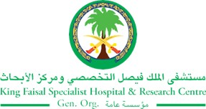
2017 Performance Improvement Report
STRATEGIC PRIORITY
1. Develop world-leading healthcare and research

Project Name
Skin integrity maintenance and pressure injury prevention

Site |  | Department
Riyadh |  | Nursing Affairs
Project Status | Project Start Date |  | Project End Date
Completed | 05-01-2014 |  | 04-30-2016

Problem:  Why the project was needed?  Pressure ulcers cause considerable harm to patients like: hindering functional recovery, causing frequent pain and development of serious infections. Additionally, Pressure ulcers have been associated with an extended length of stay, sepsis and mortality.  Since KFSHRC is a Magnet recognized Hospital, we benchmarked nursing sensitive indicators with National Database of Nursing Quality Indicators (NDNQI).  Based on NDNQI data, KFSHRC pressure injury data did not meet the NDNQI benchmark.  Therefore, this project was selected to improve clinical outcomes and setting standards for medical care. | Aims: What will the project achieve?  - To prevent Hospital and Unit Acquired Pressure Ulcers & maintain skin integrity aiming for elimination of all types of skin breakdown within the patients’ hospital stay.  - To reduce Hospital and unit Acquired Pressure Ulcer incidence rate & skin integrity incidence rate below the Mean of NDNQI by 2Q 2016
Benefits/Impact: What is the improvement outcome?  (check all that apply)  ☐ Contained or reduced costs  ☐ Improved productivity  ☒ Improved work process  ☐ Improved cycle time  ☒ Increased customer satisfaction  ☐ Other (please explain)  Click or tap here to enter text. | Quality Domain: Which of the domains of healthcare quality does this project support?  (Select only one)  Safe

Measures: Performance metrics to be evaluated | Targets: Expected outcomes
Hospital Acquired Pressure Ulcer Injuries Rate | Less than NDNQI Mean

Interventions: Overview of key steps/work completed
- Identifying structure and process gaps which is required for improvement.
- Development of Pressure Ulcer and skin breakdown prevention Standards of Care according to the new Guidelines (NPUAP & EPUAP 2014).
- New ICIS documentation was built.
- Initiation of new Risk Tool (Glamorgan Pressure Injury Risk Assessment Tool for patients from birth to 18 years)
- A mandatory NDNQI Pressure Injury Training posted on the NDNQI Homepage (annually).
- A mandatory Skin integrity maintenance and pressure Injury prevention workshop.
- New educational path (NDNQI, GNO, Wound Workshop).
- New supply & Products recommendations.
- New Other Pressure Injury classification.
- New changes in Safety Reporting System incidents’ details.
Results: Insert relevant graphs and charts to illustrate improvement pre and post project
(insert relevant graphs, data, charts, etc.)
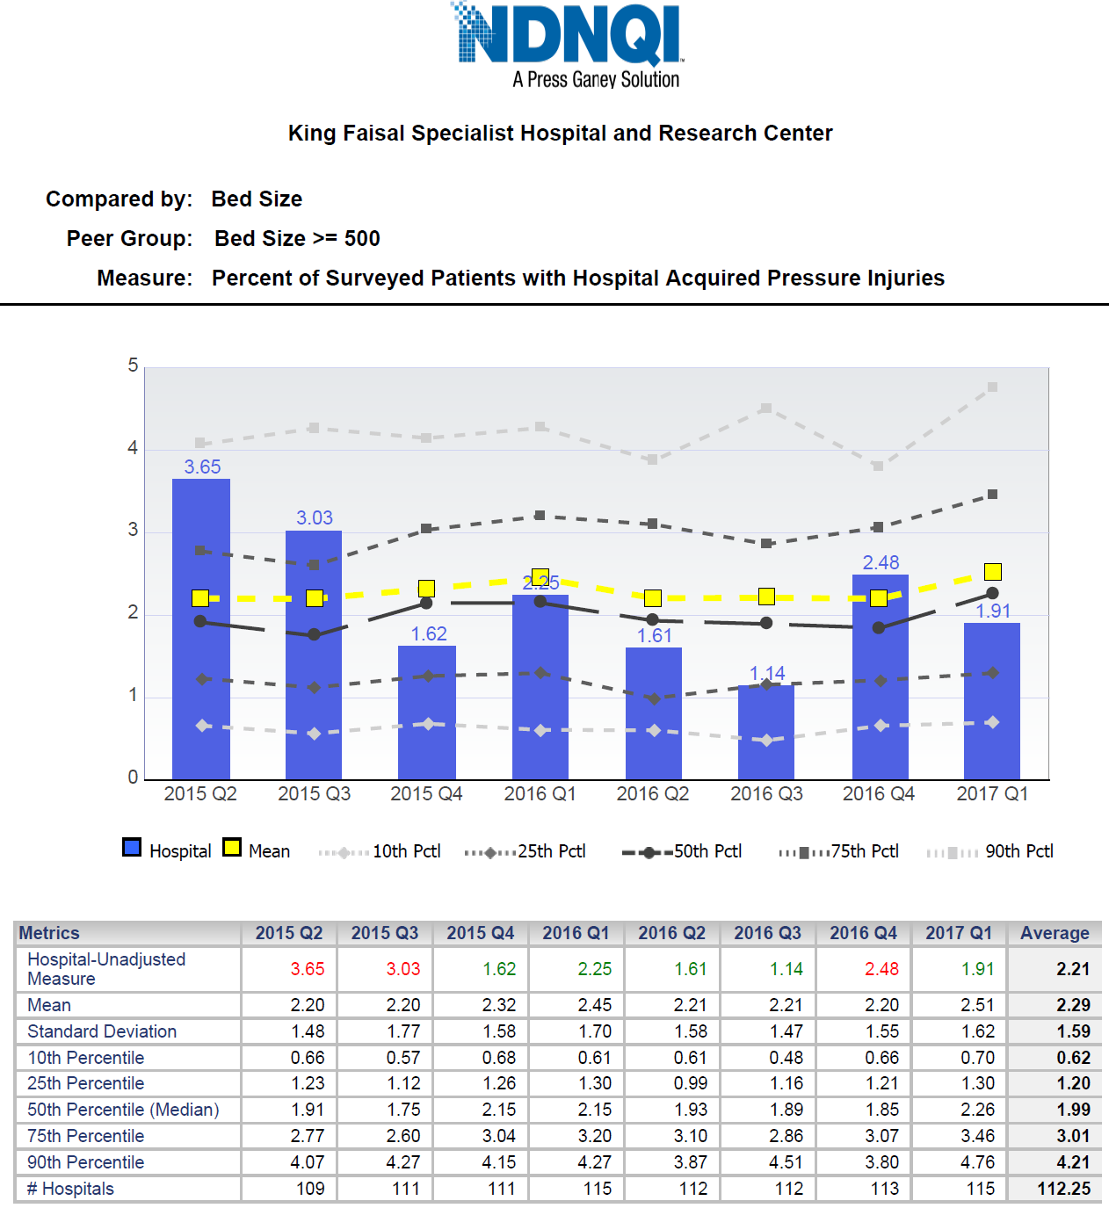

Project Lead | Team Members
Name  (person accountable for project) | Names  (persons involved in project)
Mohammed Al hawari | Eyad Bashtawi  Azza Ahmad  Angelina Fernandez  Marinha Macedo  Husam Mahmoud  Dani Halabi  Neameh Abbas Deeb  Emara, Sania abdul fatah  Mohamed, Nada farouk  Rhona Tahar  Claramma Kuriackose  Wan Mustapha  Margo Byrne  Norhayati Binti  Devaki Suppiah  Verastigue, Sara may  Cecille Valencia  Shyla Mathew  Khoo Christina  Ahlam Hadad  Ashraf Rababah  Dianna Aker  Dima Zein  Sofia Maccedo  Khalid s.  Helen Arputhan  Marianne Figveroa

