2017 Performance Improvement Report
STRATEGIC PRIORITY
3. Improve efficiency and decision-making

Project Name
Development of a new vacuum system for the CS-30 Cyclotron

Site |  | Department
Riyadh |  | Cyclotron and Radiopharmaceuticals:  Cyclotron section
Project Status | Project Start Date |  | Project End Date
Completed | 02-01-2016 |  | 12-31-2016

Problem:  Why the project was needed?  Cyclotron vacuum system is responsible for evacuating the cyclotron tank from residual gases and, hence, improve the particles acceleration and increasing extraction efficiency.  The original vacuum system was installed in 1981 and had never been replaced. Recently, we have noticed that the vacuum level is poor and continuous crowbarring was observed when the electrodes voltage was increased. Low vacuum level inside the extracted region will disturb the beam during acceleration and, hence, increase losses. | Aims: What will the project achieve?  To develop a vacuum system to increase the vacuum level inside the cyclotron by at least 25% from the baseline; this will improve the production of the isotope produced by the CS-30 cyclotron.
Benefits/Impact: What is the improvement outcome?  (check all that apply)  ☐ Contained or reduced costs  ☐ Improved productivity  ☒ Improved work process  ☐ Improved cycle time  ☐ Increased customer satisfaction  ☐ Other (please explain)  Click or tap here to enter text. | Quality Domain: Which of the domains of healthcare quality does this project support?  (Select only one)  Effective

Measures: Performance metrics to be evaluated | Targets: Expected outcomes
Vacuum level inside the cyclotron (%) | At least by 25% from the baseline

Interventions: Overview of key steps/work completed

- 1- New system (hardware and software) was developed to improve the vacuum level inside the cyclotron.
- 2- Design and simulate the system using Solidworks and Labview in-house by department’s engineers.
- 3- Fabricate the hardware in the Cyclotron precision machine shop.

Results: Insert relevant graphs and charts to illustrate improvement pre and post project
(insert relevant graphs, data, charts, etc.)

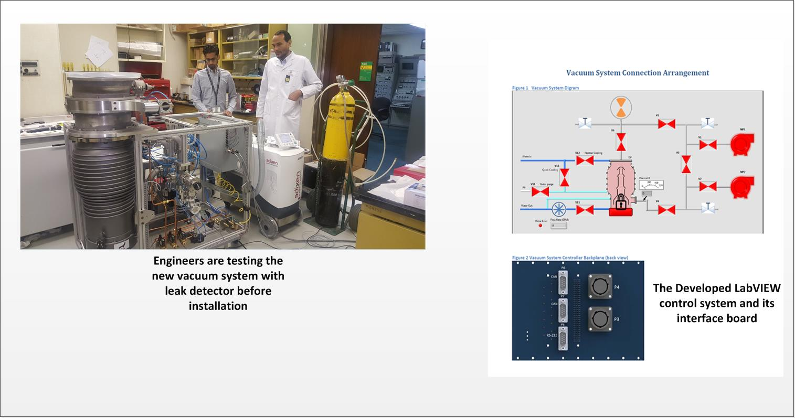

Project Lead | Team Members
Name  (person accountable for project) | Names  (persons involved in project)
Faisal AlRumayan | John Schneider  Amr Hendy  Qassem Akkam  Ahmed Al-Ghaith  Salam Rahma

