2017 Performance Improvement Report
STRATEGIC PRIORITY
3. Improve efficiency and decision-making

Project Name
Enhance the Annals of Saudi Medicine Peer-Review Process
Site |  | Department
Riyadh |  | Academic and Training Affairs (ATA), Scientific Publications Office
Project Status | Project Start Date |  | Project End Date
Completed | 01-01-2016 |  | 12-31-2016

Problem:  Why was the project needed?  The Annals of Saudi Medicine (ASM) submission and peer review process takes 150 days from submission of the manuscript to final decision on publication status. In order to smooth the workflow process and ensure rapid publication, the ASM has concentrated on improving the ability to find suitable peer reviewers by activating the Reviewer Locator feature under the ScholarOneTM submission system and ensuring the availability and responsiveness of the peer reviewers. | Aims: What will the project achieve?  To improve the ASM submission and peer-review process by decreasing the turnaround time from submission to final decision from 150 to 30 days before the end of 2016.
Benefits/Impact: What is the improvement outcome?  (check all that apply)  ☐ Contained or reduced costs  ☒ Improved productivity  ☒ Improved work process  ☒ Improved cycle time  ☐ Increased customer satisfaction  ☐ Other (please explain)  Click or tap here to enter text. | Quality Domain: Which of the domains of healthcare quality does this project support?  (Select only one)  Efficient

Measures: Performance metrics to be evaluated | Targets: Expected outcomes
Turnaround time from submission to final decision | Within 30 days

Interventions: Overview of key steps/work completed
- The ASM has improved its peer-review process to ensure rapid publication.
- All manuscripts are subject to a strict peer-review process involving members of the Editorial Board and external reviewers with expertise in the subject matter.
- The process starts with an initial review by a scientist who makes an initial assessment of suitability for publication in the ASM.
- Reviewing editor makes an immediate decision or invites external reviewers, who are blinded to the manuscript author(s), to assess the manuscript further, recommend any revisions, and offer their opinion on acceptability.

Results: Insert relevant graphs and charts to illustrate improvement pre and post project
(insert relevant graphs, data, charts, etc.)

Improvement of the Annals of Saudi Medicine workflow process.

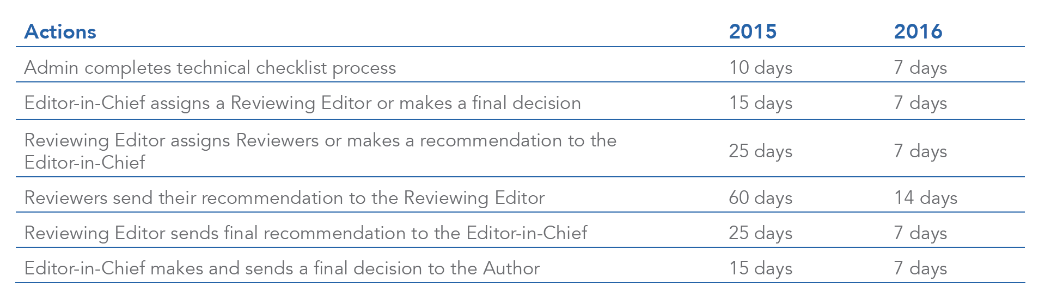
Improvement of the Annals of Saudi Medicine workflow process.

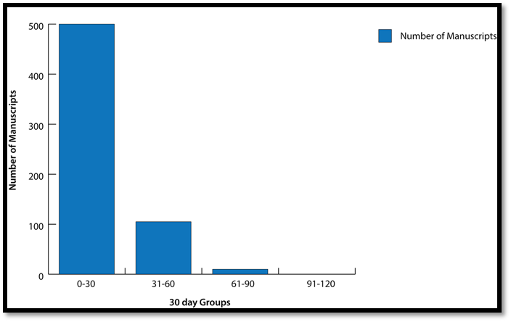
500 manuscripts within 30 days

Project Lead | Team Members
Name  (person accountable for project) | Names  (persons involved in project)
Prof. Nasser Al-Sanea, Editor-in-Chief of  ASM | Dr. Yaser Adi, Scientist  Amal Al-Ghammas, Editorial Supervisor and Senior Editorial Assistant  Reina Tejano-Berina, Desktop Publisher  Raquel Glorioso-Rivera, Editorial Assistant  Kimberly Cristobal, Editorial Assistant  Janelle Vales-Yasay, Editorial Assistant

