2017 Performance Improvement Report
STRATEGIC PRIORITY
3. Improve efficiency and decision-making

Project Name
Enhancement of boarding patients’ flow in DEM waiting room in collaboration with DMU
Site |  | Department
Riyadh |  | Day Medical Unit Ambulatory Care Nursing
Project Status | Project Start Date |  | Project End Date
Completed | 01-01-2017 |  | 09-17-2017

Problem:  Why the project was needed?  This is to reduce the crowdedness in DEM waiting room and to increase the DMU slot utilization for boarding DEM patients. | Aims: What will the project achieve?  To increase DEM-DMU slot utilization by 5% from the baseline (153 slots in 2016) by the end of 3Q 2017
Benefits/Impact: What is the improvement outcome?  (check all that apply)  ☐ Contained or reduced costs  ☒ Improved productivity  ☐ Improved work process  ☐ Improved cycle time  ☒ Increased customer satisfaction  ☐ Other (please explain)  Click or tap here to enter text. | Quality Domain: Which of the domains of healthcare quality does this project support?  (Select only one)  Efficient

Measures: Performance metrics to be evaluated | Targets: Expected outcomes
DEM_DMU slot Number | 5% from the baseline (Target = 161 slots)

Interventions: Overview of key steps/work completed
- Participation of DMU manager in the operational huddles in DEM.
- Development and approval of Internal agreement / guideline between DMU & DEM detailing the process of transfer of boarding DEM patients to DMU.

Results: Insert relevant graphs and charts to illustrate improvement pre and post project
(insert relevant graphs, data, charts, etc.)
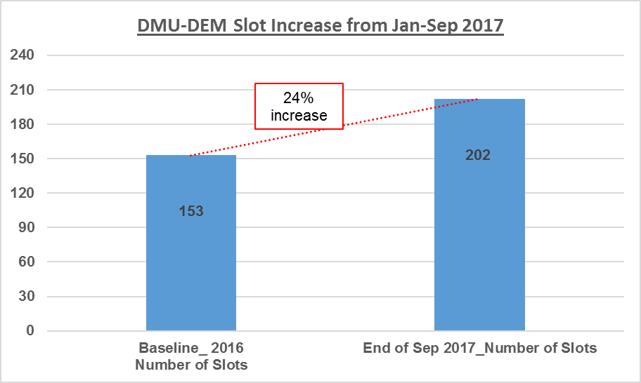

Project Lead | Team Members
Name  (person accountable for project) | Names  (persons involved in project)
Abdullah Al-Alawi | Aysha Awaji  Vanessa Lewis  Joana Buencamino

