2017 Performance Improvement Report
STRATEGIC PRIORITY
3. Improve efficiency and decision-making

Project Name
Enhancement of Nutritional Formula Monitoring
Site |  | Department
Riyadh |  | Nutrition Services Department
Project Status | Project Start Date |  | Project End Date
Completed | 01-01-2015 |  | 12-31-2017

Problem:  Why the project was needed?  Patients are expected to receive high quality nutritional formula and supplements that are not expired. Unfortunately, there have been incidents where patients, nurses and staff have reported receiving expired formula for inpatients / outpatients settings.  Due to the high volume of nutritional formula ordered, consumed and issued, the risk of issuing expired formula is very likely to happen. This project was initiated to enhance patient safety by preventing the use of expired nutritional formula. | Aims: What will the project achieve?  Decrease number of incidents (SRS) related to expired Nutritional Formula from average of 8 per Quarter to zero by end of 2017
Benefits/Impact: What is the improvement outcome?  (check all that apply)  ☐ Contained or reduced costs  ☐ Improved productivity  ☒ Improved work process  ☐ Improved cycle time  ☒ Increased customer satisfaction  ☐ Other (please explain)  Click or tap here to enter text. | Quality Domain: Which of the domains of healthcare quality does this project support?  (Select only one)  Safe
Measures: Performance metrics to be evaluated | Targets: Expected outcomes
Number of incidents of expired formula reaching the patient. | zero

Interventions: Overview of key steps/work completed
- A policy was developed with all departments involved explaining in detail all the steps of monitoring nutritional formula from: ordering, preparation, delivery, storage and issuing.
- Process maps, work flow diagrams, and forms were developed and/or updated to explain the process of monitoring formula expiry.
- An audit tool was developed and used to measure the improvement in different areas around the hospital.
- An educational presentation was developed and is available in I-learn
- Refrigerators were purchased to ensure the safe storage of prepared formulas in a separate refrigerator.
- The new policy was uploaded and accessible to all staff, and concerned staff were educated about its use by their responsible superiors.
Results: Insert relevant graphs and charts to illustrate improvement pre and post project
(insert relevant graphs, data, charts, etc.)

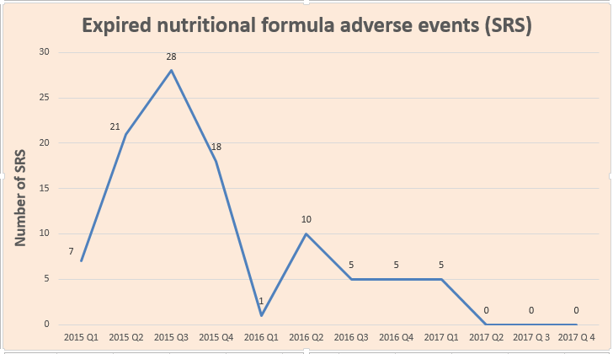

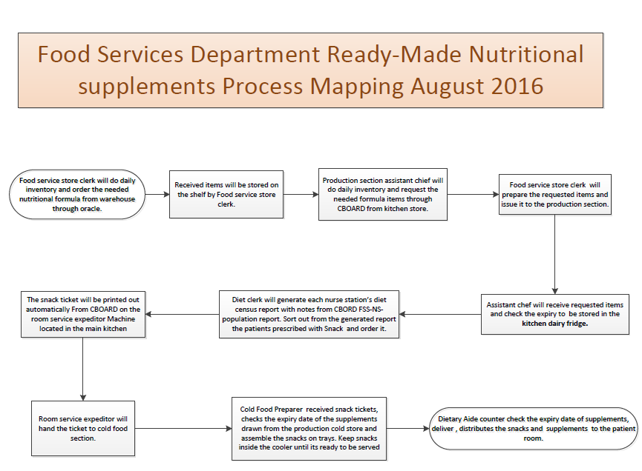
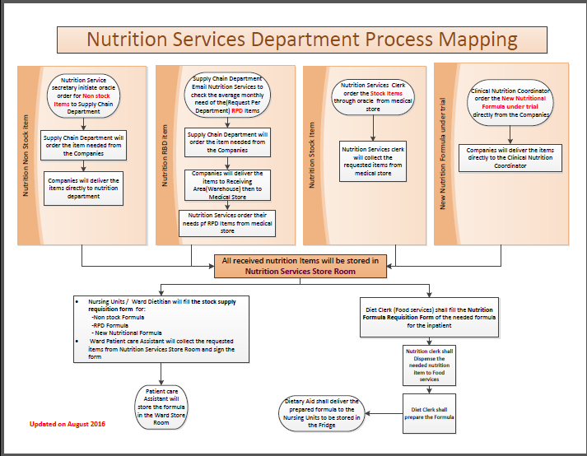

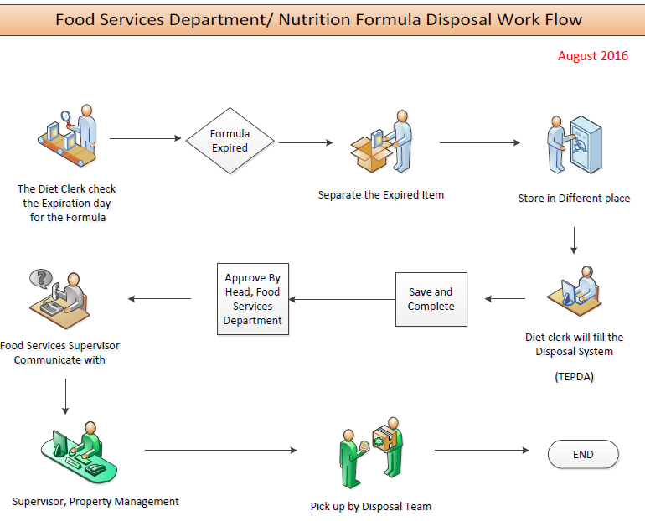

Project Lead | Team Members
Name  (person accountable for project) | Names  (persons involved in project)
Dima Abosaleh | Rania Alobari  Rafat Malkawi  Sasikalan Subrayan  Sozan Alqarni  Bader Alhazaa  Sawsan Albalawi  Saif Almutaeri  Leodivina Abel Reyes  Saud AlEnazi

