2017 Performance Improvement Report
STRATEGIC PRIORITY
3. Improve efficiency and decision-making

Project Name
Low Dose Computed Tomography (CT) Pulmonary Embolism (PE) Protocol
Site |  | Department
Riyadh |  | Radiology Department
Project Status | Project Start Date |  | Project End Date
Completed | 01-01-2016 |  | 12-31-2016

Problem:  Why the project was needed?  Radiology department believes that patient safety is number one priority to any healthcare organization.  Nowadays, staff are utilizing high dose of radiation for Computed Tomography Pulmonary Embolism CT PE examinations.  Giving high dose of radiation will compromise patient safety. In addition, it is not following the ALARA principles. | Aims: What will the project achieve?  To reduce the amount of ionizing radiation exposure for patient undergoing CT for PE studies by 50% before the end of 2016
Benefits/Impact: What is the improvement outcome?  (check all that apply)  ☐ Contained or reduced costs  ☐ Improved productivity  ☒ Improved work process  ☐ Improved cycle time  ☐ Increased customer satisfaction  ☐ Other (please explain)  Click or tap here to enter text. | Quality Domain: Which of the domains of healthcare quality does this project support?  (Select only one)  Safe

Measures: Performance metrics to be evaluated | Targets: Expected outcomes
Radiation dose for patient undergoing CT PE | To be below 335 mGY.cm

Interventions: Overview of key steps/work completed
- Data collection has been done.
- Revision of the protocol before implementing it.
- Implementation of New protocol in all the CT machines for CT PE studies.
- New protocol was disseminated among all CT staff.
- Initiation of a New indicator to maintain compliance.

Results: Insert relevant graphs and charts to illustrate improvement pre and post project
(insert relevant graphs, data, charts, etc.)

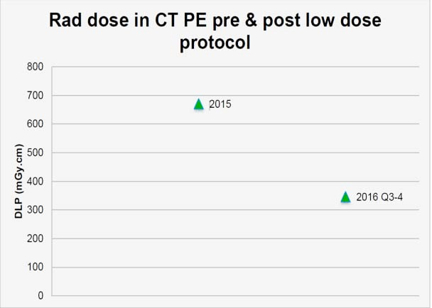
Dose decrease by 349 (52% reduction)
671
322
Dose before low dose protocol
Dose After low dose protocol
Radiation dose for patient undergoing CT PE before and after implementation of low dose protocol

Project Lead | Team Members
Name  (person accountable for project) | Names  (persons involved in project)
Mashael Alrujaib | Dr. Yusuf Alkadhi  Manhal Alqurashi
Raquel Tubera
Saad Alenazi
Khalid Aldossari
Ibrahim Alkhargi
Fawaz Skaff

