2017 Performance Improvement Report
STRATEGIC PRIORITY
1. Develop world-leading healthcare and research

Project Name
Reduce The Number of Incidents Related to Bone Marrow Transplant (BMT) Program.
Site |  | Department
Jeddah |  | Pathology and Laboratory Medicine -J
Project Status | Project Start Date |  | Project End Date
Completed | 07-24-2017 |  | 09-14-2017

Problem:  Why the project was needed?  A trend was noticed in the number of BMT related incidents. These errors can be high risk to patient when it’s not discovered and corrected. They were caused by manual handling of all BMT procedures. | Aims: What will the project achieve?  Reduce the number of incidents related to BMT program (83 per 2016 year) caused by manual handling for all processes and difficulties by 90%.
Benefits/Impact: What is the improvement outcome?  (check all that apply)  ☐ Contained or reduced costs  ☒ Improved productivity  ☒ Improved work process  ☒ Improved cycle time  ☐ Increased customer satisfaction  ☐ Other (please explain)  Click or tap here to enter text. | Quality Domain: Which of the domains of healthcare quality does this project support?  (Select only one)  Effective

Measures: Performance metrics to be evaluated | Targets: Expected outcomes
Incidents Related to Bone Marrow Transplant (BMT) | Reduce the number of incidents related to BMT program (83 per 2016 year) caused by manual handling for all processes and difficulties by 90%.

Interventions: Overview of key steps/work completed
- E-DELPHYN system was installed by collaboration with BMT lab team in Riyadh,
- The team from both sides has programed the requirement, workflow that comply with FACT-JACIE standards & JCIA Standards.
- The system has been validated for the accuracy for three months before went life with real patient testing.
- Periodical E- DELPHYN System upgrade is requested, and whenever corrective action required for occurred incidents.
- Staff trained on the newly developed process and got their individualized access.
- Full electronic labeling for Stem Cells
- ISBT 128 (International Society of Blood Transfusion) full compliance.
- Improve patient confidentiality by having Access Rights based on User Credentials.
- The system offered as well full electronic archiving and retrieving of previous patients/ donor documents in the system was achieved. That saved time and present accurate statistics.
- System programmed to alert, and hold approval for positive serology before releasing stem cell products.
- Eliminate manual documentation of transplant process.
- Insure patient’s safety /proper patient identification.
- Accurate/reliable stem cell units tracking & stem cell dose calculation.

Results: Insert relevant graphs and charts to illustrate improvement pre and post project
(insert relevant graphs, data, charts, etc.)
- Eliminate the number of incidents related to processing: incidents reduced to 0.0%

- Full electronic labeling for Stem Cells
After the Project
Before the Project

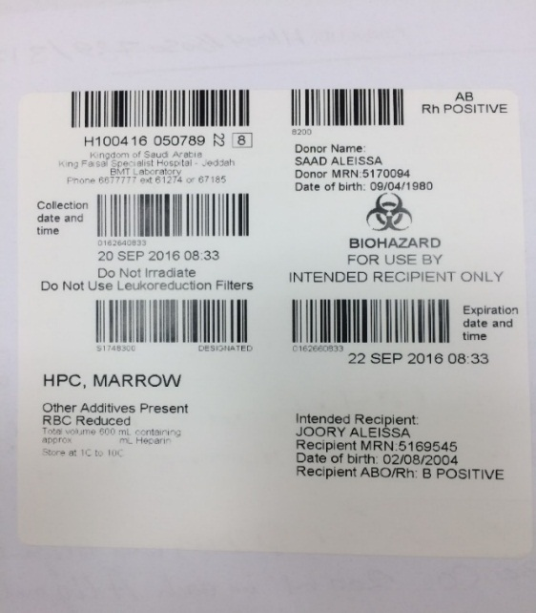
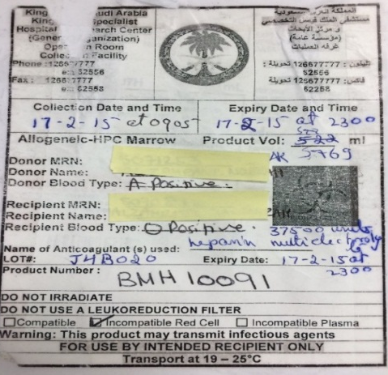

Project Lead | Team Members
Name  (person accountable for project) | Names  (persons involved in project)
Banan Khadwardi | Amr Raggam  Mohammed Alghuthami  Wagdy Samargandi  Ayham Almomani  Nasreen Basalem  Sarfinaz Habazaza  Shorooq Zakariya

