2017 Performance Improvement Report
STRATEGIC PRIORITY
1. Develop world-leading healthcare and research

Project Name
Decreasing the number of Central Line Blood Stream Infections (CLBSI) rate below National Health Safety Network (NHSN) benchmark (0.9) in Cardiovascular Telemetry Unit (CVT) by the end of 2017
Site |  | Department
Jeddah |  | CVT
Project Status | Project Start Date |  | Project End Date
Completed | 04-01-2017 |  | 10-31-2017

Problem:  Why the project was needed?  There was a rise in CL-BSI rate (CVT 2 North and 2 South) for the calendar year 2016 reached 9.8. It was above the (NHSN) benchmark of 0.9. | Aims: What will the project achieve?  Reduce the number of CL-BSI infections in 2 North and 2 South from 9.8 to below NHSN benchmark
Benefits/Impact: What is the improvement outcome?  (check all that apply)  ☒ Contained or reduced costs  ☐ Improved productivity  ☐ Improved work process  ☐ Improved cycle time  ☒ Increased customer satisfaction  ☐ Other (please explain)  Click or tap here to enter text. | Quality Domain: Which of the domains of healthcare quality does this project support?  (Select only one)  Patient Centred

Measures: Performance metrics to be evaluated | Targets: Expected outcomes
Central Line Blood Stream Infections (CL-BSI) rate | Reduce the number of CLABSI infections in 2 North and 2 South from 9.8 to below NHSN benchmark with stretch goal to reach zero by the end of 30 Sept 2017.

Interventions: Overview of key steps/work completed
- The KPIs monthly performance data (Infection control and Nursing Quality and Practice monthly data) from 2016 were reviewed and analyzed and the team brainstormed the potential causes and actions needed to be taken. These actions included;
  - In-services regarding hand hygiene and Central Venous Catheter (CVC) management.
  - Increase the staff awareness and compliance by increasing the frequency of Peripheral Intravenous (PIV)/CVC audits, implementing internal CVT “Infection Control Officers”.
  - Increase the environmental rounds in CVT by HN, AHN, and NCs.
  - Internal and external hand hygiene auditors.
  - Ensure that nurses have accessible equipment at bedside, i.e. Alcohol swabs, and needless cap covers.
  - Promote the use of Tegaderm dressing with CVCs.

Results: Insert relevant graphs and charts to illustrate improvement pre and post project
(insert relevant graphs, data, charts, etc.)
The pre data showed a high rate of CLBSI reached 9.8 compared to a benchmark of 0.9 during the year of 2016.
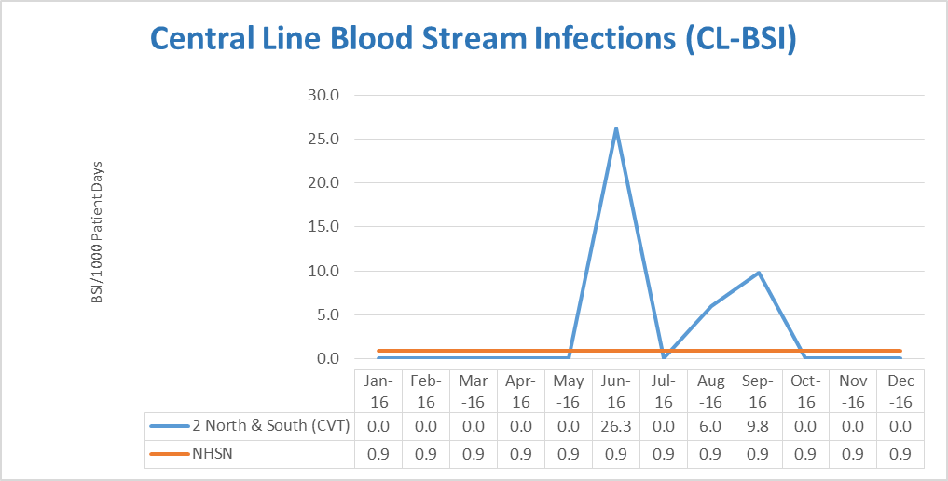

After completing the Performance Improvement project in October 2017, the data showed an improved result reached 0 in the period from November 2016 to October 2017. Which exceed the new adopted NHSN benchmark which is 0.7.
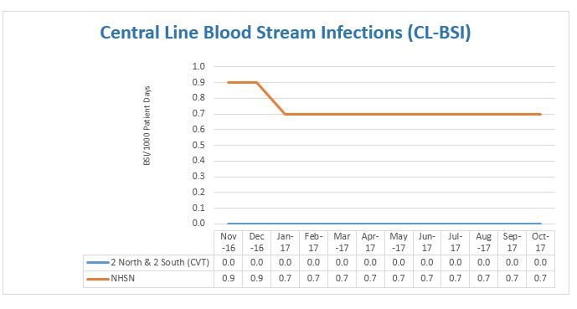

Project Lead | Team Members
Name  (person accountable for project) | Names  (persons involved in project)
Adel Alhayari | Lojain Khalid  Batoul Bugis  Thamer Al Keleyleh  Cynthia Filoteo  Devagi Thachinamoorthy  Keisha Anglin  Abrar Maghrabi  Wessal Assiri  Wejdan Barayan  Batoul Bugis  Jo Ann Espolong  Gisselle Pimentel  Banan Bagarish  Nezar Essam Mohammed  Eireen Macalinao  Ruth Descalzo  Zethu Zulu  Medalin Sundaresan  Samer Dardas

