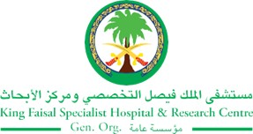
2017 Performance Improvement Report
STRATEGIC PRIORITY
1. Develop world-leading healthcare and research

Project Name
Decrease Central Line Associated Blood Stream Infection (CLABSI) in Adult Oncology Unit
Site |  | Department
Jeddah |  | Adult Oncology
Project Status | Project Start Date |  | Project End Date
Completed | 05-01-2016 |  | 12-31-2016

Problem:  Why the project was needed?  Central line-blood stream infection rate increased in the first 4 months of 2016 to 2.1 in hematology /oncology service while the NHSN (National Healthcare Safety Network) rate is 1.3 | Aims: What will the project achieve?  Control the central line related to blood stream infection and to decrease the rate in the Hem/Oncology Service to reach the national benchmark = 1.3
Benefits/Impact: What is the improvement outcome?  (check all that apply)  ☒ Contained or reduced costs  ☒ Improved productivity  ☒ Improved work process  ☐ Improved cycle time  ☒ Increased customer satisfaction  ☐ Other (please explain)  Click or tap here to enter text. | Quality Domain: Which of the domains of healthcare quality does this project support?  (Select only one)  Patient Centred

Measures: Performance metrics to be evaluated | Targets: Expected outcomes
Central line-blood stream infection rate | Reach the national benchmark = 1.3

Interventions: Overview of key steps/work completed
- Weekly audit (hand washing, CVC (Central Venous Catheter), environmental, partner audit.
- Change in practice in cooperation with NPQR (Nursing Practice, Quality And Research Department ) department to use 3 way device on our patients CVCs and cover the rubber port of IV line to make sure not been used by the nurses.
- Re-certifying all staff for CVC management.
- Monitoring nurses practice intensively.
- Staff education quarterly.
- Patient & family education daily.
- Hand washing campaign quarterly

Results: Insert relevant graphs and charts to illustrate improvement pre and post project
(insert relevant graphs, data, charts, etc.)

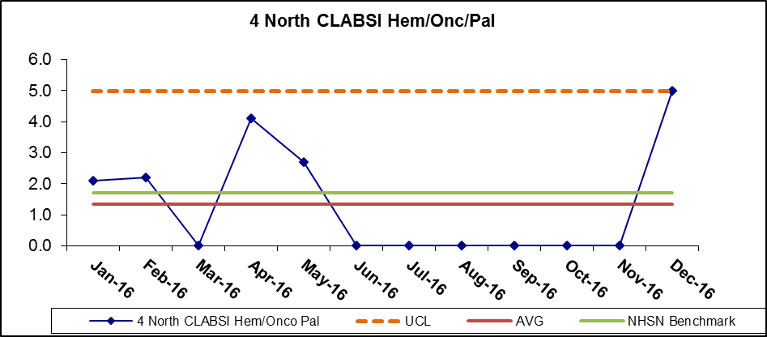
Based on one case only, low device days.

Project Lead | Team Members
Name  (person accountable for project) | Names  (persons involved in project)
Mohammad badawi jaber | Dr.masud nabi  Sundersand madline  Ahmad adam  WELAGAMAGE DON, JOSEPH  Aliberth  Mary, gayan  Diana ecardo  Liza briza  Sithara john  Nada turkistani  Princess austria  Bintu baby  Kristina evasco  Bintamol baly  Reham hariri  Maiden salas  Ibrahim Qoulaghasi

