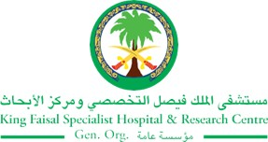
2017 Performance Improvement Report
STRATEGIC PRIORITY
1. Develop world-leading healthcare and research

Project Name
Reduction and Prevention of Central Line Associated Blood Stream Infection ( CLABSI) In Neonatal Intensive Care Unit
Site |  | Department
Jeddah |  | NICU
Project Status | Project Start Date |  | Project End Date
Completed | 05-01-2016 |  | 12-31-2016

Problem:  Why the project was needed?  High CLABSI rate in two of NICU birth weight categories above the international benchmark of National Health Safety Network (NHSN). | Aims: What will the project achieve?  - To have a total reduction in the CLABSI rate for all NICU birth weight categories by more than 50% in the third Quarter 2016  - To reach zero CLABSI rate in the fourth Quarter of 2016
Benefits/Impact: What is the improvement outcome?  (check all that apply)  ☒ Contained or reduced costs  ☒ Improved productivity  ☐ Improved work process  ☐ Improved cycle time  ☒ Increased customer satisfaction  ☒ Other (please explain)  Reduced length of stay | Quality Domain: Which of the domains of healthcare quality does this project support?  (Select only one)  Patient Centred

Measures: Performance metrics to be evaluated | Targets: Expected outcomes
- CLABSI rate | - Reduction in the CLABSI rate for all NICU birth weight categories by more than 50% in the third Quarter 2016  - Reach zero CLABSI rate in the fourth Quarter of 2016

Interventions: Overview of key steps/work completed
- In April 2016, One Collaborative meeting to discuss the NICU CLABSI cases chaired by the Nurse Manager and attended by NICU nursing staff, Unit Council Chair and Co-chair, Medical Team and Infection Control and Program Director for Specialty Services
- Hand Hygiene Campaign (Hand Hygiene training through the use of Ultraviolet light) since the start of April for all health care workers in the unit
- Every single positive case is being extensively reviewed through root cause analysis and the findings discussed with unit staff with review of practice and related policies. Line necessity was the major contributing factor in all reported cases due to the fact of having multiple invasive lines of (CVC & PIV) with multiple lumens being kept as KVO with no plans of when to be discontinued.
- Prevention of CLABSI education sessions focusing on the Aseptic technique practice, central line bundle compliance, conducted at the unit level with 100% staff attendance.
- Infection control awareness sessions during the month of April 2016, related to the use of safe work practices specific to hand hygiene and the use of the personal protective equipment to protect self and limit the spread of contamination.
- CVC skills review and privileges updates performed for all NICU staff nurses.
- Daily inspection for every single case with peripheral and central line reviewing line necessity during multidisciplinary Patients round.
- Plans for specific cases are being specifically documented reflecting the plan of how long in situ the line will continue and for what rational is being kept as KVO.
- SNIs as auditors have been identified to perform CVC audits at bed side and provide feedback specific to practice compliance.
- Early identification of infection signs and symptoms for internal and external transferred patients to the unit and immediate action is being taken.

Results: Insert relevant graphs and charts to illustrate improvement pre and post project
(insert relevant graphs, data, charts, etc.)

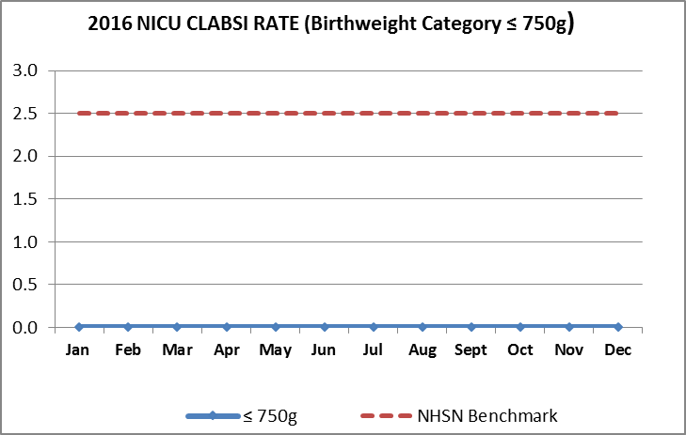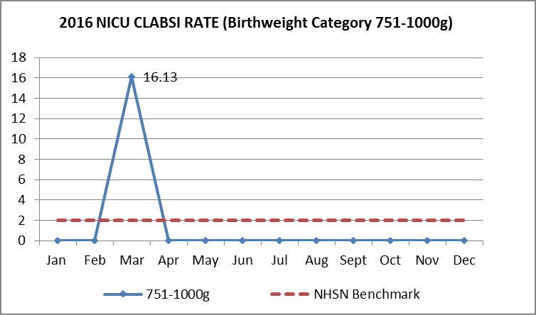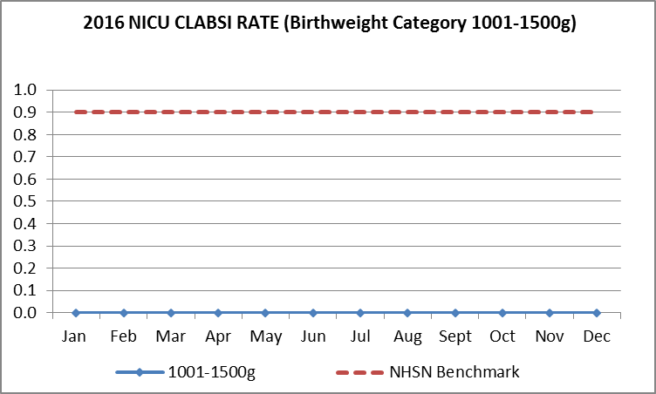

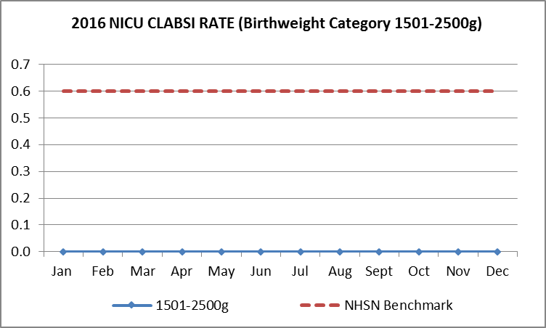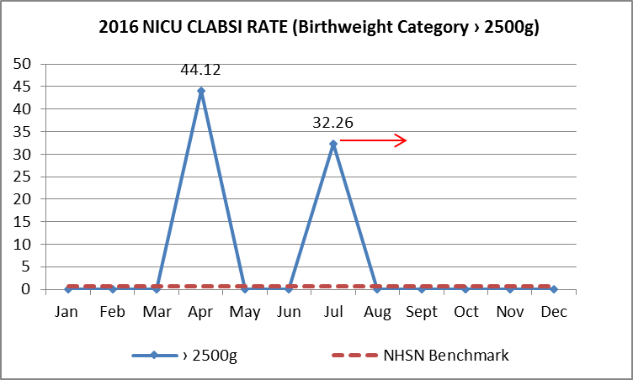

Project Lead | Team Members
Name | Names
Salma Najjar | Gina Oliva,  Eunice Lopez  Marife Calapatia  Maria Cristina Ricaplaza  Josephine Catanyag  Liza Cronje  Amal Zubani  Medalin Sundaresan  Hanif kamal  Maria Theresa Arceo  Fadi Al-Shatarat,  Ohood Al-Haddad

