2017 Performance Improvement Report
STRATEGIC PRIORITY
2. Increase capacity and patient access

Project Name
Improve Turnaround Time (TAT) of Pain Management for Patients With Severe Pain (Score 8-10)
Site |  | Department
Jeddah |  | Department of Emergency Medicine
Project Status | Project Start Date |  | Project End Date
Completed | 10-29-2016 |  | 05-31-2017

Problem:  Why the project was needed?  the TAT from triage to administer medication for the patients with severe pain (score 8-10) is 94 minutes & TAT from medication administration to reassessment is 109 minutes which consider prolonged time in comparison to our guidelines | Aims: What will the project achieve?  1.To reduce time frame from triage time to administer medication from 94 to 60 minutes  2.To reduce time frame from medication administration to reassessment by 50% from the baseline data of 2016 (which was 109 minutes) for the patients with severe pain (score 8-10)
Benefits/Impact: What is the improvement outcome?  (check all that apply)  ☒ Contained or reduced costs  ☒ Improved productivity  ☒ Improved work process  ☒ Improved cycle time  ☒ Increased customer satisfaction  ☐ Other (please explain)  Click or tap here to enter text. | Quality Domain: Which of the domains of healthcare quality does this project support?  (Select only one)  Timely

Measures: Performance metrics to be evaluated | Targets: Expected outcomes
TAT of pain management for the patients with severe pain (score 8-10) | - To reduce time frame from triage time to administer medication from 94 to 60 minutes  - To reduce time frame from medication administration to reassessment by 50% from the baseline data of 2016 (which was 109 minutes)

Interventions: Overview of key steps/work completed
- Multiple education sessions was done to increase staff awareness regarding the proper assessment of pain score and Hospital IPP of pain management and emphasize on providing management within the assigned time line
- DEM nursing educational calendar was updated by adding monthly in-services about the pain management in DEM by Nurse Clinician or designee
- In-service for the physician on departmental meeting to increase the awareness of the physician for the pain management done by Dr. Sayed
- Pre & post data was shared with DEM nurses and physician to show the gaps and increase the compliance
- Random audit conducted to ensure proper management is followed
- Maintain the monitoring of the data in quarterly basis to insure improving and compliance
Results: Insert relevant graphs and charts to illustrate improvement pre and post project
(insert relevant graphs, data, charts, etc.)
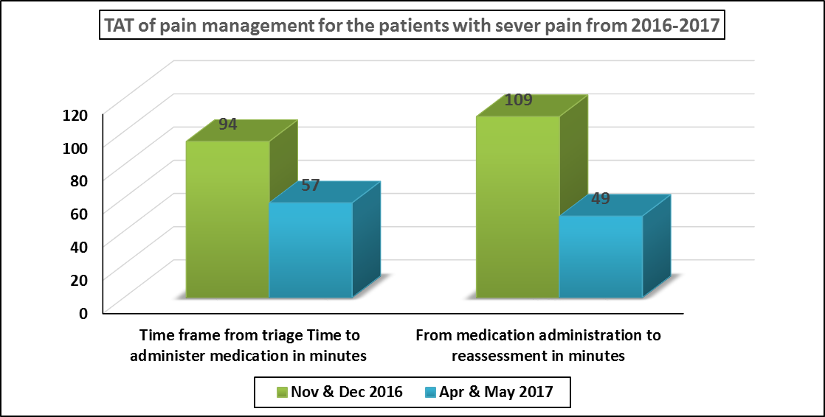
Note: We have been able to reduce time frame from medication administration to reassessment by 55% which exceed our goal.
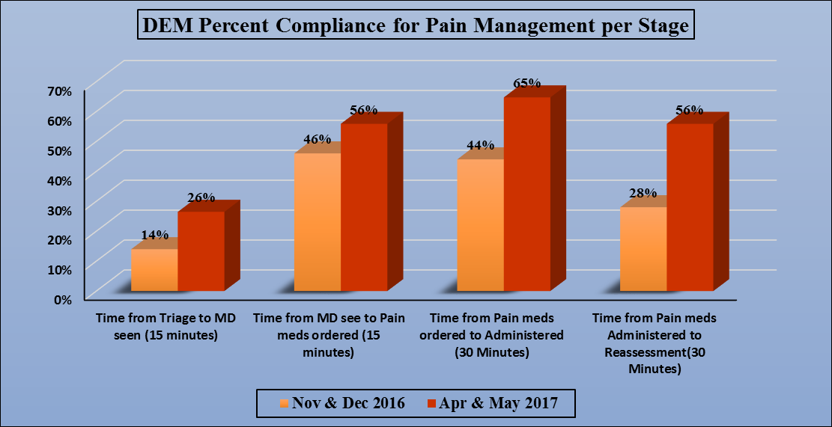

Project Lead | Team Members
Name  (person accountable for project) | Names  (persons involved in project)
Dr. Syed G. Naqvi | Dr. Ibrahim Alomary  Dr. Ahmed Madkhali  Anaam Khatatbeh  Taghreed Jilan  Khalaf Al-Zyod  Soud Sbehat  Marwa Abid  Sarbonza Meera

