2017 Performance Improvement Report
STRATEGIC PRIORITY
2. Increase capacity and patient access

Project Name
Improving The Process of Neurology Outpatient Discharge From KFSH&RC
Site |  | Department
Jeddah |  | Neurosciences/Adult Neurology
Project Status | Project Start Date |  | Project End Date
Completed | 05-01-2016 |  | 12-12-2017

Problem:  Why the project was needed?  Patients discharge process from Neurology outpatient services after completing the treatment for tertiary care is fragmented and ineffective.  This results in patients being retained in the system unnecessarily for services that can be provided in their primary healthcare system. The project will focus on facilitation of the permanent outpatient discharge process from the KFSHRC system. | Aims: What will the project achieve?  - To increase the rate of outpatients discharged adult neurology clinics to 20% of patients seen by December 31 2017.  - 2. To increase the rate of discharge from the KFSHRC system to 10% by December 31 2017.
Benefits/Impact: What is the improvement outcome?  (check all that apply)  ☒ Contained or reduced costs  ☒ Improved productivity  ☒ Improved work process  ☒ Improved cycle time  ☒ Increased customer satisfaction  ☒ Other (please explain)  Improve access to care for patients at KFSHRC | Quality Domain: Which of the domains of healthcare quality does this project support?  (Select only one)  Efficient

Measures: Performance metrics to be evaluated | Targets: Expected outcomes
Outpatients discharged adult neurology rate. | - To increase the rate of outpatients discharged adult neurology clinics to 20% of patients seen by December 31 2017.  - 2. To increase the rate of discharge from the KFSHRC system to 10% by December 31 2017.

Interventions: Overview of key steps/work completed
- A team was developed and multiple brainstorming sessions were held.
- An initial mapping process was developed
- A fishbone diagram was created
- The top 4 causes were determined by a Pareto chart
- Review of IPPs and introduction the intervention (an outpatient facilitator from Case Management)

Results: Insert relevant graphs and charts to illustrate improvement pre and post project
(insert relevant graphs, data, charts, etc.)

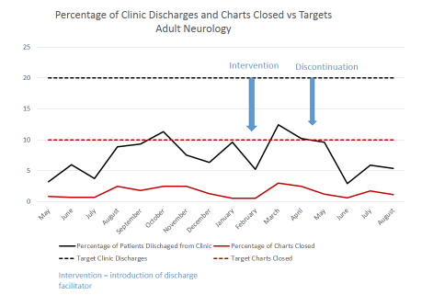

At the beginning of the project our clinic discharge rate was 3.2 % and chart closure rate was 0.5%. Our intervention began in February with the addition of a discharge facilitator and ended in March. After the intervention, our rate of clinic discharge reached 12.4% and chart closure rate reached 3%. This data demonstrates the benefit and need of an outpatient discharge planner. Additional work is required to reach our target goals.

Project Lead | Team Members
Name  (person accountable for project) | Names  (persons involved in project)
Edward Cupler | Yousef Al-Said  Khadeejah Mohammad Al-Hasani  Bandar Ahmed Rashwan  Meshal AL-Thiban  Khlaid Saleh Awad Alqadi, MD  Sameer Alkathiri  Manal Abdulrazzak Badawi, MD  Ahmed Aly Hassan , MD  Syed Ghazanfar Ali Naqvi, MD  Rainavel Anadon Romano, Asst. HN  Heyam Saleh Al-Rached,MD, Asst. Consultant  Zinab Basser Ali Rashed  Moira Faith Abrahams  Abdulaziz Abdullah Al-Sohaibani  Omra Mouafak Wazzan, MD  Alanood Abdulfattah

