2017 Performance Improvement Report
STRATEGIC PRIORITY
3. Improve efficiency and decision-making

Project Name
Improvement in Percentage of Finalized Echo Reports for Procedures Performed During On-Call Hours
Site |  | Department
Jeddah |  | Cardiology Non-Invasive Laboratory
Project Status | Project Start Date |  | Project End Date
Completed | 05-01-2017 |  | 08-31-2017

Problem:  Why the project was needed?  Only finalized echo reports were accessible in ICIS (Heartnet). Preliminary echo reports were only viewed in Xcelera system. Access to Xcelera system is exclusively given to cardiologists and not to all physicians.  Based on data gathered for the month of April 2017, only 64% of echo procedures performed during on-call hours were finalized and can be viewed in ICIS. In some cases, echo procedure was repeated for some patients due to unavailability of echo reports in the ICIS. | Aims: What will the project achieve?  To improve the percentage of finalized Echo Reports for procedures performed during On-Call Hours from 64% to 85% at the end of August 2017
Benefits/Impact: What is the improvement outcome?  (check all that apply)  ☐ Contained or reduced costs  ☒ Improved productivity  ☒ Improved work process  ☒ Improved cycle time  ☒ Increased customer satisfaction  ☐ Other (please explain)  Click or tap here to enter text. | Quality Domain: Which of the domains of healthcare quality does this project support?  (Select only one)  Timely

Measures: Performance metrics to be evaluated | Targets: Expected outcomes
Percentage of finalized Echo Reports for procedures performed during On-Call Hours | Improve the percentage of finalized Echo Reports for procedures performed during On-Call Hours from 64% to 85% at the end of August 2017

Interventions: Overview of key steps/work completed
- A team leader has been assigned to track all the echo procedures performed during on-call hours.
- A list of all pending echo reports was generated on a daily basis.
- Pending report was given to the Consultant for finalization. First reminder was given to the Consultant by the Team Leader.
- A second reminder will be given at the end of the week and delinquent report will be submitted to the Acting Manager.
- A monthly delinquent report was submitted to the Consultant respectively.
- The data will still be monitored monthly to confirm the compliance with the newly introduced process.
Results: Insert relevant graphs and charts to illustrate improvement pre and post project
(insert relevant graphs, data, charts, etc.)
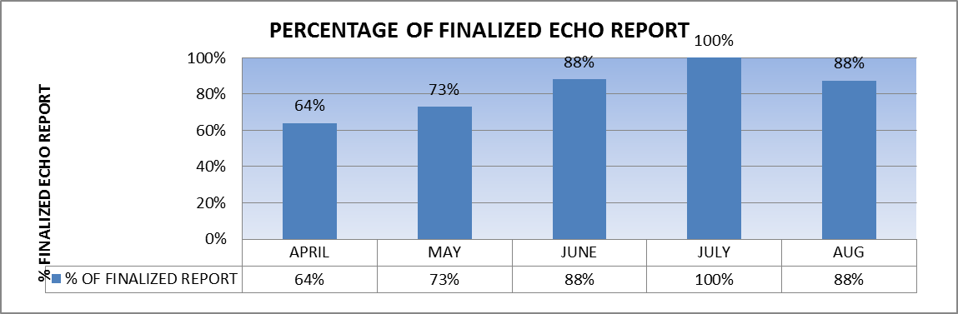

Project Lead | Team Members
Name  (person accountable for project) | Names  (persons involved in project)
Avegin Fajardo | Shaian Shesha  Saud Al-Ghamdi  Ruby Negrillo  Frances Soriano  Emma Concepcion dela Vega  Nour Al-Attas

