2017 Performance Improvement Report
STRATEGIC PRIORITY
3. Improve efficiency and decision-making

Project Name
Minimize Mix Up of Pace Maker and Implantable Cardio Defibrillator Tray Instrument, Cath. Lab
Site |  | Department
Jeddah |  | Central Sterilization Supply Department
Project Status | Project Start Date |  | Project End Date
Completed | 06-01-2016 |  | 05-01-2017

Problem:  Why the project was needed?  The instruments from the pace maker trays gets mixed up with other tray instruments while packing from CSSD. The incident was known only when the sterilized tray was opened in Cath. Lab during procedure. This cause delay in procedure (approximately one hour), surgeon dissatisfaction, and pressure on staff and also impact on quality patient care,wastage of time and resources were also another concern.  Out of average 10 cases monthly, approximately 2 incidents of mix up/missing instruments were reported monthly. In the year 2015, we had 18 reported incidents. The delay in procedure was about one hour. This delay was caused to find another sterile tray, to get the instrument needed in order to complete the procedure. If this happens to the last case, then the delay will be more than one hour as all trays were used. CSSD had to re-sterilize the used instruments as soon as possible and it will take a minimum Two hour delay. | Aims: What will the project achieve?  Minimize the mix up incidents of Pace Maker and ICD tray instruments, thereby assuring smooth instrumentation facilities for the surgeon to perform successful Pace maker insertion
Benefits/Impact: What is the improvement outcome?  (check all that apply)  ☐ Contained or reduced costs  ☐ Improved productivity  ☐ Improved work process  ☒ Improved cycle time  ☒ Increased customer satisfaction  ☐ Other (please explain)  Click or tap here to enter text. | Quality Domain: Which of the domains of healthcare quality does this project support?  (Select only one)  Safe

Measures: Performance metrics to be evaluated | Targets: Expected outcomes
Incidents of mix up/missing instruments | Reduce number of Incidents of mix up/missing instruments to Zero.

Interventions: Overview of key steps/work completed
- The CSSD Technicians apply name and number to device using a stencil so the trays will be easier to be identified.
- Improve the cooperation and promptness in compliance to in and out check list by Cath. Lab Nurses.
- Another approach was the provision of continuous education (in-services) for CSSD Technicians of the new instruments.
- Finally, with the coordination of the CSSD secretary, the in and out check list is being updated on count list codes in the CSSD master file.

Results: Insert relevant graphs and charts to illustrate improvement pre and post project
(insert relevant graphs, data, charts, etc.)
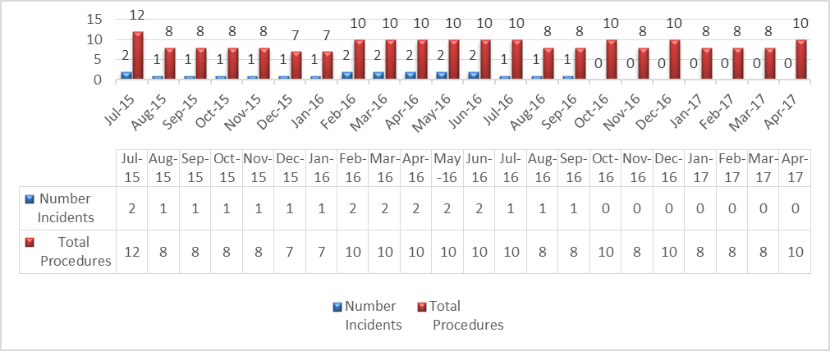

Project Lead | Team Members
Name  (person accountable for project) | Names  (persons involved in project)
Abdullah Ahmed Mattar | Raphael Kumbalath
 | Dinard Jalilul
 | Faisal Talab
 | Ahmed Mohammed
 | Nour Al-Attas

