2017 Performance Improvement Report
STRATEGIC PRIORITY
3. Improve efficiency and decision-making

Project Name
Reduction of Repeated CT Simulations for Oncology Patients Receiving Radiation Therapy.
Site |  | Department
Jeddah |  | Radiation Oncology
Project Status | Project Start Date |  | Project End Date
Completed | 01-01-2018 |  | 05-31-2017

Problem:  Why the project was needed?  The number of Repeated-CT Simulation has more than doubled from 2015 to 2016. For the patient and staff safety, the radiation dose should be minimized, hence we follow the ALARA (As low as Reasonably Achievable) radiation safety principle. Repeated-CT simulation falls under the category of unnecessary and overexposure, as it can be avoided. During year 2016, 5% of CT Simulation was repeated.  The benefit of reducing the Repeated-CT Simulation besides reducing the radiation dose to patient is to save time and effort involved in doing another CT Simulation especially that our slots are limited in CT Simulation, resulting in late CT bookings and subsequently in late start of radiation treatment. Inevitably, delay in treatment affects patient care and prognosis. | Aims: What will the project achieve?  To reduce the percentage of repeated CT simulations from 5% to 3% or less by May 2017
Benefits/Impact: What is the improvement outcome?  (check all that apply)  ☐ Contained or reduced costs  ☒ Improved productivity  ☒ Improved work process  ☐ Improved cycle time  ☐ Increased customer satisfaction  ☐ Other (please explain)  Click or tap here to enter text. | Quality Domain: Which of the domains of healthcare quality does this project support?  (Select only one)  Safe

Measures: Performance metrics to be evaluated | Targets: Expected outcomes
Percentage of repeated CT simulations | Reduce the percentage of repeated CT simulations from 5% to 3% or less by May 2017

Interventions: Overview of key steps/work completed
- Care plans for different Diagnosis were developed, example, rectum Cancer must have contrast.
- New process were introduced include:
  - Booking form must be complete. CT Simulation staff should not accept incomplete forms for CT Simulation.
  - If patient requires Bolus it should be indicated on the form.
  - Type of the technique, this is 3-Dimensional or Intensity Modulated Radiotherapy/Volumetric Arc Therapy needs to be established at the time of booking.
  - Diagrams to be completed showing superior and inferior margins.
  - Physician should be present for Intact Breast Cancer patients to see the setup, wire the breast and the scar.
  - All repeat-CT Simulation require consultant approval.
Results: Insert relevant graphs and charts to illustrate improvement pre and post project
(insert relevant graphs, data, charts, etc.)
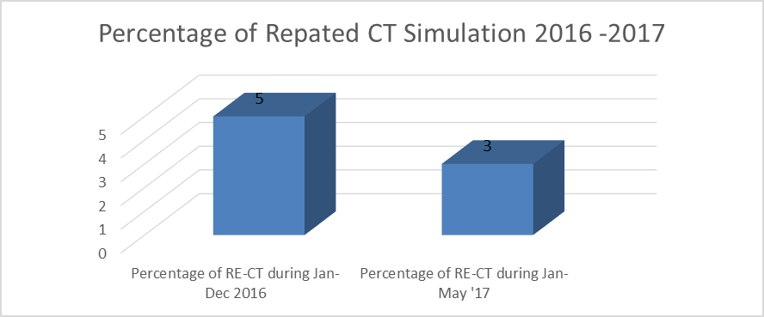

Project Lead | Team Members
Name  (person accountable for project) | Names  (persons involved in project)
Zaheeda Mulla | Dr Essam Senan  Dr Ahmed Ahmed  Mashael AlSomali  Hiba Taha  Maria Coogen  Guillaume Aznar  Dr Yasir Bahader  Sarbonza Meera

