2017 Performance Improvement Report
STRATEGIC PRIORITY
3. Improve efficiency and decision-making

Project Name
To Improve the average Turnaround Time (TAT) from the principle investigator’s submission of research proposal to Institute Review Board (IRB) response by 10%
Site |  | Department
Jeddah |  | Research Centre
Project Status | Project Start Date |  | Project End Date
Completed | 04-01-2017 |  | 09-30-2017

Problem:  Why the project was needed?  There was a steady increase in the number of research proposals submitted to IRB for in-depth review. Data showed that the average TAT was 4 weeks before 2017. This project aims to Improve the average TAT from research proposal submission to IRB until the initial IRB response. This will help streamline the research application process and encourage in-house research while maintaining the quality of in-depth review. | Aims: What will the project achieve?  To reduce the average TAT from the principle investigator’s submission of a completed IRB application to the initial IRB response to the principal investigator by at least 10% ( an average of 3.7 weeks compared to the current average of 4.1 weeks)
Benefits/Impact: What is the improvement outcome?  (check all that apply)  ☐ Contained or reduced costs  ☒ Improved productivity  ☒ Improved work process  ☒ Improved cycle time  ☐ Increased customer satisfaction  ☐ Other (please explain)  Click or tap here to enter text. | Quality Domain: Which of the domains of healthcare quality does this project support?  (Select only one)  Efficient

Measures: Performance metrics to be evaluated | Targets: Expected outcomes
TAT from the principle investigator’s submission of a completed IRB application to the initial IRB response to the principal investigator | Reduce the average TAT from the principle investigator’s submission of a completed IRB application to the initial IRB response to the principal investigator by at least 10% ( an average of 3.7 weeks compared to the current average of 4.1 weeks)

Interventions: Overview of key steps/work completed
- A Processing Officer has been assigned to improve the timely processing of research proposals.
- Receive the proposal package and check there are all relevant forms and documents are attached before forwarding the proposal package to IRB’S member by email.
- Send email notification to the assigned reviewer and request a written copy of the proposal review form.
- Email was sent to IRBs' member regarding a new framework which to improve the average timeline from research proposal submitted to IRB until the initial IRB response.
- The processing officer followed-up members to submit the initial response in the timeline.
- The processing Officer Collected and calculated the time of the period from submission of responses and compared the current average data to previous before and after 2017 Q2 and Q3.

Results: Insert relevant graphs and charts to illustrate improvement pre and post project
(insert relevant graphs, data, charts, etc.)
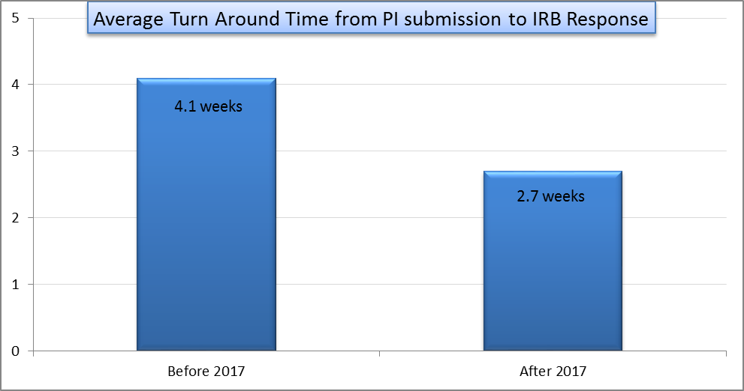

Project Lead | Team Members
Name  (person accountable for project) | Names  (persons involved in project)
Hossam Abdelrahman | Estela Sandiego  Sawsan Bassi  Hawazin Abdulbagi  Lubna Alsalmi  Nour Al Attas

