2017 Performance Improvement Report
STRATEGIC PRIORITY
3. Improve efficiency and decision-making

Project Name
Improving maintenance and tracking process for Cardiac Cath. Lab CCL equipment’s
Department /Unit:
Site |  | Department
Jeddah |  | Cardiac Catheterization Laboratory
Project Status | Project Start Date |  | Project End Date
Completed | 01-01-2017 |  | 07-31-2017

Problem:  Why the project was needed?  During month of Jan 2017 an audit was conducted an to check (Periodic Preventive Maintenance) PPM validity of CCL equipment maintenance, data shows only 39% of CCL equipment’s were with valid PPM, this might compromise patient safety and will affect our compliance with JCI requirments. | Aims: What will the project achieve?  To improve percentage of cath. lab equipment’s with valid PPM (periodic Preventive Maintenance) from 39% to at least 95% by end of Sep 2017.
Benefits/Impact: What is the improvement outcome?  (check all that apply)  ☐ Contained or reduced costs  ☒ Improved productivity  ☒ Improved work process  ☒ Improved cycle time  ☒ Increased customer satisfaction  ☐ Other (please explain)  Click or tap here to enter text. | Quality Domain: Which of the domains of healthcare quality does this project support?  (Select only one)  Efficient

Measures: Performance metrics to be evaluated | Targets: Expected outcomes
percentage of cath. lab equipment’s with valid PPM (periodic Preventive Maintenance) | To improve percentage of cath. lab equipment’s with valid PPM (periodic Preventive Maintenance) from 39% to at least 95% by end of Sep 2017.

Interventions:
- Equipment’s master list has been updated
- Daily checklist maintenance record has been developed and updated
- Cleaning tags has been provided for equipment’s with missing tags, the compliance for checking the dates and initials was addressed to the staff
- Equipment’s borrower’s log sheet has been initiated and updated
- Regularly updated the schedule for PPM
Results: Insert relevant graphs and charts to illustrate improvement pre and post project
(insert relevant graphs, data, charts, etc.)
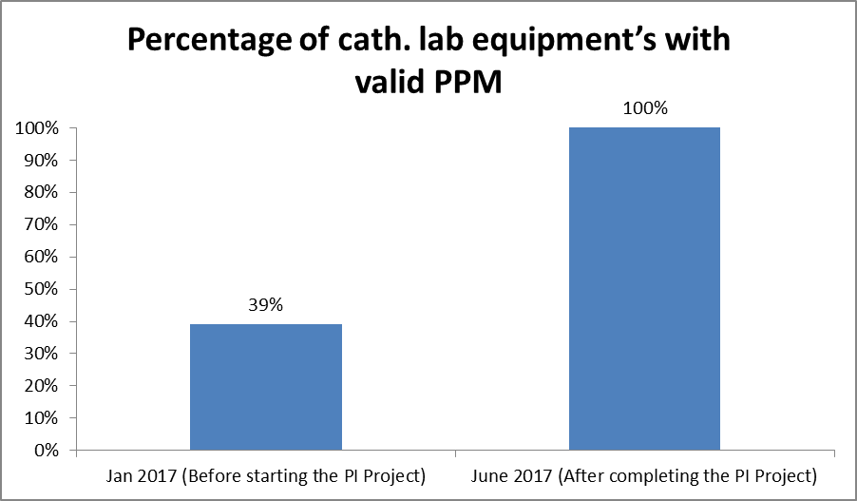

Project Lead | Team Members
Name  (person accountable for project) | Names  (persons involved in project)
Ahmad Moh’d | Suzette Belanio  Lourdes Gozum  Agapito Recio  Houssam Hoblos  Sarah Arellano  Wissam Elzein  Samuel Go  Ruel Veñales  Ebrahim Sandokji  Samer Dardas

