2017 Performance Improvement Report
STRATEGIC PRIORITY
3. Improve efficiency and decision-making

Project Name
Improving Patient booking under named consultant clinics in department of Family Medicine
Site |  | Department
Jeddah |  | Family Medicine
Project Status | Project Start Date |  | Project End Date
Completed | 01-01-2017 |  | 07-31-2017

Problem:  Why the project was needed?  Family Medicine department provides walk in format clinics on daily basis. However, it emerged from the data that here are frequent incidents where the patients were booked under non-consultant named clinics. Collected Data showed that Total walk in clinics provided in Month of March 2017 in Family Medicine =153  Walk in clinics under named consultant =145  Hence the percentage of name Walk in clinic under a consultant =145/153 = 94.77%  In line with the Organization’s policy the aim of this project was to improve this percentage of total walk in clinics provided under a named consultant by 5% | Aims: What will the project achieve?  Improving the percentage of Family Medicine walk in clinics booked under named consultant’s clinics from 94.7% to 100% by end of July 2017
Benefits/Impact: What is the improvement outcome?  (check all that apply)  ☐ Contained or reduced costs  ☐ Improved productivity  ☒ Improved work process  ☐ Improved cycle time  ☒ Increased customer satisfaction  ☐ Other (please explain)  Click or tap here to enter text. | Quality Domain: Which of the domains of healthcare quality does this project support?  (Select only one)  Effective

Measures: Performance metrics to be evaluated | Targets: Expected outcomes
Family Medicine walk in clinics booked under named consultant’s clinics | Improving the percentage of Family Medicine walk in clinics booked under named consultant’s clinics from 94.7% to 100% by end of July 2017

Interventions: Overview of key steps/work completed
- Abolished use of resident clinic slots in Family medicine to solve the problem
Results: Insert relevant graphs and charts to illustrate improvement pre and post project
(insert relevant graphs, data, charts, etc.)

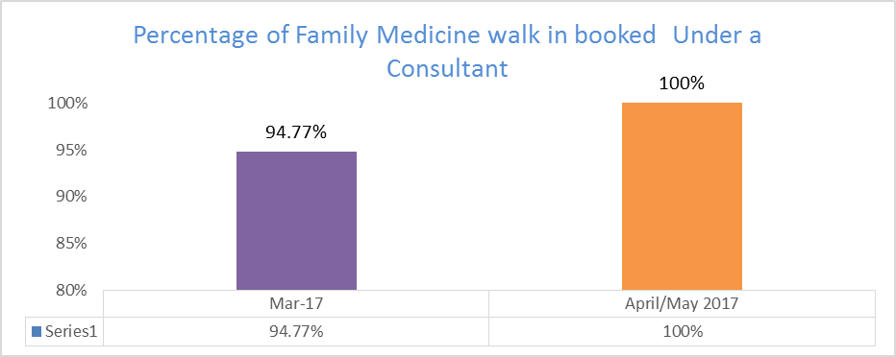

Project Lead | Team Members
Name  (person accountable for project) | Names  (persons involved in project)
Dr Salman Shahid | Dr Aziz Ahmed  Dr Faisal Araki  Aletta Barnard  Azoof Al Farikh  Ibrahim Qoulaghasi

