2017 Performance Improvement Report
STRATEGIC PRIORITY
5. Promote external relations and funding

Project Name
Reduction In Disposal Of Expired Medical Items In Cardiac Catheterization Laboratory.
Site |  | Department
Jeddah |  | CARDIAC CATH LAB
Project Status | Project Start Date |  | Project End Date
Completed | 01-01-2017 |  | 07-01-2017

Problem:  Why the project was needed?  During year 2016 (1546 expired items was disposed during year 2016), having that numbers of expired medical items leads to initiate this project to improve maximum utilization of the medical items as a Hospital initiative to achieve cost effectiveness & budget saving | Aims: What will the project achieve?  - Reduce the number of disposed expired medical items in 2017 to less than 25 %
Benefits/Impact: What is the improvement outcome?  (check all that apply)  ☒ Contained or reduced costs  ☐ Improved productivity  ☒ Improved work process  ☐ Improved cycle time  ☒ Increased customer satisfaction  ☐ Other (please explain)  Click or tap here to enter text. | Quality Domain: Which of the domains of healthcare quality does this project support?  (Select only one)  Safe

Measures: Performance metrics to be evaluated | Targets: Expected outcomes
- Number of disposed expired medical items in cardiac cathlab. | - 25% or less

Interventions: Overview of key steps/work completed
1. The items in the store rooms / procedure rooms (LAB 1 /LAB 2 / Hybrid) were arranged according to the expiry date , making the nearly expired items at the front of the shelf and easy to access and be distinguished and identified to the staff by using different colored removable stickers with statement “ USE IT FIRST ” .
2. The items which will expire within 6 months were removed from the main stores and label it with special stickers.
3. A list of medical items that will expire within the coming 3 month displayed on the board and the staff’s taking care with these items were notified.
4. Creating a list of the items that having the highest expiration number and find the main causes lead it to be expired before getting used and share it with the managers.

Results: Insert relevant graphs and charts to illustrate improvement pre and post project
(insert relevant graphs, data, charts, etc.)
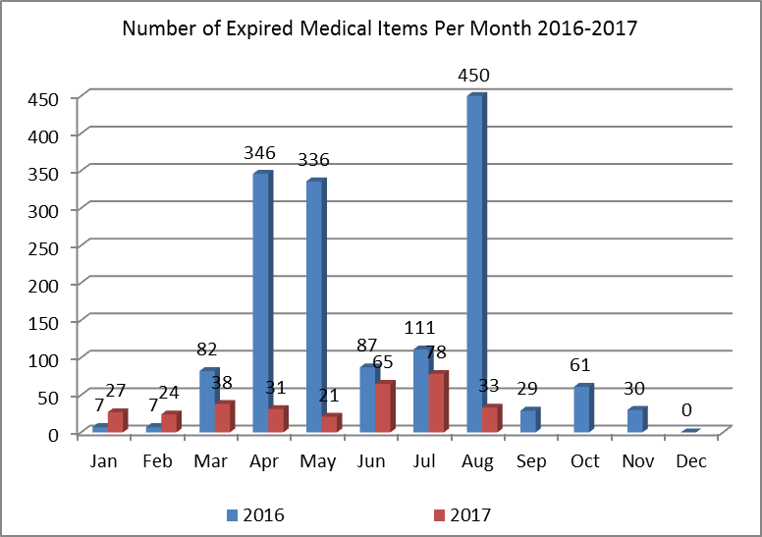
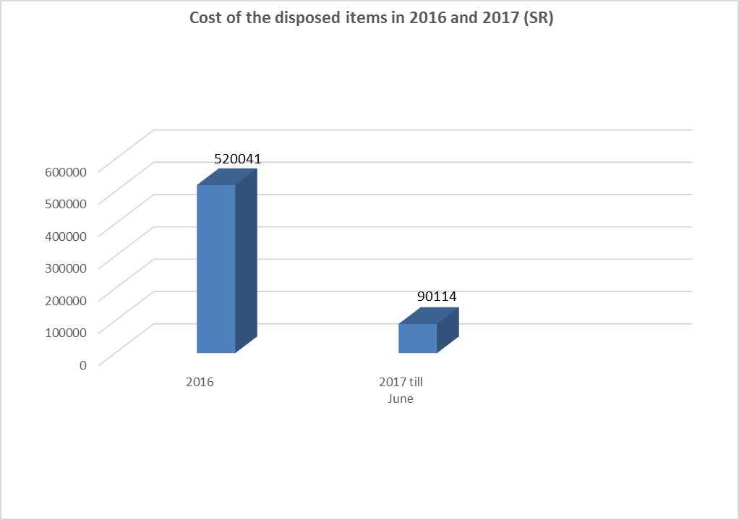
From Jan to Aug 2016 there was 1426 expired medical item comparing to the same period in 2017 there was 317 expired medical items, which represents a reduction by 1109 items , which is more than 25% reduction in the expired items number .

Project Lead | Team Members
Name  (person accountable for project) | Names  (persons involved in project)
AYHAM MANSI | FAISAL TALAB
 | OSAMA ELSAYED
 | TINI EPHRIME
 | RAMI ABU SAIF
 | RUEL VENALES
 | ARWA ALSHARIF
 | AHMAD MOH`D
 | RANA BUKHARI
 | LEE YU
 | ROLA Al KHATTIB

