2017 Performance Improvement Report
STRATEGIC PRIORITY
5. Promote external relations and funding

Project Name
Standardize the Record-to-Report Process on all Contracted Services within the Administrative Services
Site |  | Department
Jeddah |  | Administrative Services
Project Status | Project Start Date |  | Project End Date
Completed | 03-07-2017 |  | 11-02-2017

Problem:  Why the project was needed?  Ineffective contract payment processing, recording, and reporting procedures  for approval and/or financial information of senior executives because of:  - Inconsistent and multiple sources of data  - Lengthy data validation process  - Enterprise Correspondence EC memo are returned for changes because inaccurate details  - Delayed and/or redundant work  Loss or unavailable data due to employee’s absence or separation from the department. | Aims: What will the project achieve?  - To establish a standard and efficient database and consolidate relevant information from contract awarding to the closing of the same contract (company profile)  - To simplify the process of department recording, payment requisitions, and submits management reports on time.  - To reduce the number of errors in payment requests and reports  - To enable independent reporting (Administrative Services)  - To reduce the percentage of Memos returned for changes from 28% in 2016 to zero % in 2017
Benefits/Impact: What is the improvement outcome?  (check all that apply)  ☐ Contained or reduced costs  ☒ Improved productivity  ☒ Improved work process  ☐ Improved cycle time  ☒ Increased customer satisfaction  ☐ Other (please explain)  Click or tap here to enter text. | Quality Domain: Which of the domains of healthcare quality does this project support?  (Select only one)  Effective

Measures: Performance metrics to be evaluated | Targets: Expected outcomes
- Percentage of Memos returned for correction due to inaccurate details. | - From 28% in 2016 to zero % in 2017

Interventions: Overview of key steps/work completed
- Development and testing of unified database for all contracted services under the Administrative Services Group to ensure reliability and availability of data
- Streamline the process of preparing the EC payment request by generating memo draft from the database after recording the payment details.
- Database administrator has been assigned to Administrative Services (Div.-J)
- Access shared among business owners
- Training of end users and delegates

Results: Insert relevant graphs and charts to illustrate improvement pre and post project
(insert relevant graphs, data, charts, etc.)
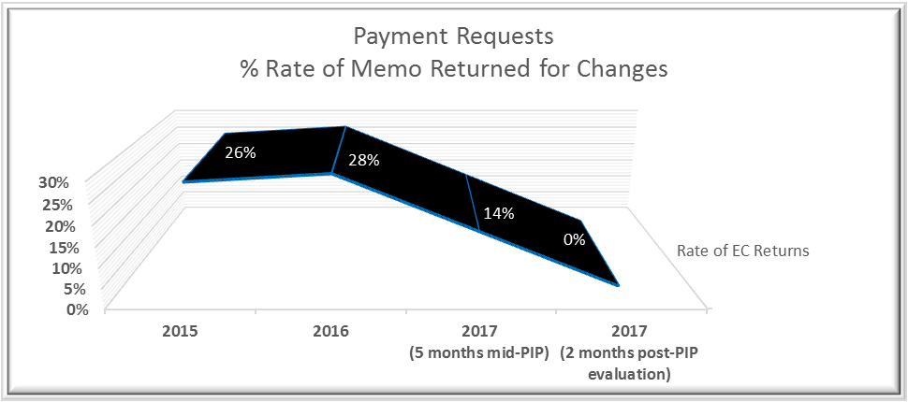

Project Lead | Team Members
Name  (person accountable for project) | Names  (persons involved in project)
Cynthia P. Camangyan | Abdulaziz AlOwaydhi
 | Dima Mominkhan
 | Samah Alim
 | Ma. Pilar B. Quilon
 | Sinagtala Firmalo
 | Jumana Al Gashgari
 | Nour Al-Attas

